

Universiti Tunku Abdul Rahman

Foundation in Science

**FHCT1024 Programming Concepts and Design**

Session 202210

FINAL REPORT

|  |  |
| --- | --- |
| **Practical Group:** | **P1** |
| **Practical Lecturer’s Name:** | **Mr. Ling Kock Sheng** |
| **Group Name:** | **Practical 1 Group 1** |
|  |  |

|  |  |  |  |
| --- | --- | --- | --- |
|  | Name | Student ID | Signature |
| 1. | Evelyn Wong Xing Ling | 2206530 | Evelyn |
| 2. | Jacqueline Lim Siao Ching | 2204538 | Jacqueline |
| 3. | Lee Mun Onn | 2206403 | Munonn |
| 4. | Lee Wei Jin | 2204345 | Leeweijin |
| 5. | Ngu Kiong Xiong | 2204535 | Xiong |
| 6. | Yu Xiao Shi | 2205761 | Yuxioashi |

Table of Content

|  |  |
| --- | --- |
| Content | Page Number |
| Front Page | 1 |
| Table of Content | 2 |
| Task Distribution | 3 |
| Flowchart:  1. Mainmenu  2. Student Maintenance  3. Course Maintenance  4. Question Bank Maintenance  5. Generate Test Paper | 4 – 5  6 – 20  21 – 34  35 – 61  62 – 74 |
| Screenshot of Program  1. Mainmenu  2. Student Maintenance  3. Course Maintenance  4. Question Bank Maintenance  5. Generate Test Paper | 75 – 76  77 – 91  92 – 112  113 – 133  134 – 144 |
| Source Code (Program Code)  1. Mainmenu  2. Student Maintenance  3. Course Maintenance  4. Question Bank Maintenance  5. Generate Test Paper | 145 – 146  147 – 152  153 – 157  158 – 167  168 – 173 |
|  |  |

Task Distribution

|  |  |
| --- | --- |
| Name | Task |
| Yu Xiao Shi | Code:  1. Main menu  2. Student Maintenance  Flowchart:  1. Main menu |
| Lee Wei Jin | Code:  1.Main menu  2. Course Maintenance  Flowchart:  1. Question Bank |
| Evelyn Wong Xing Ling | Flowchart:  1. Student Maintenance  2. Course Maintenance 3. Question Bank |
| Lee Mun Onn | Code:  1. Question Bank  Flowchart:  1. Question Bank |
| Jacqueline Lim Siao Ching | Code:  1. Generate Question Paper  Flowchart:  1. Generate Question Paper |
| Ngu Kiong Xiong | Code:  1. Generate Question Paper  Flowchart:  1. Generate Question Paper |

Flowcharts

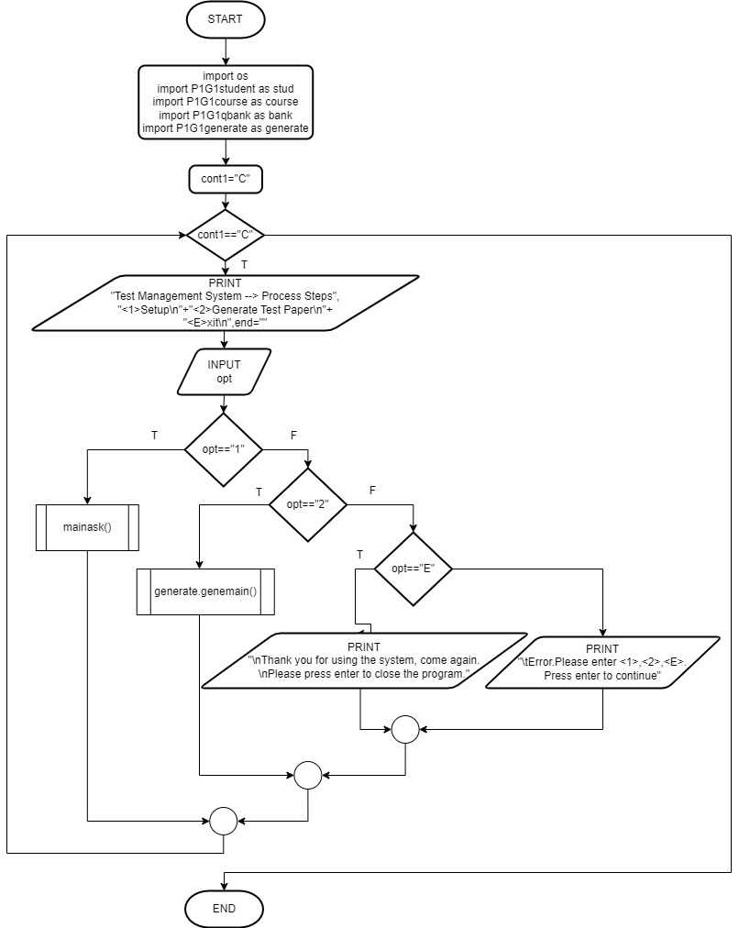1. Mainmenu

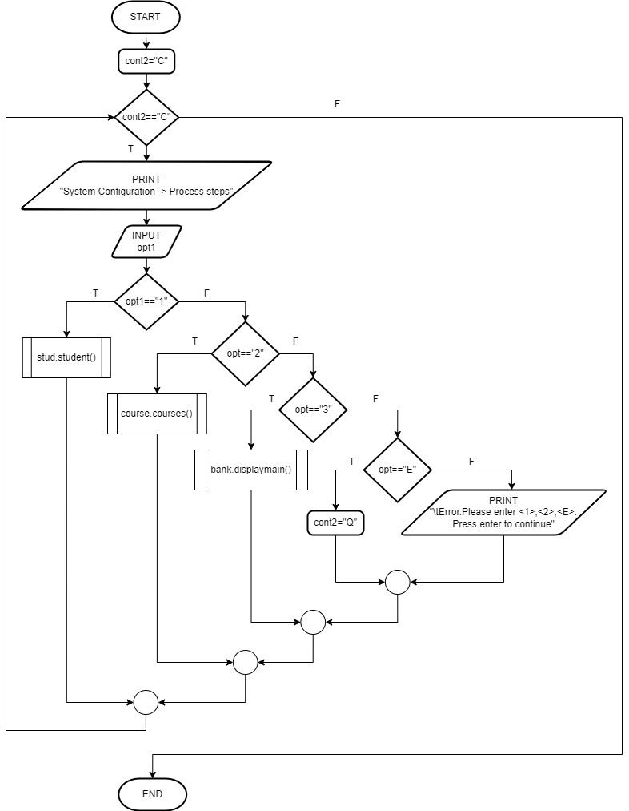

**2. Student Maintenance**

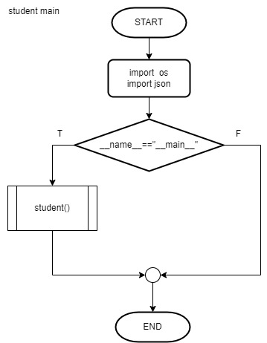

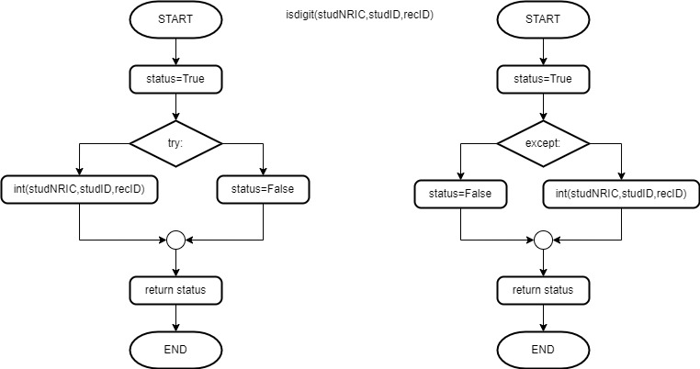

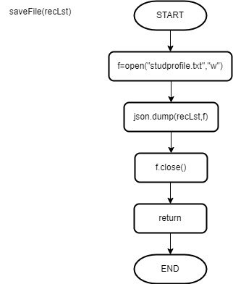

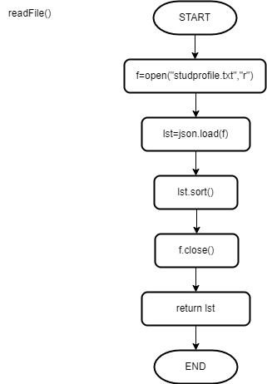

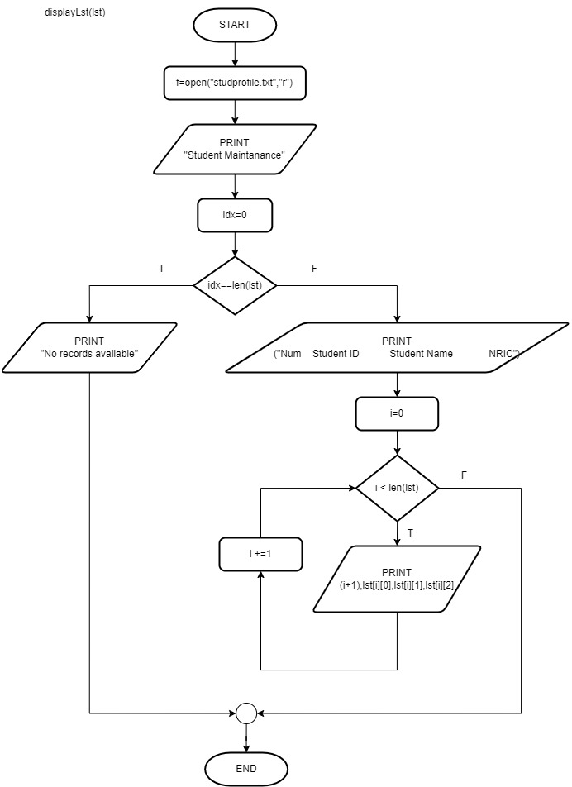

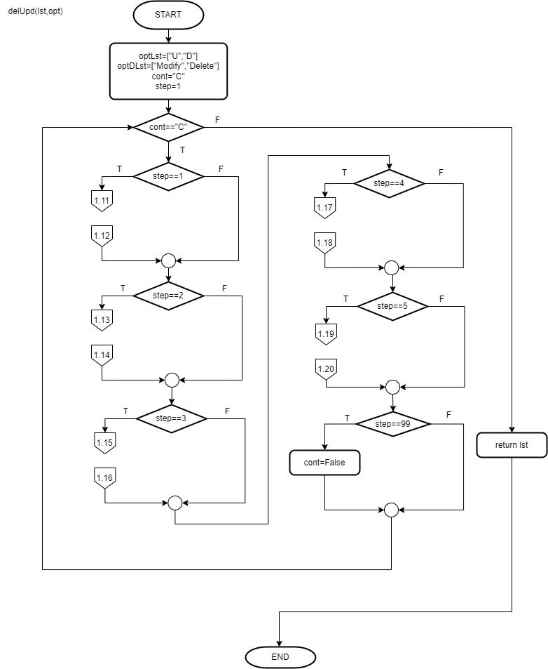

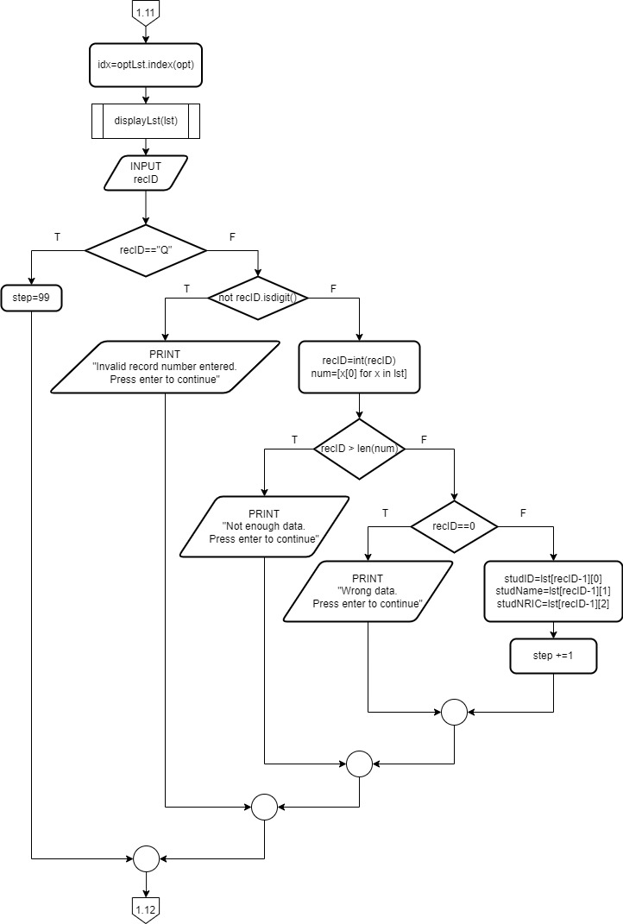

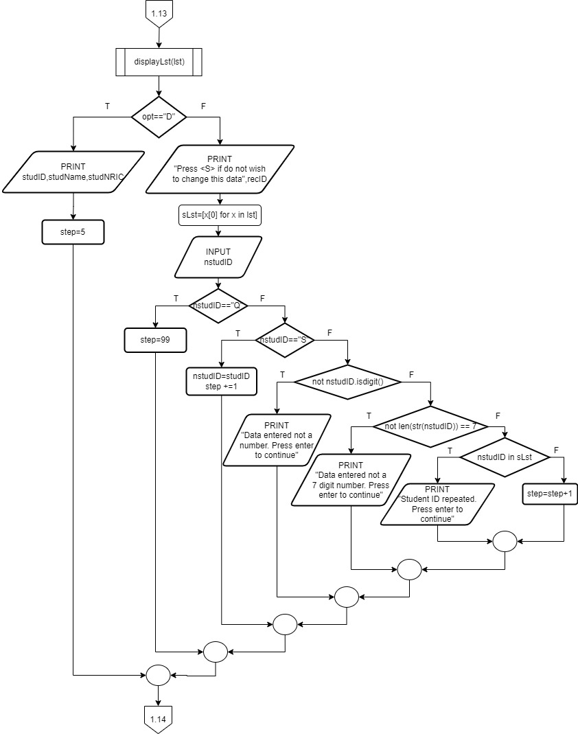

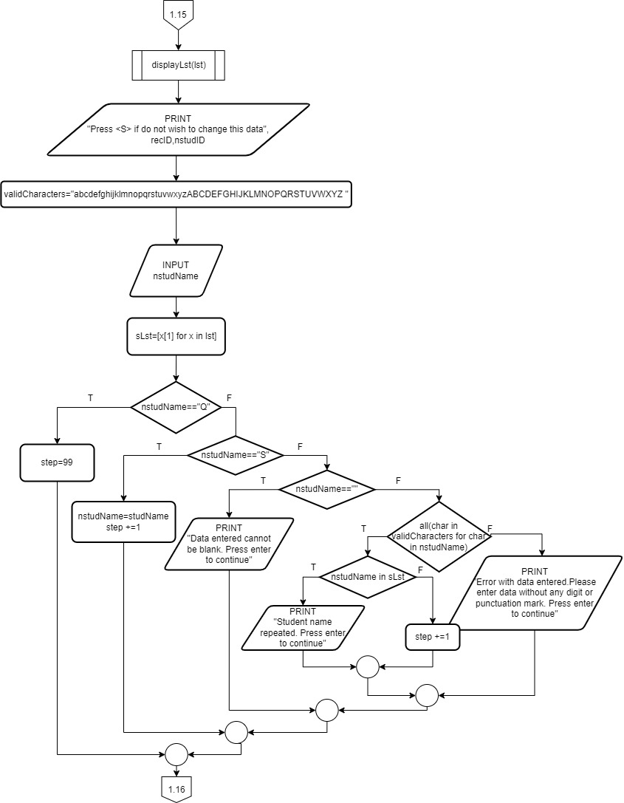

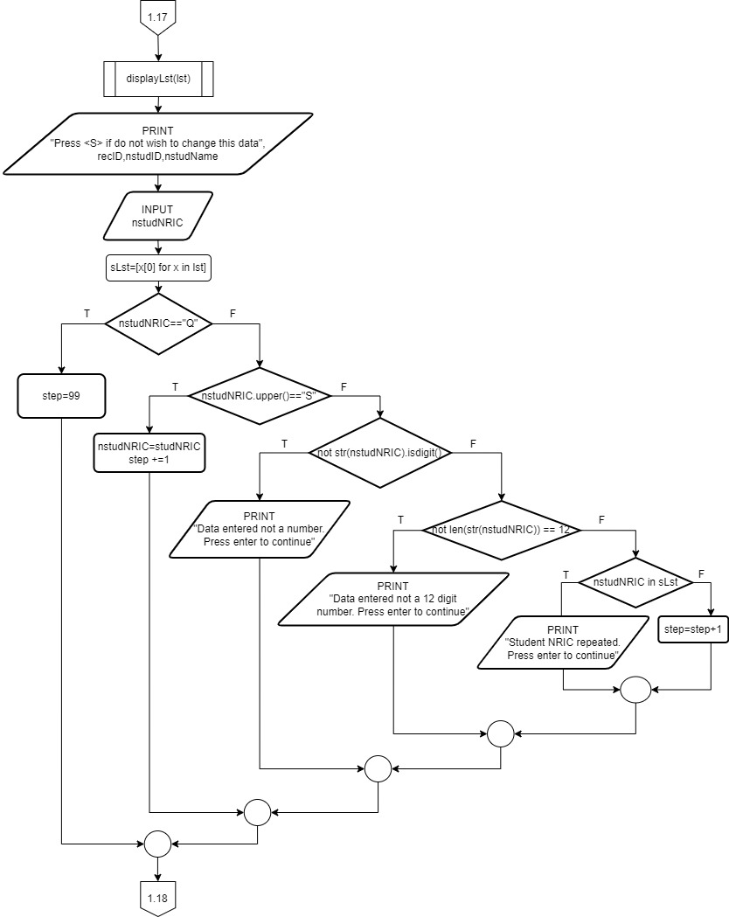

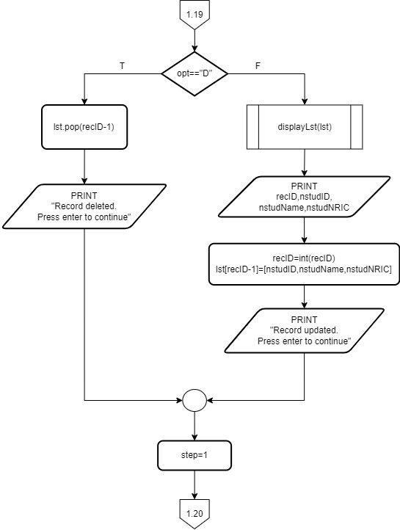

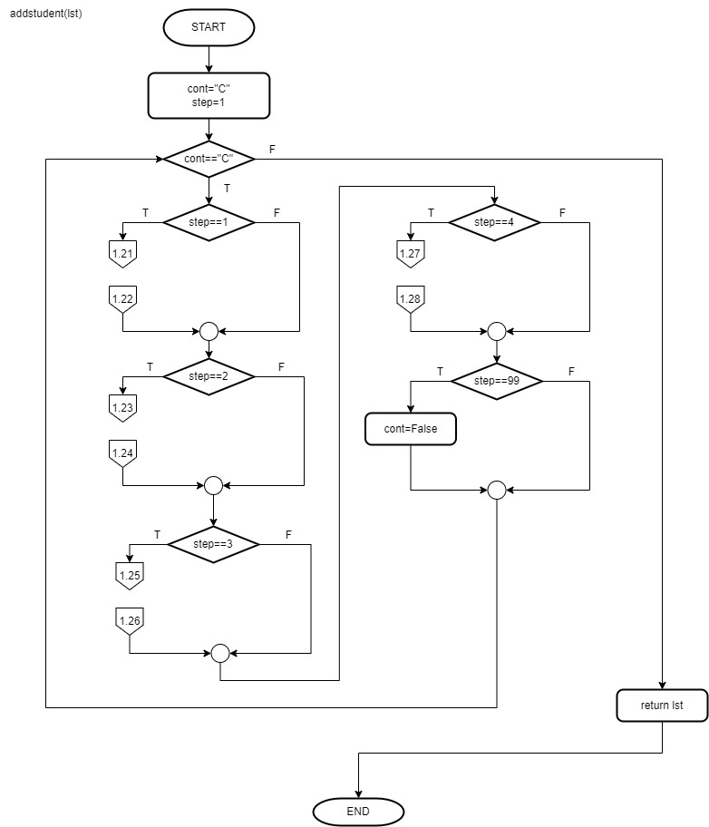

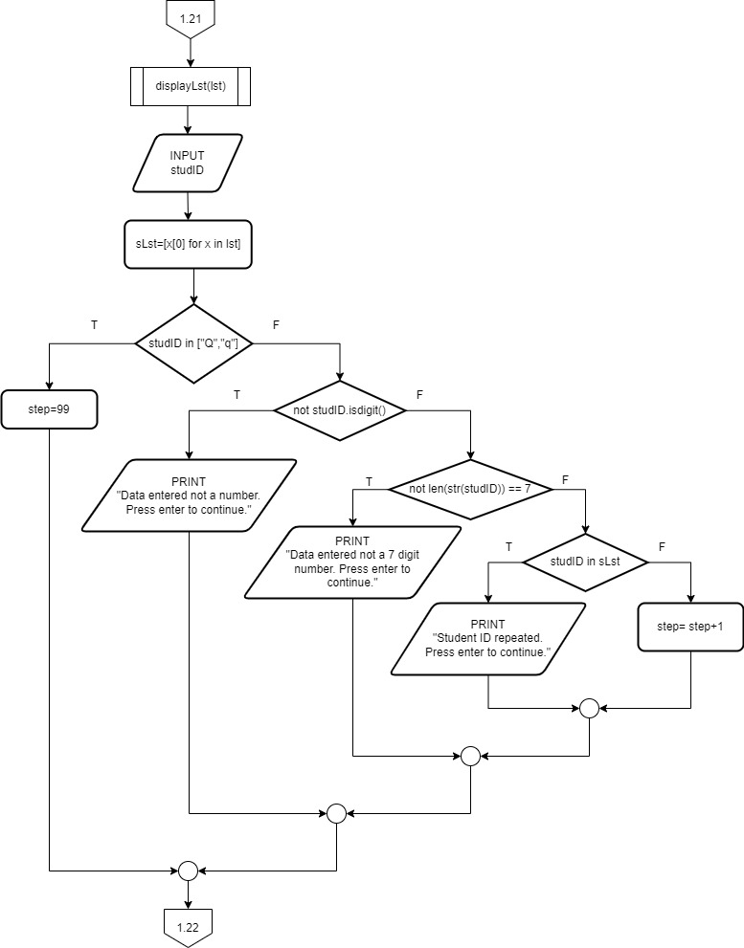

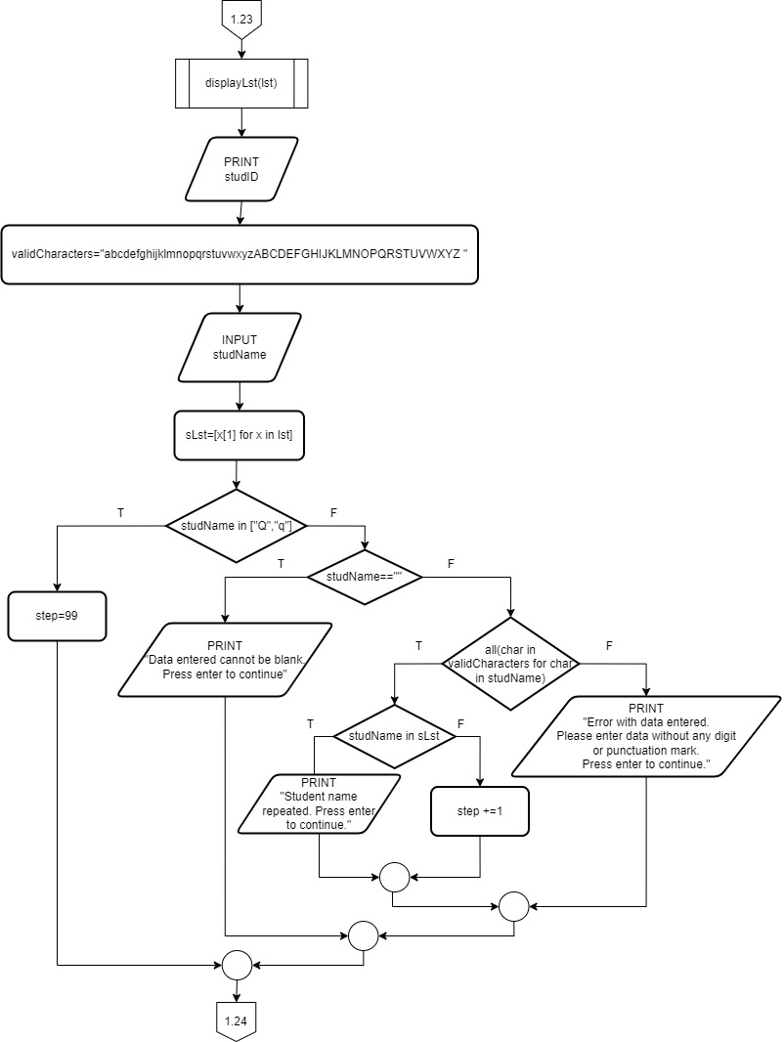

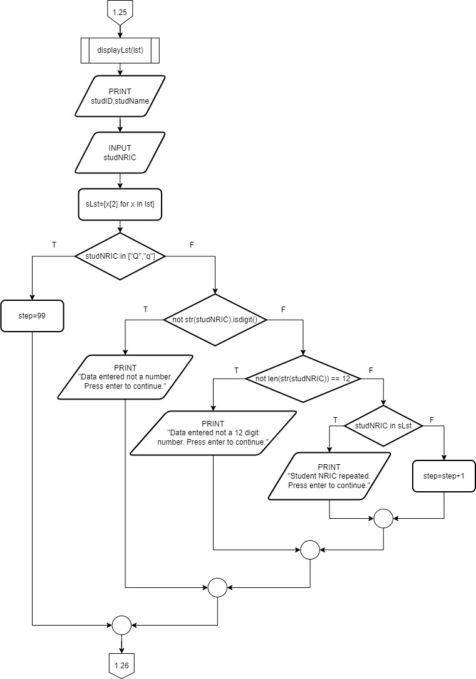

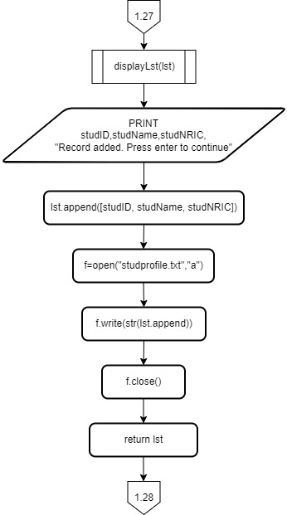

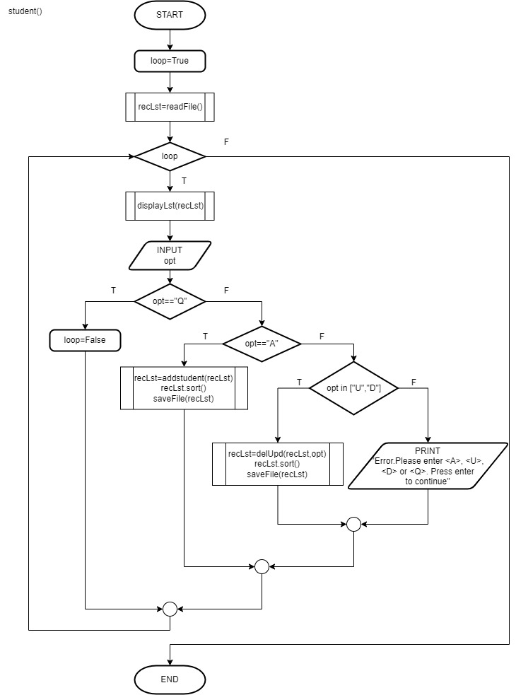

**3. Course Maintenance**

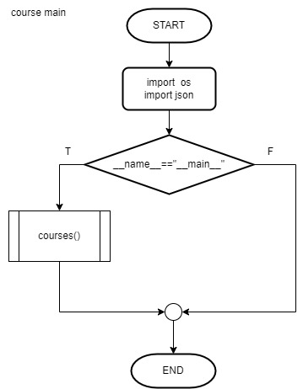

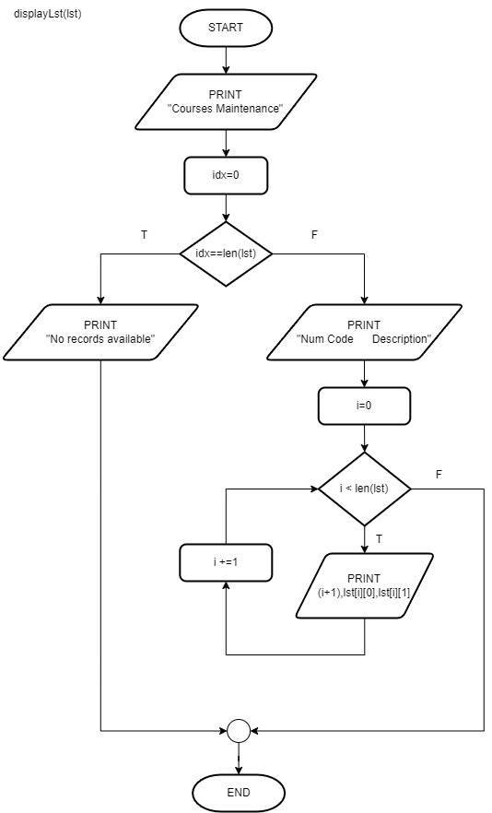

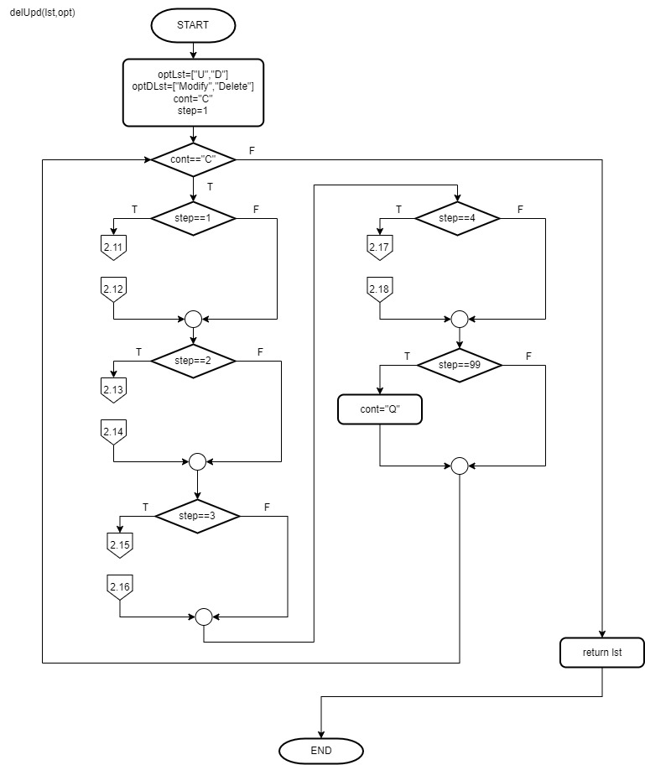

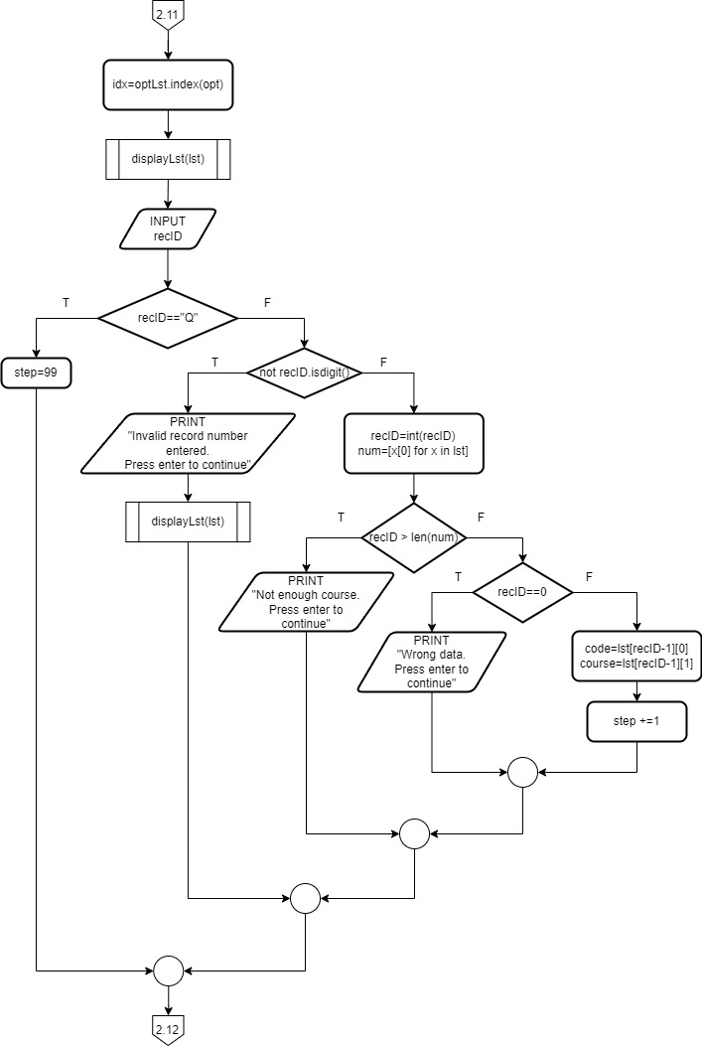

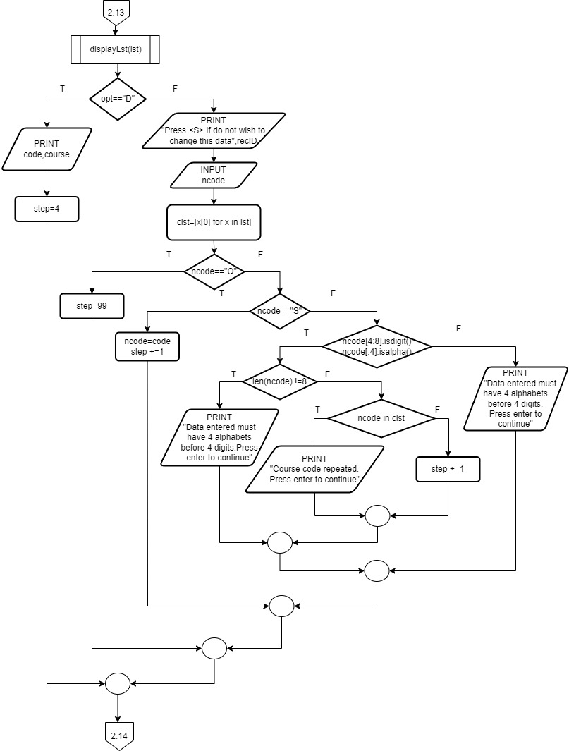

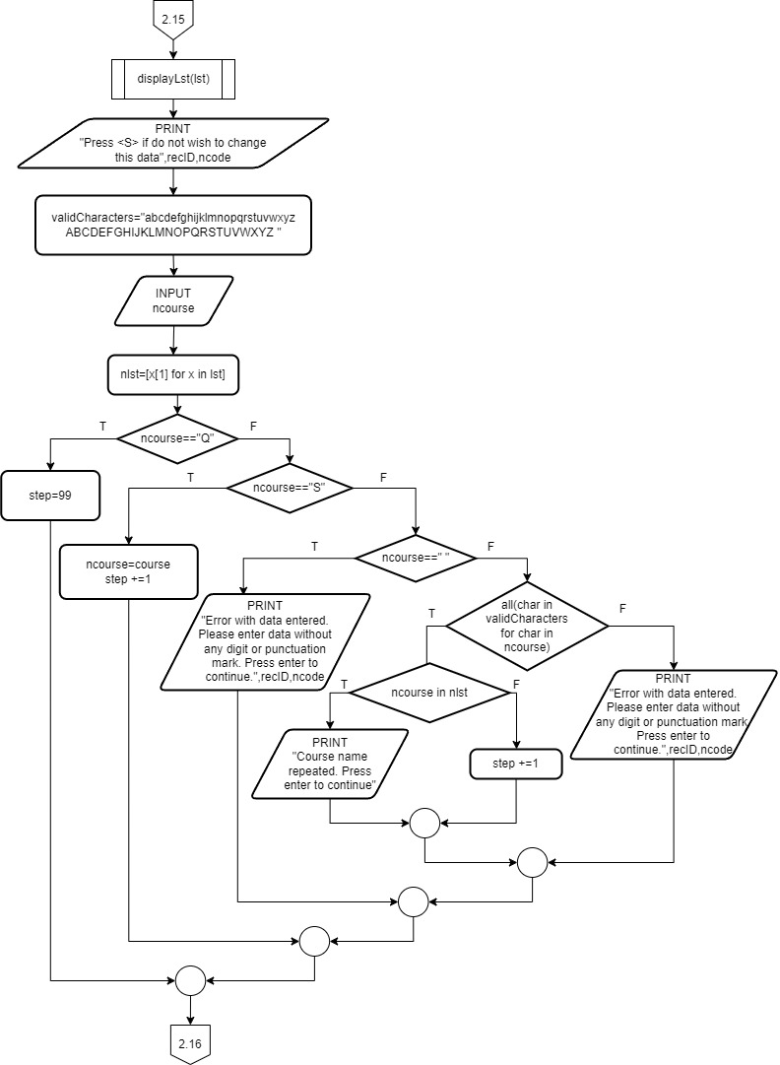

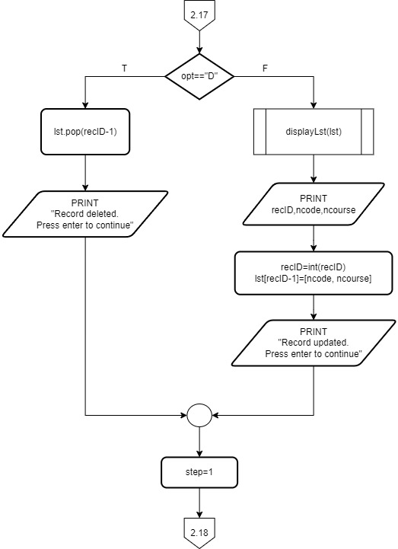

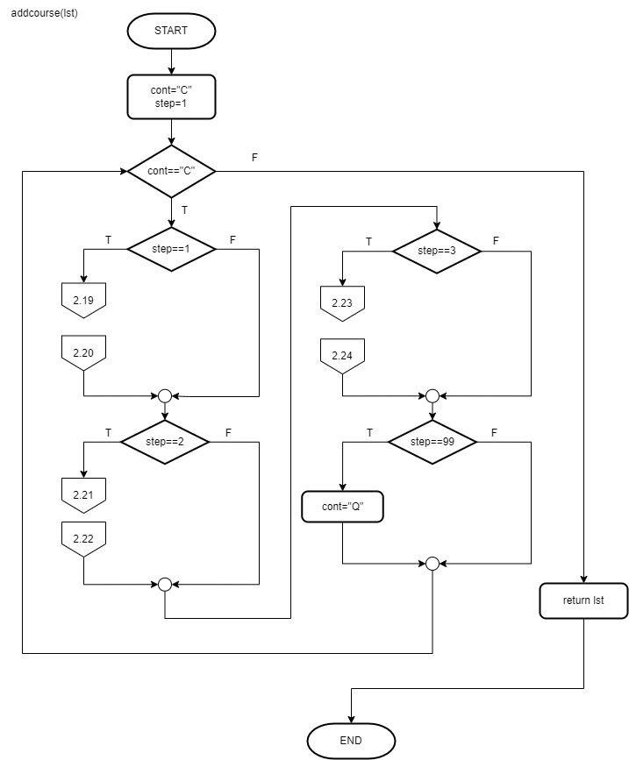

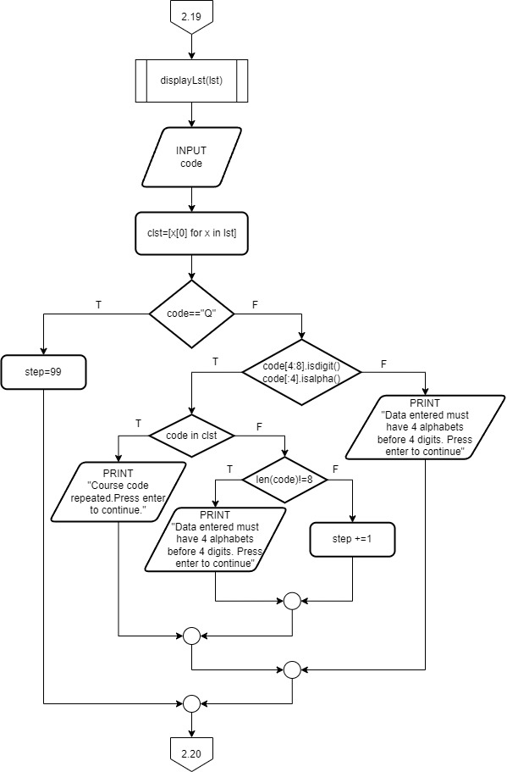

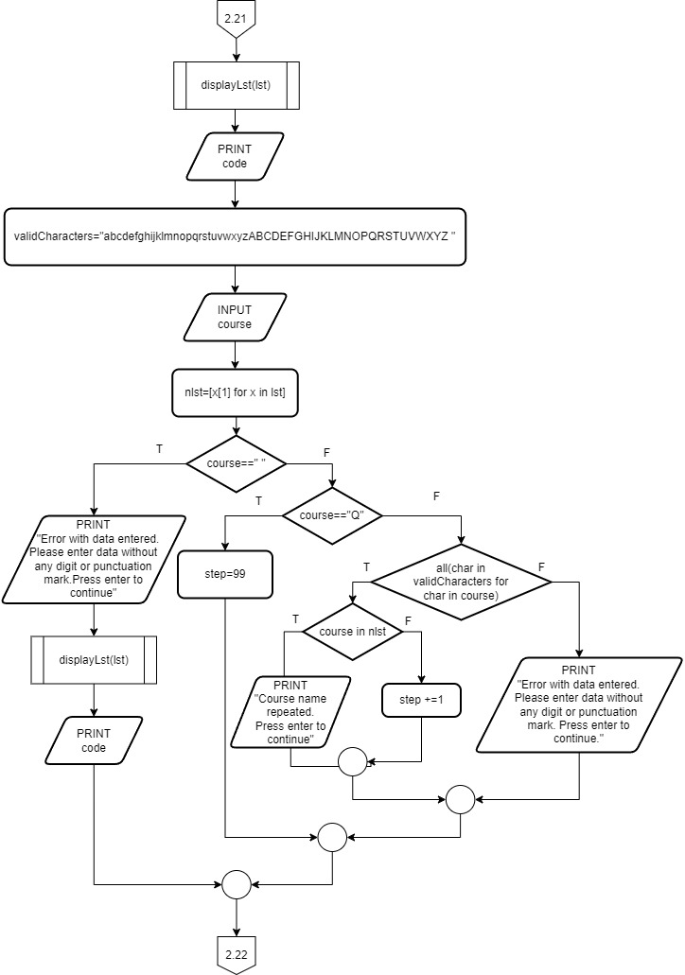

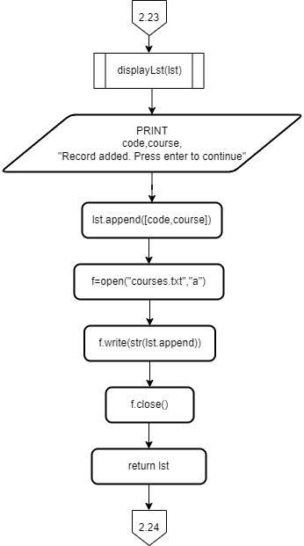

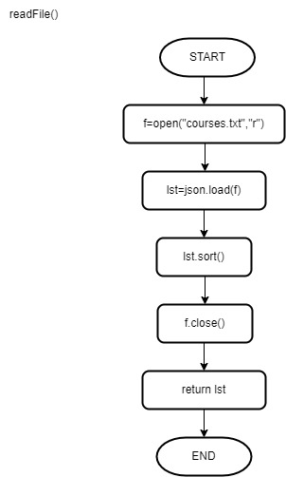

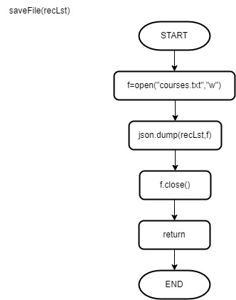

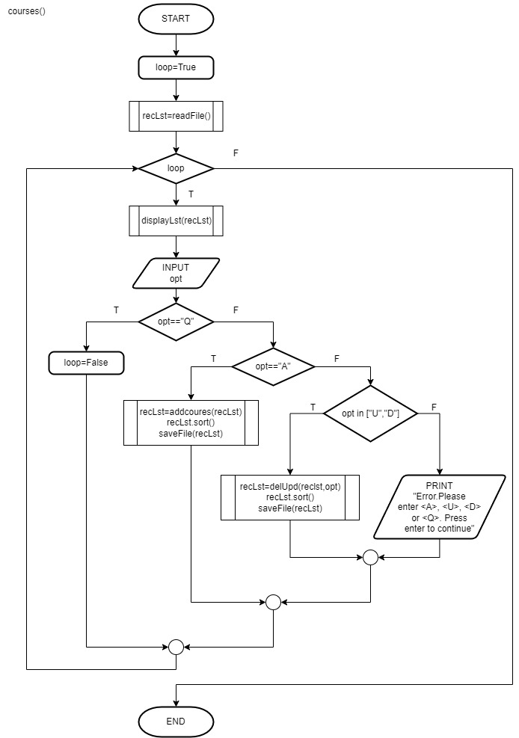

**4. Question Bank Maintenance**

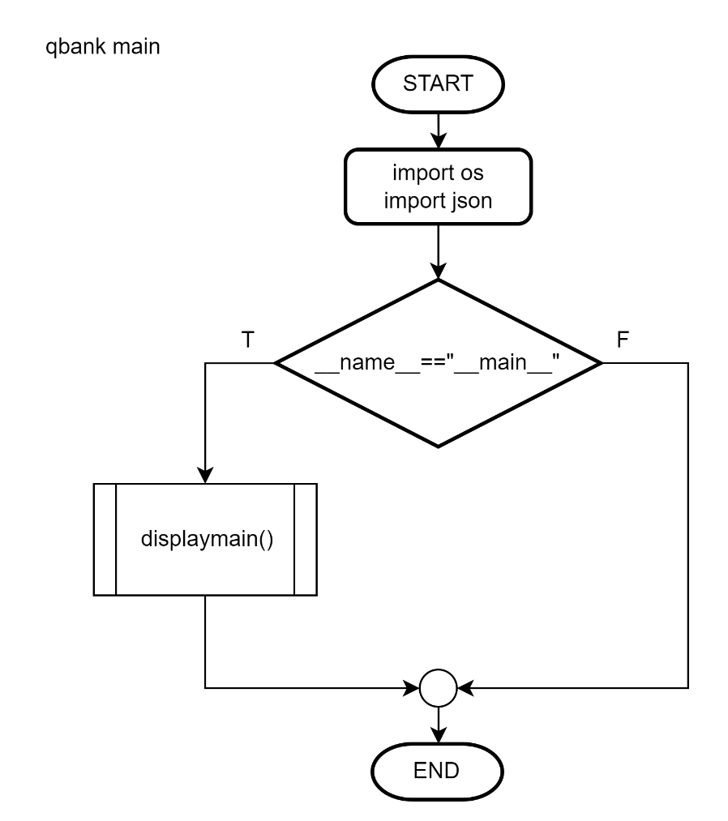

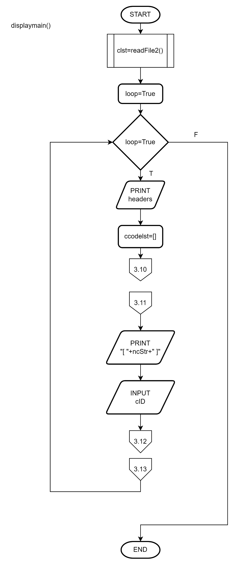

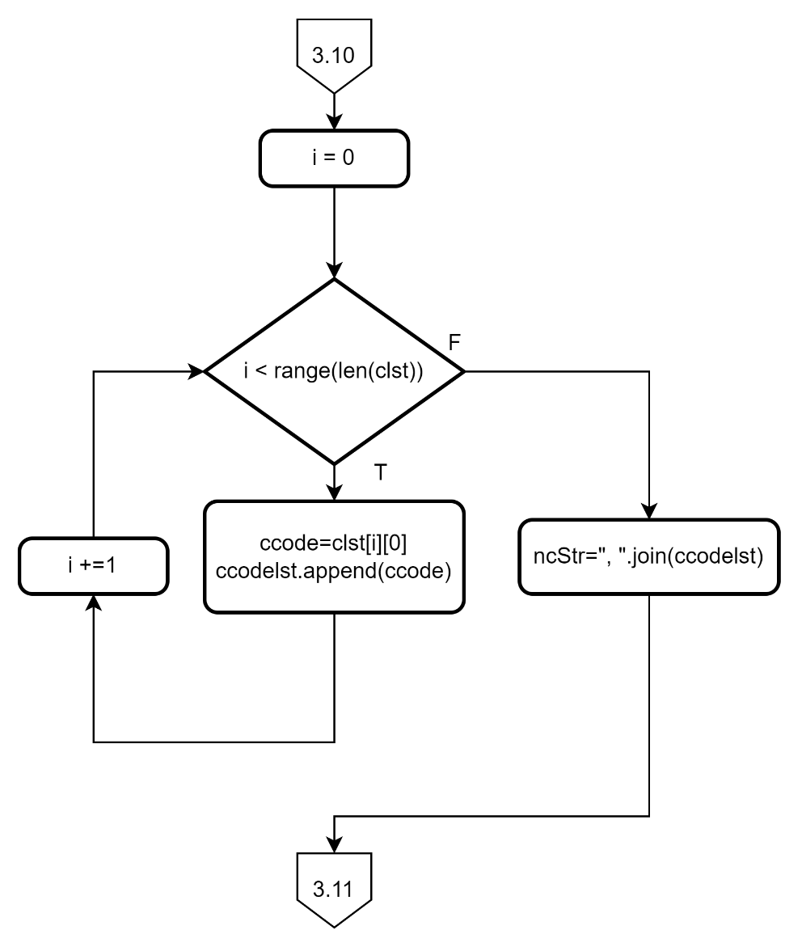

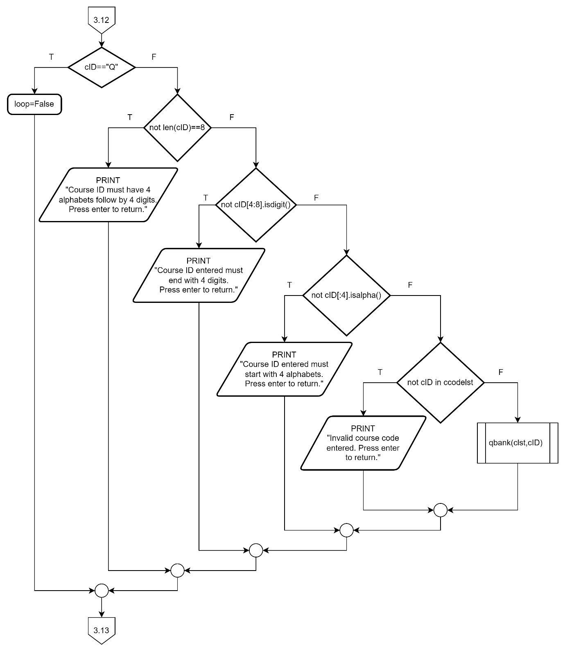

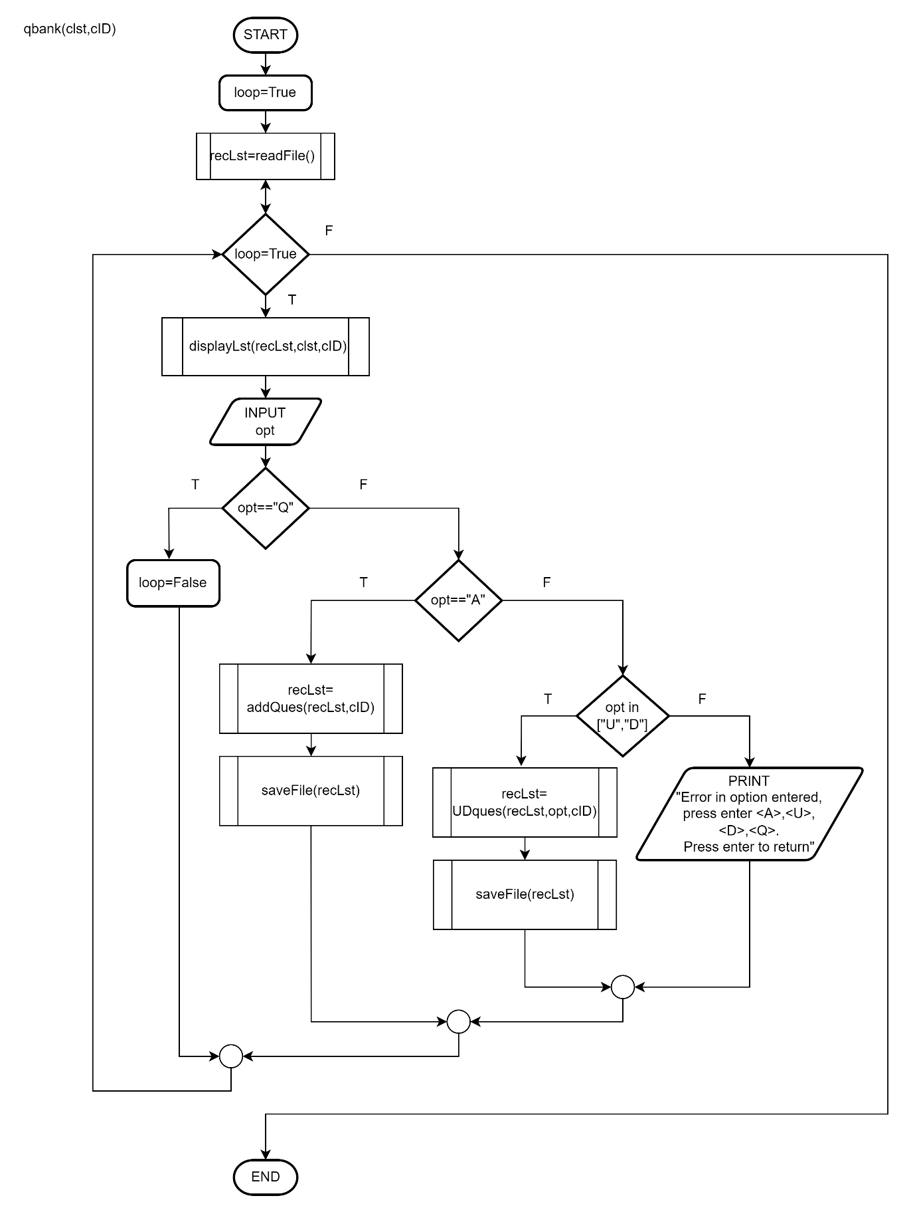

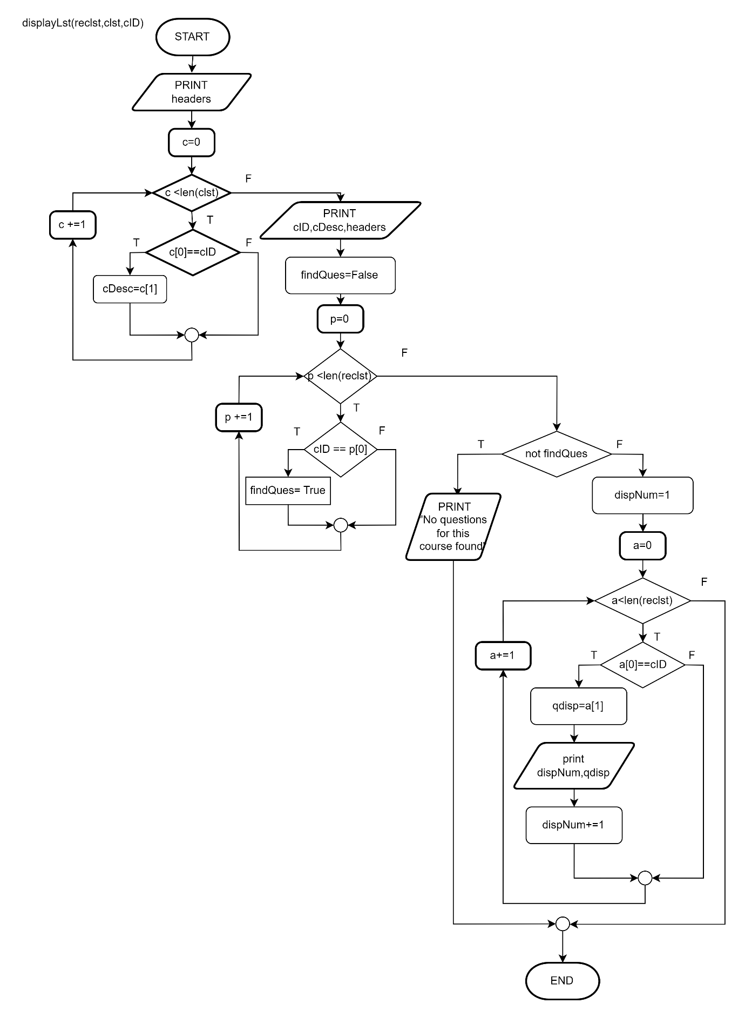

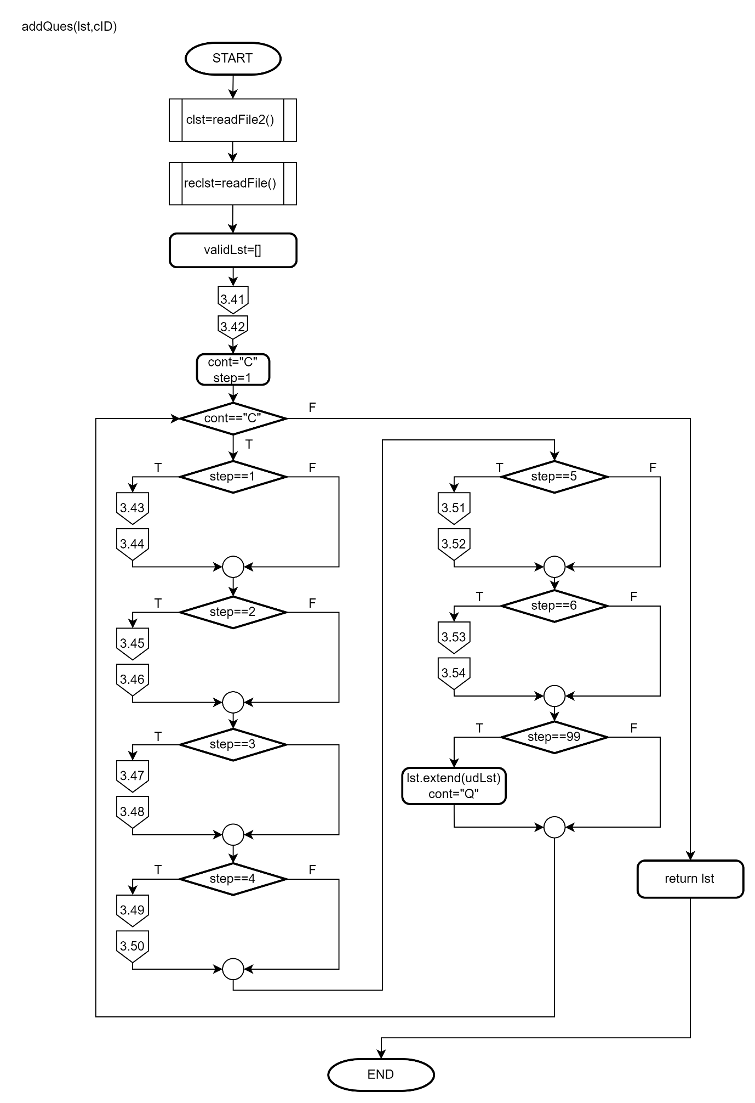

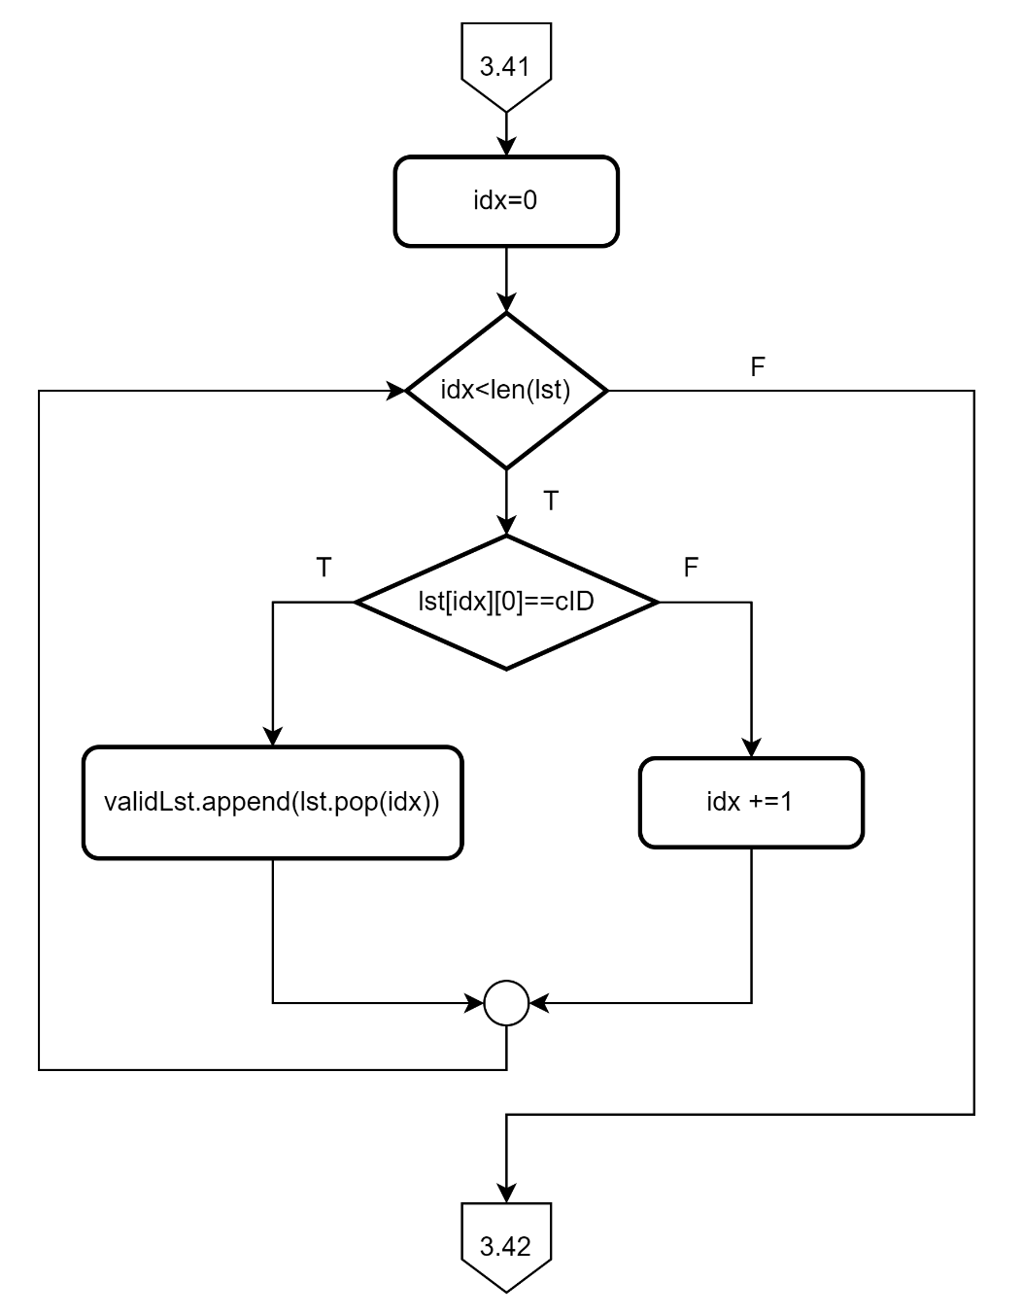

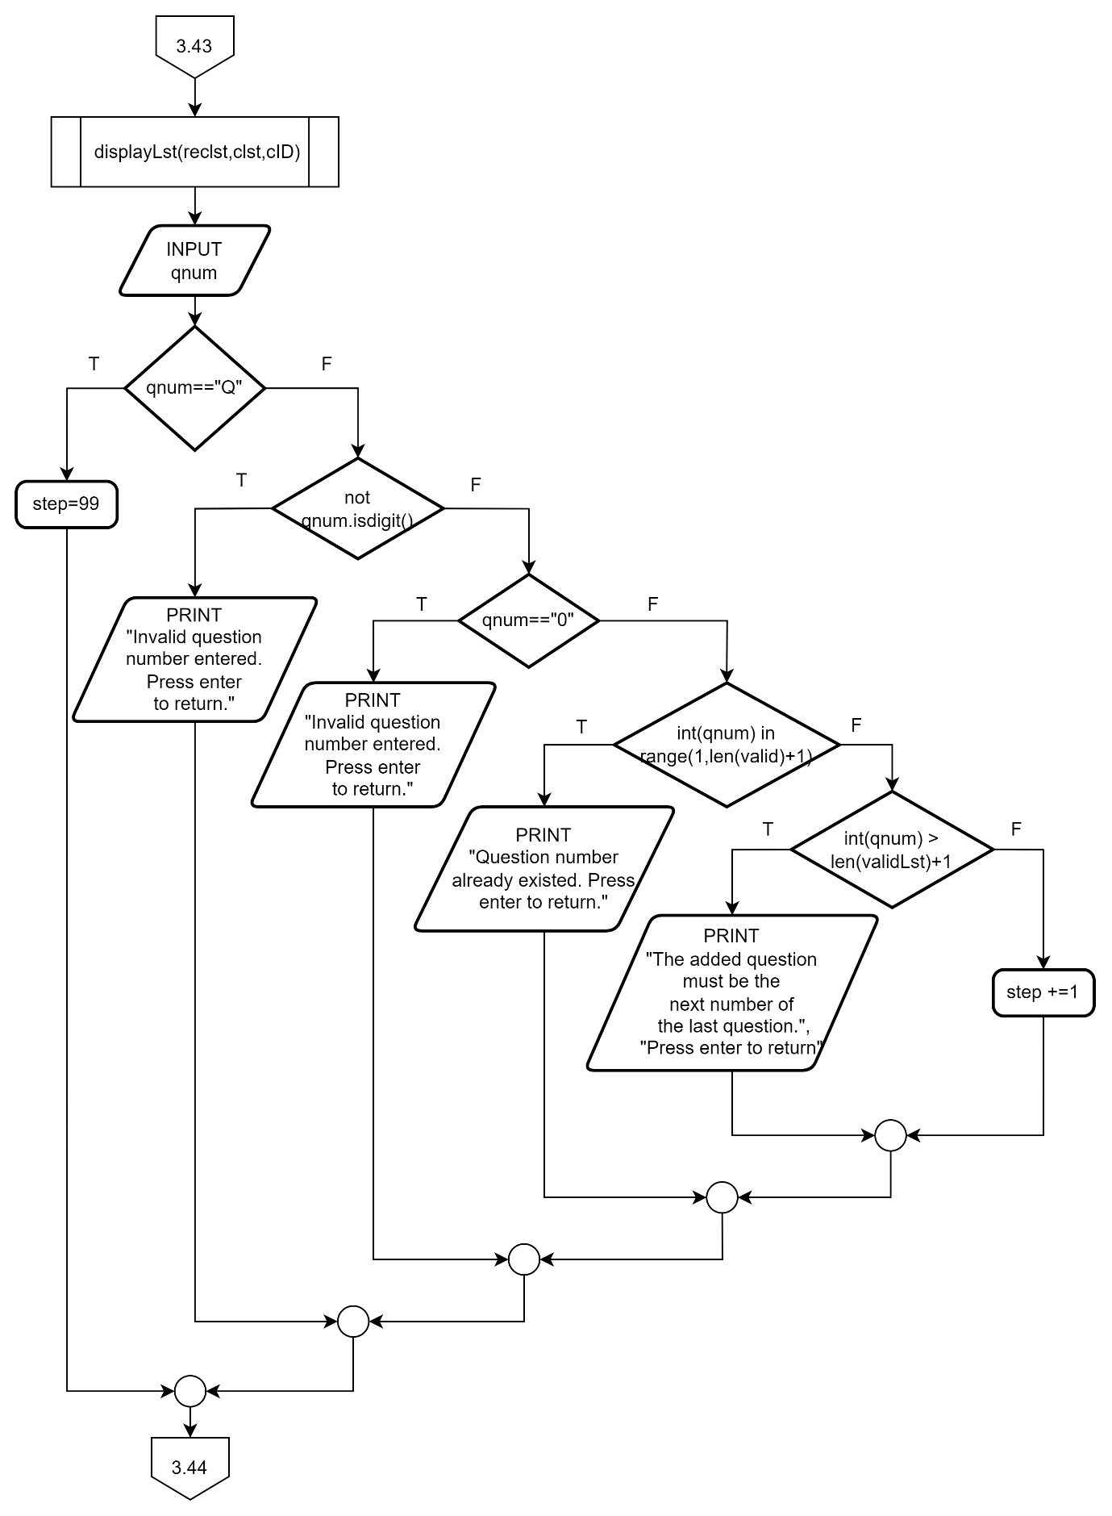

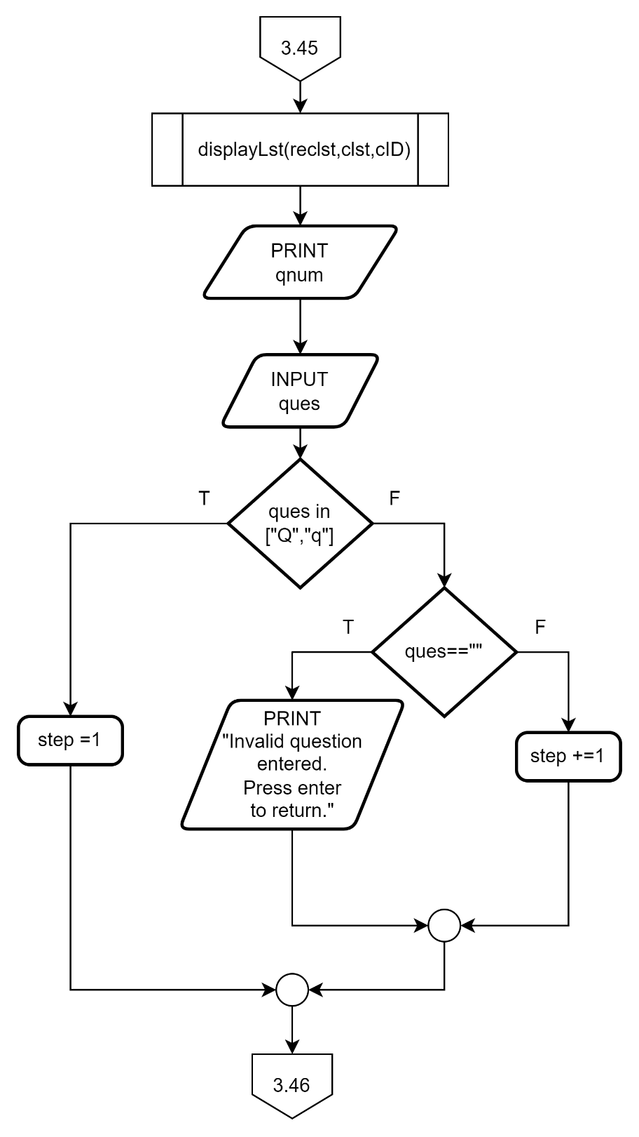

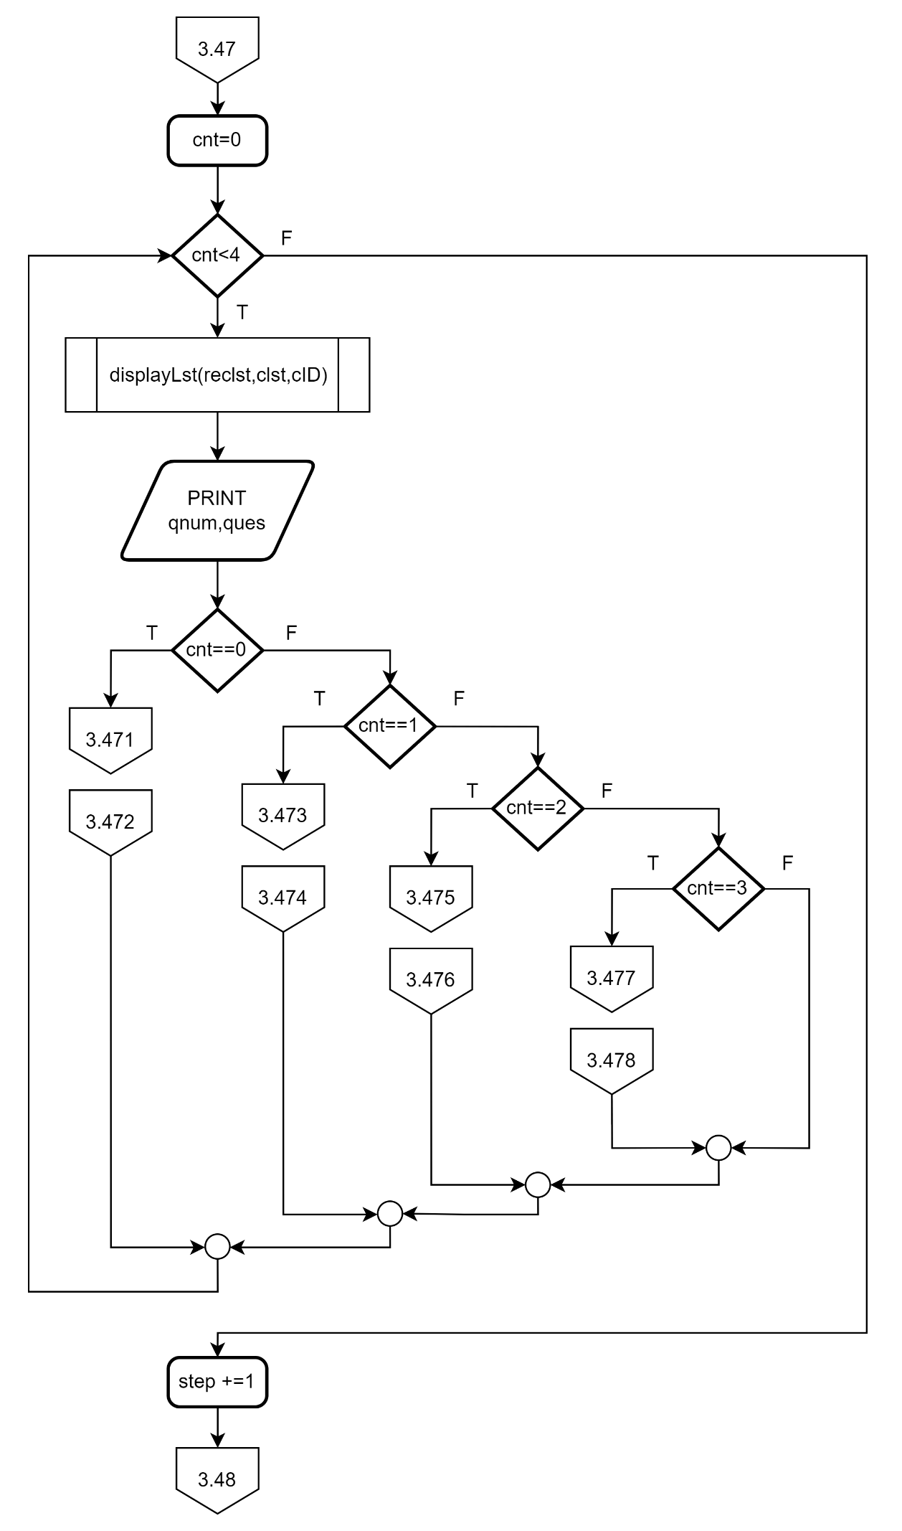

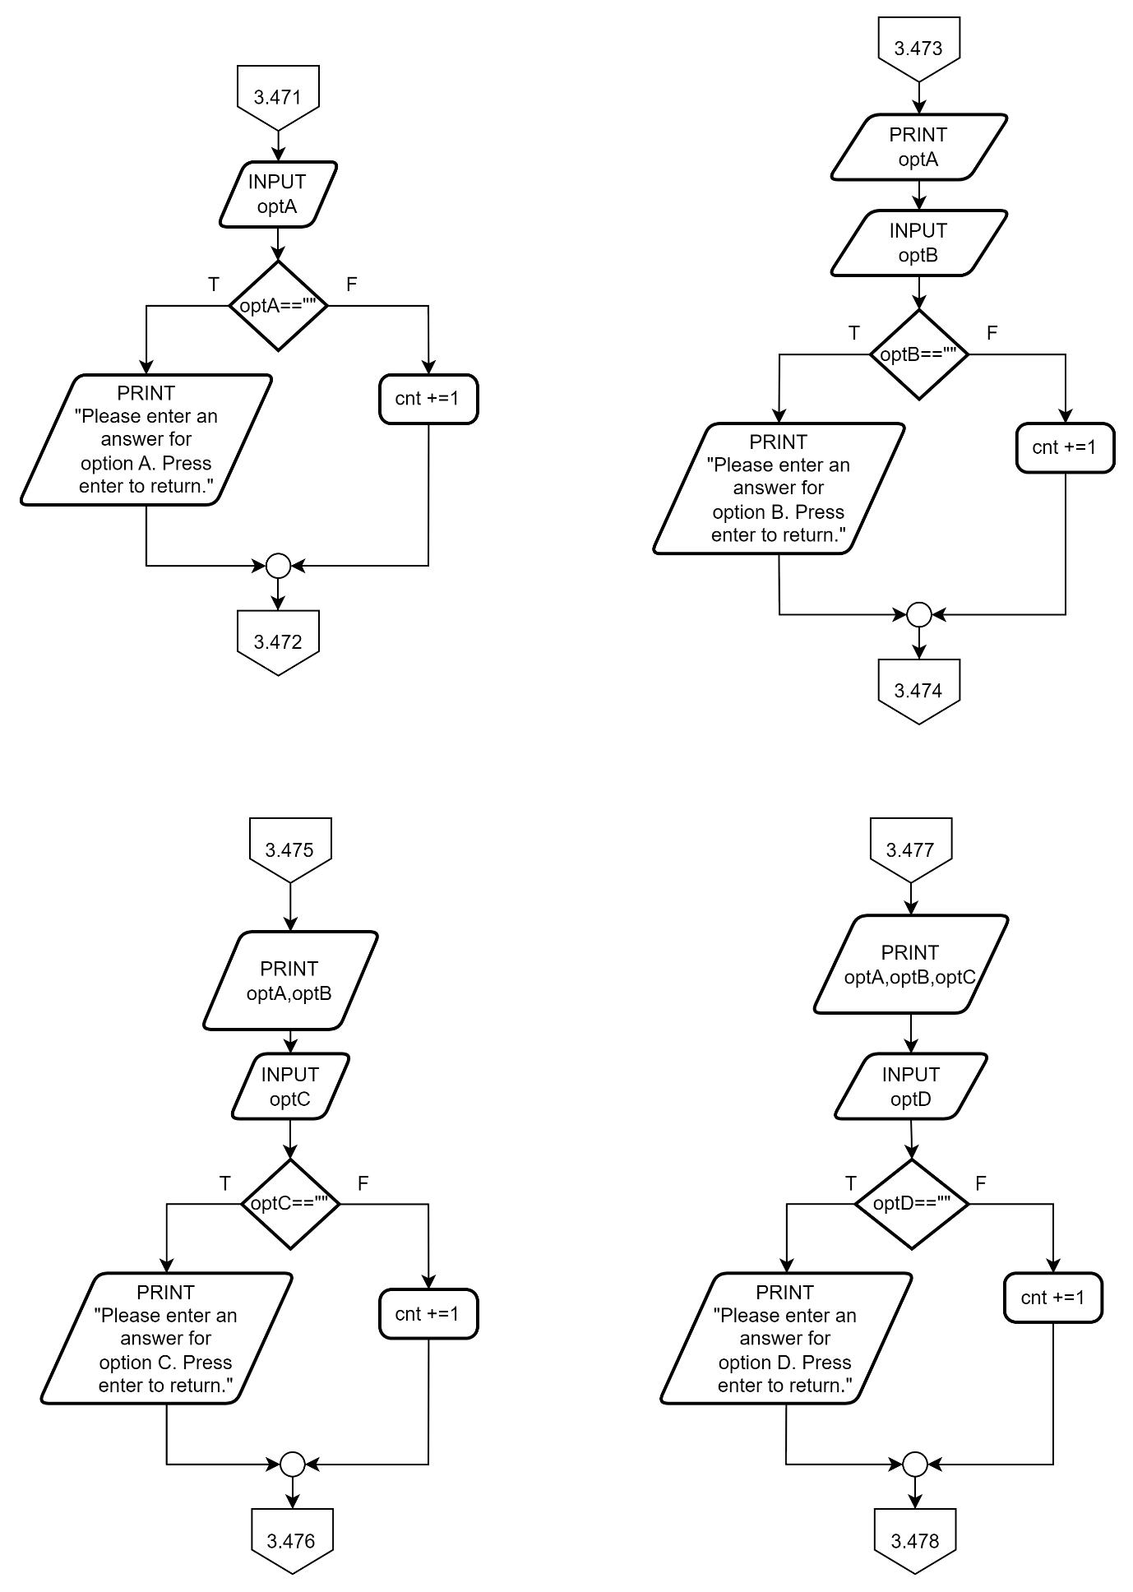

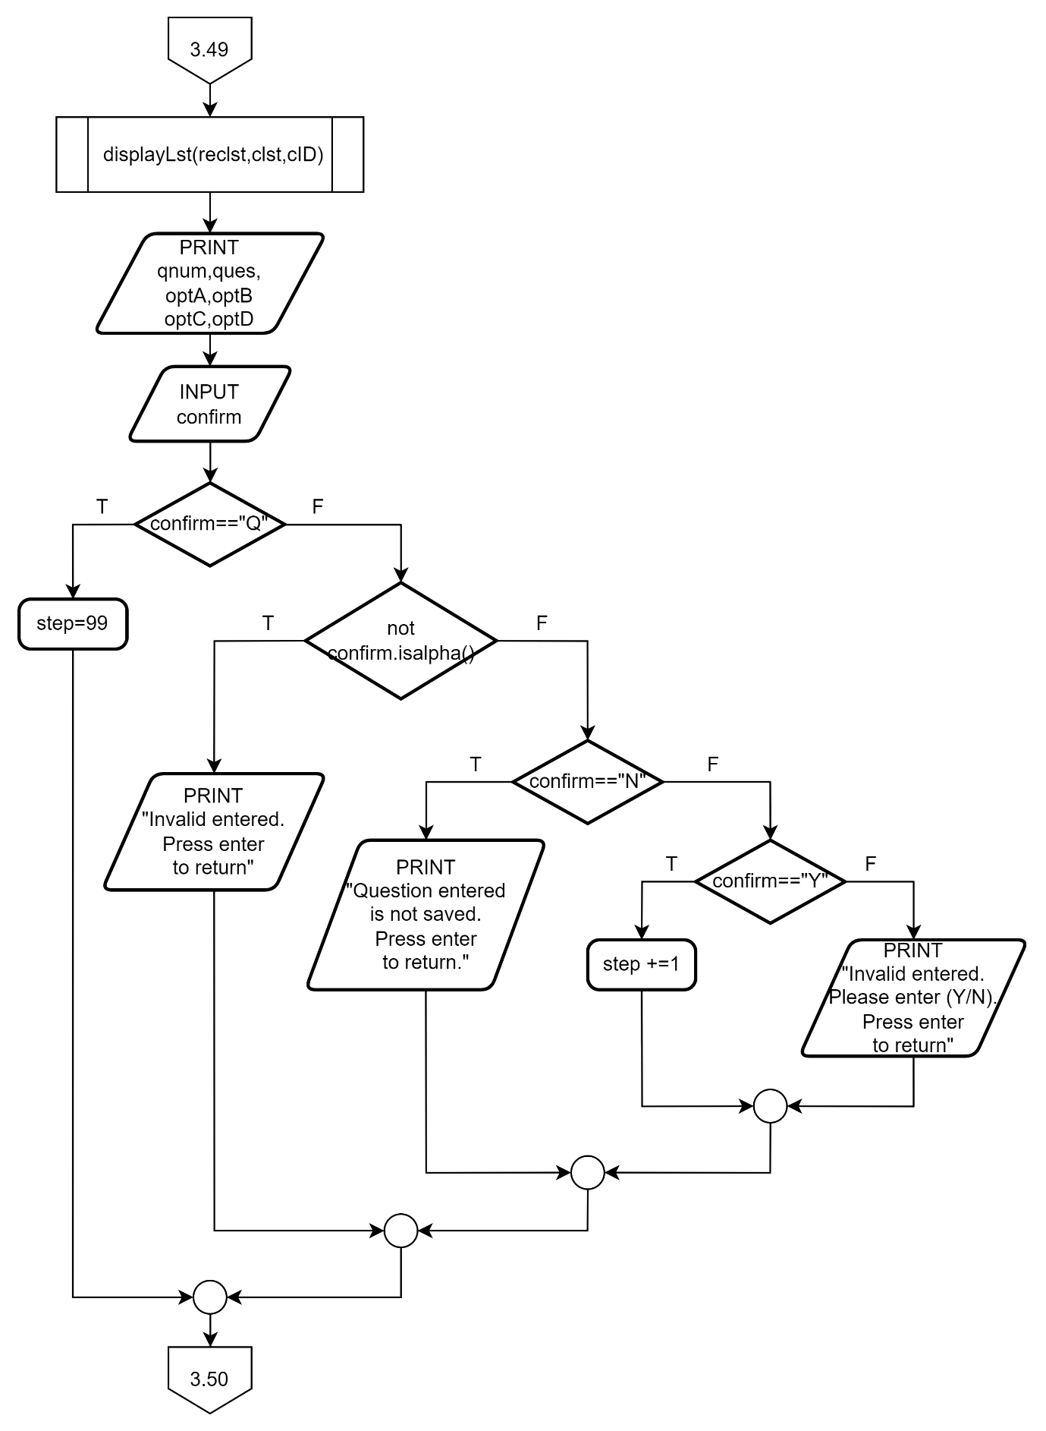

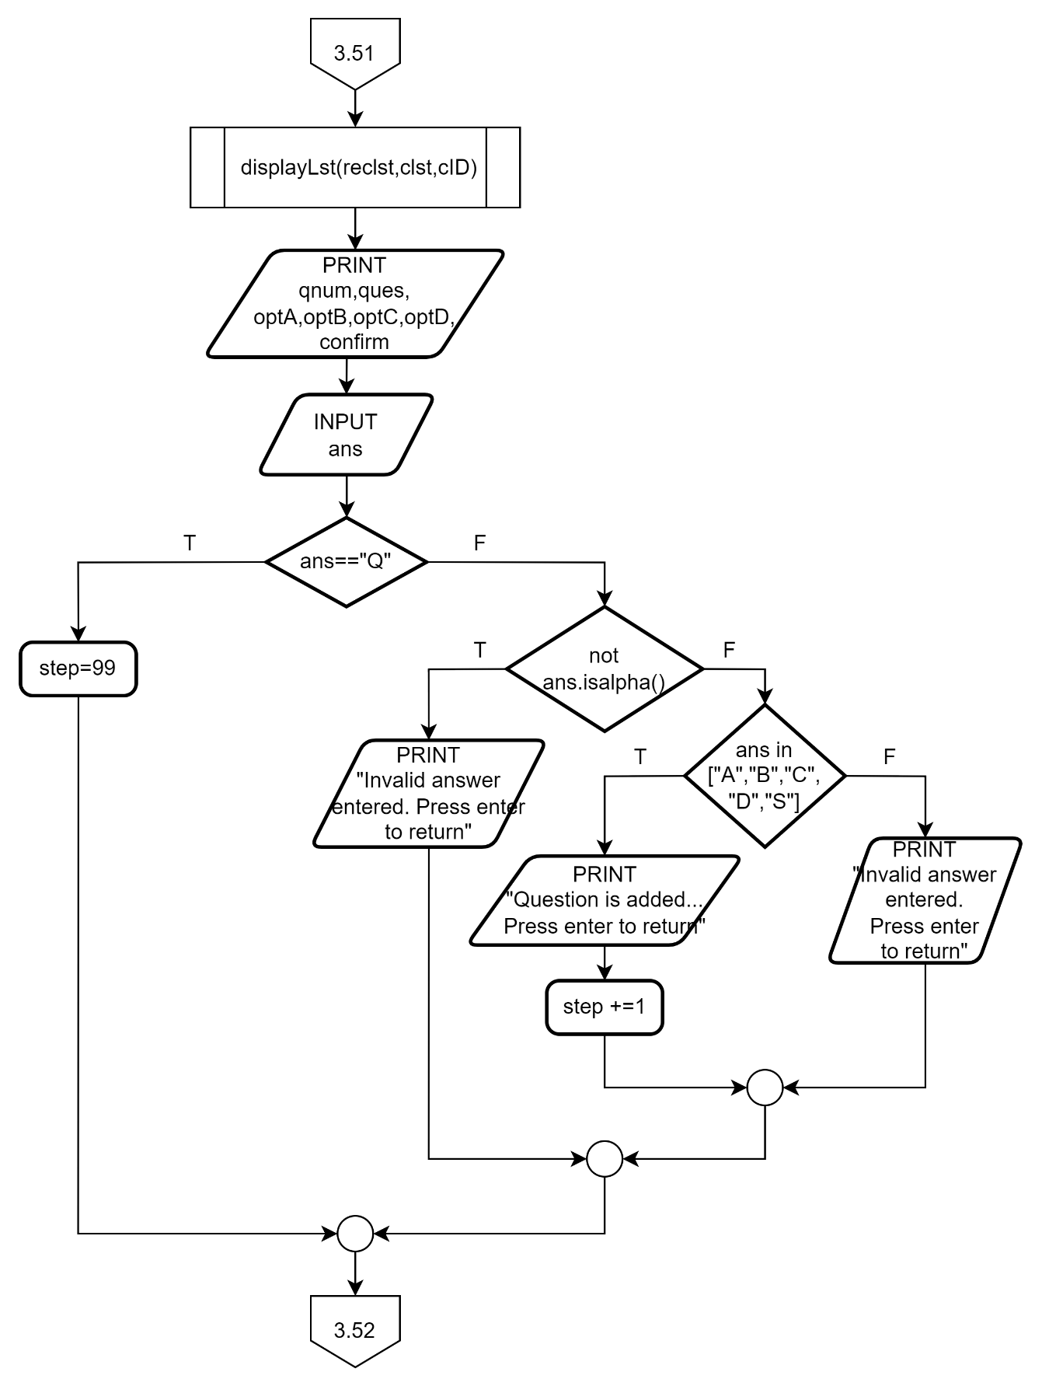

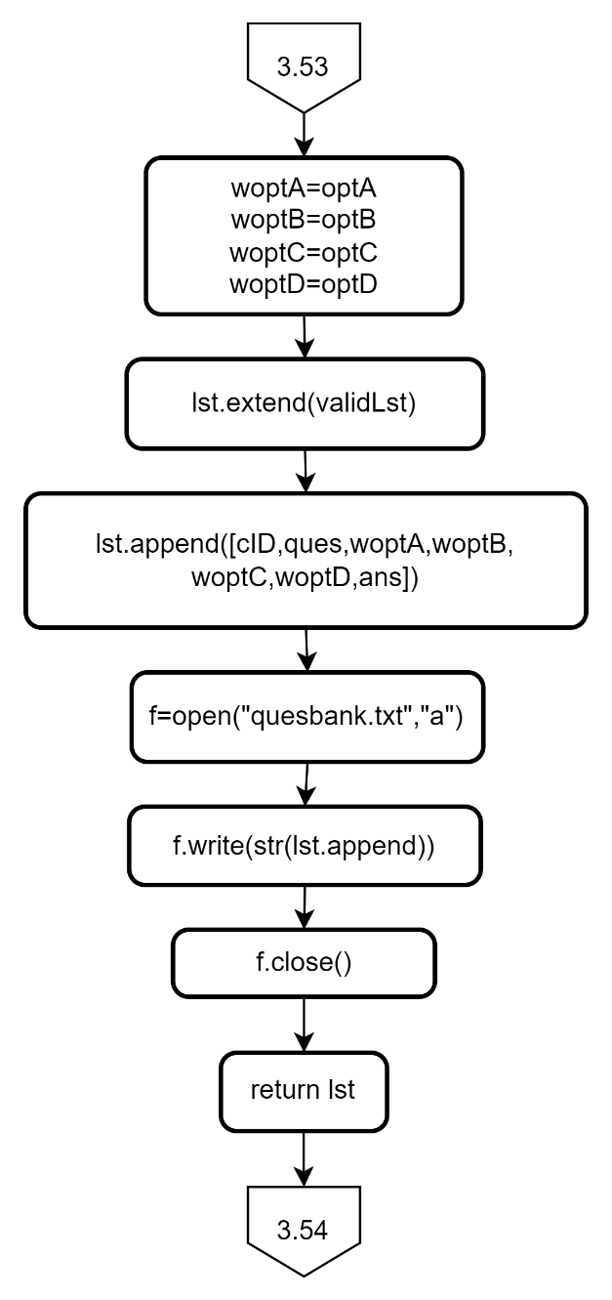

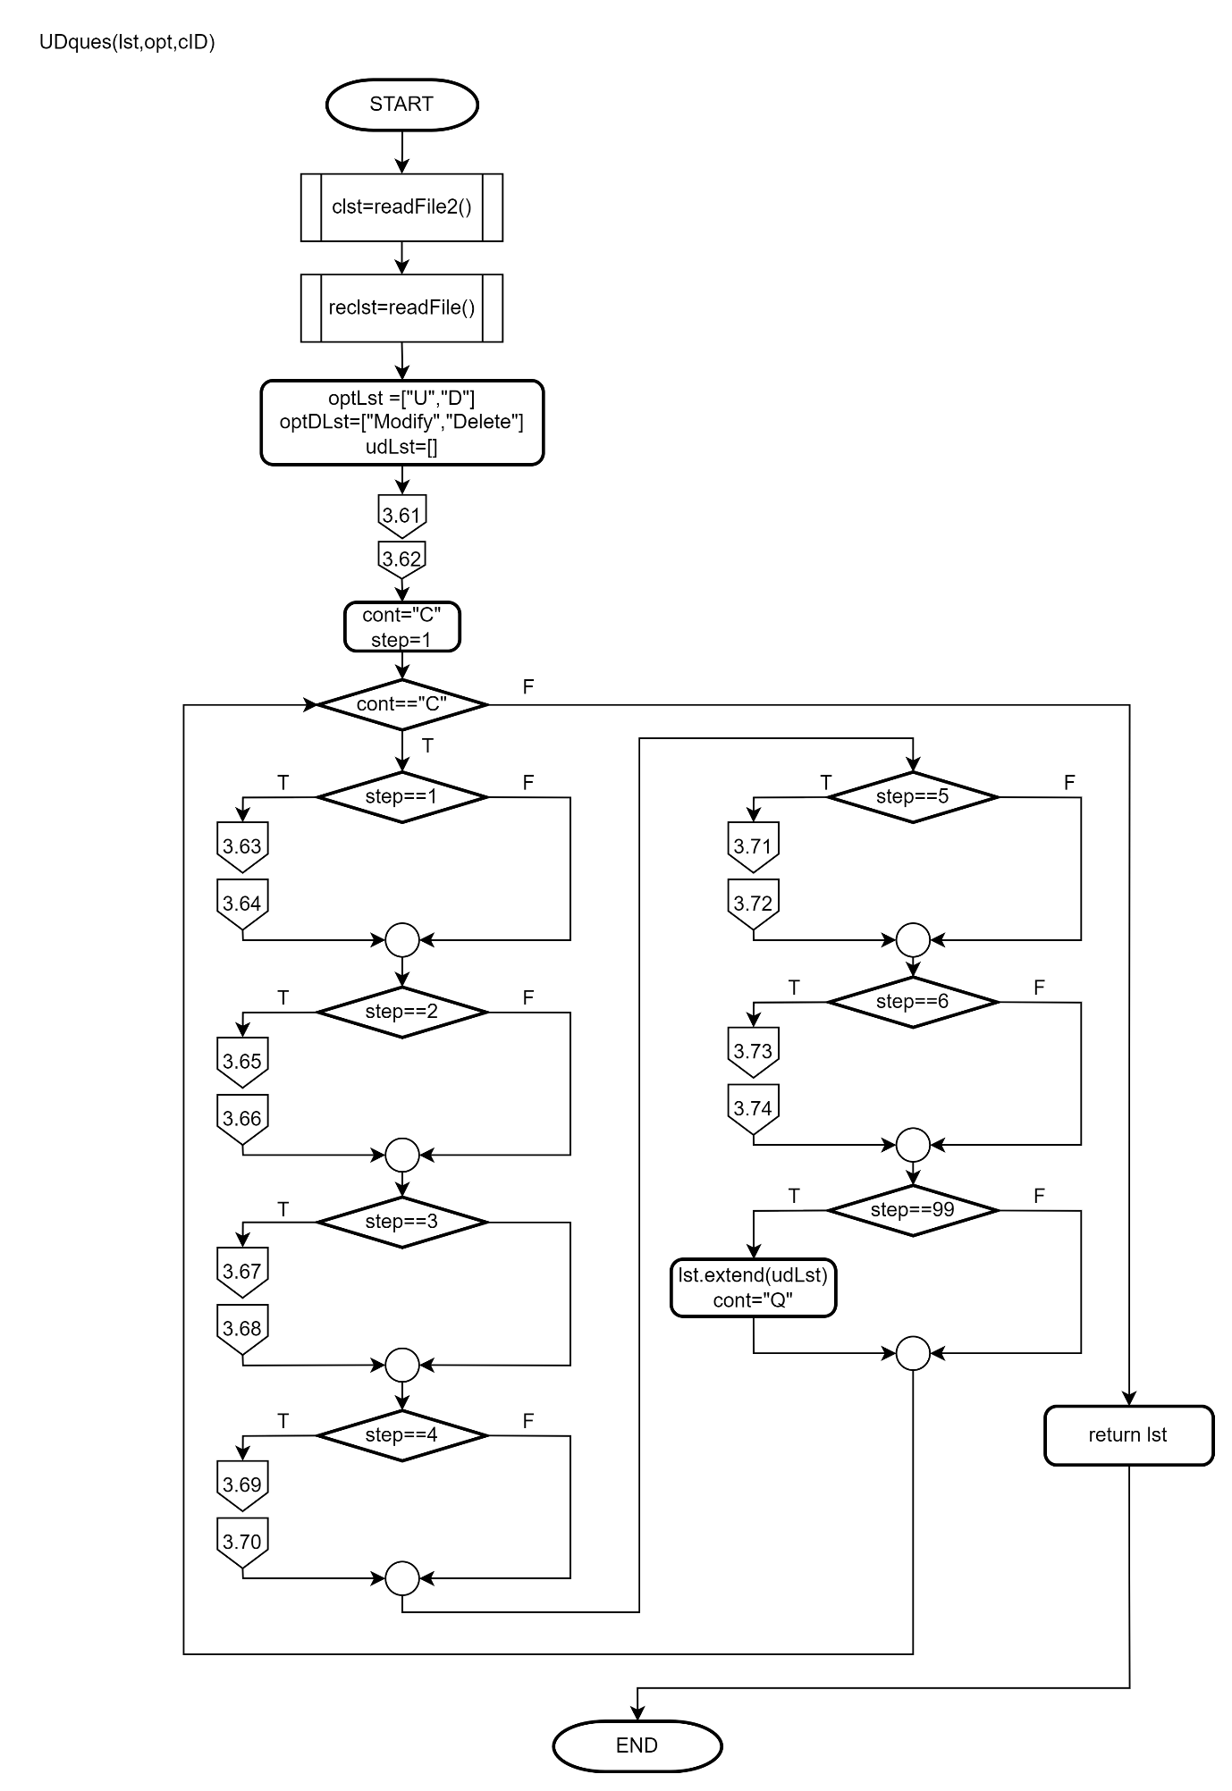

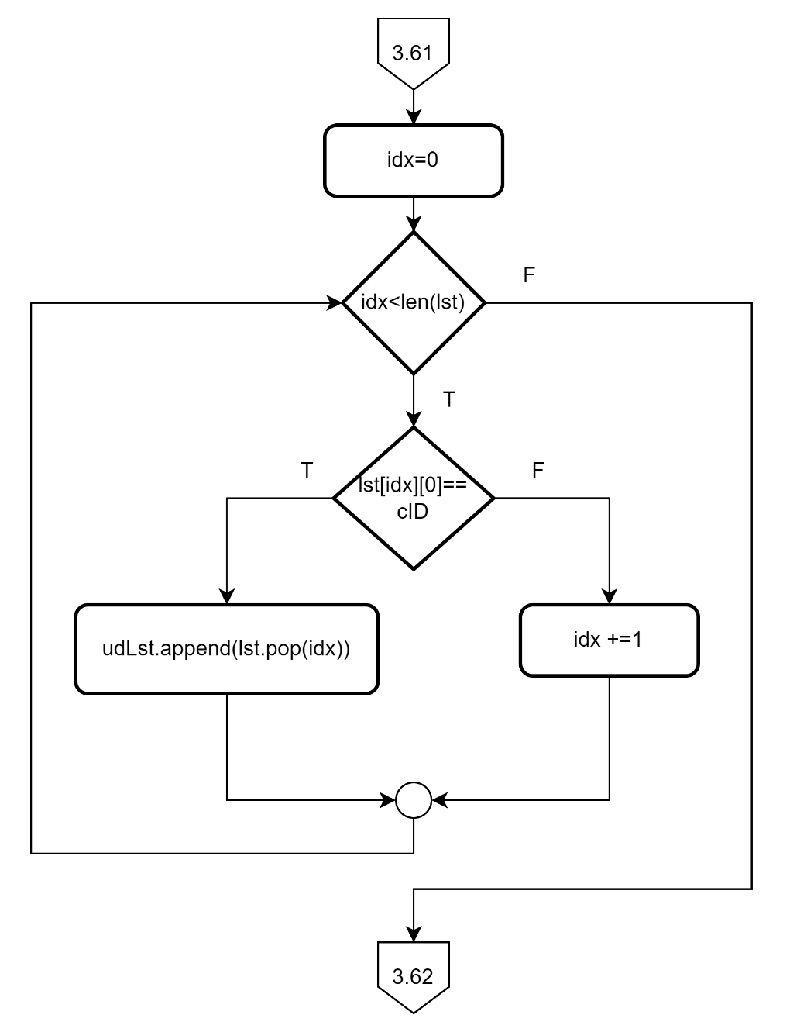

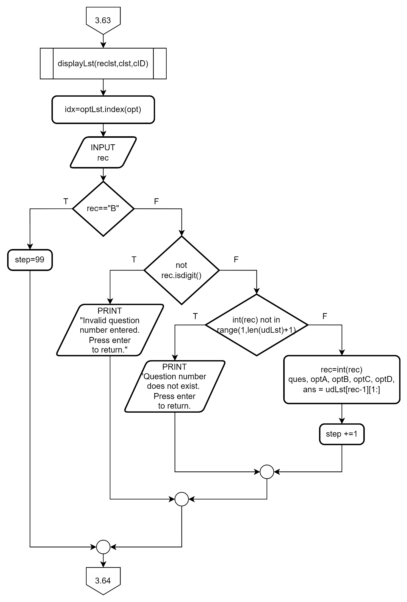

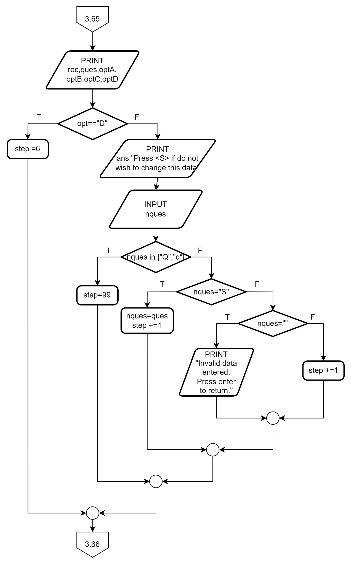

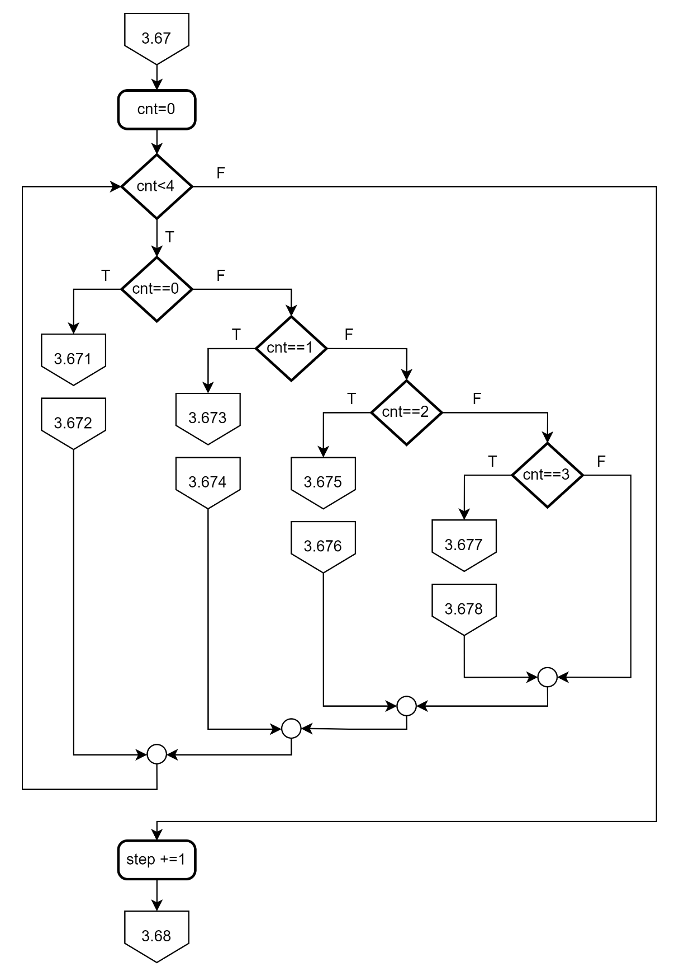

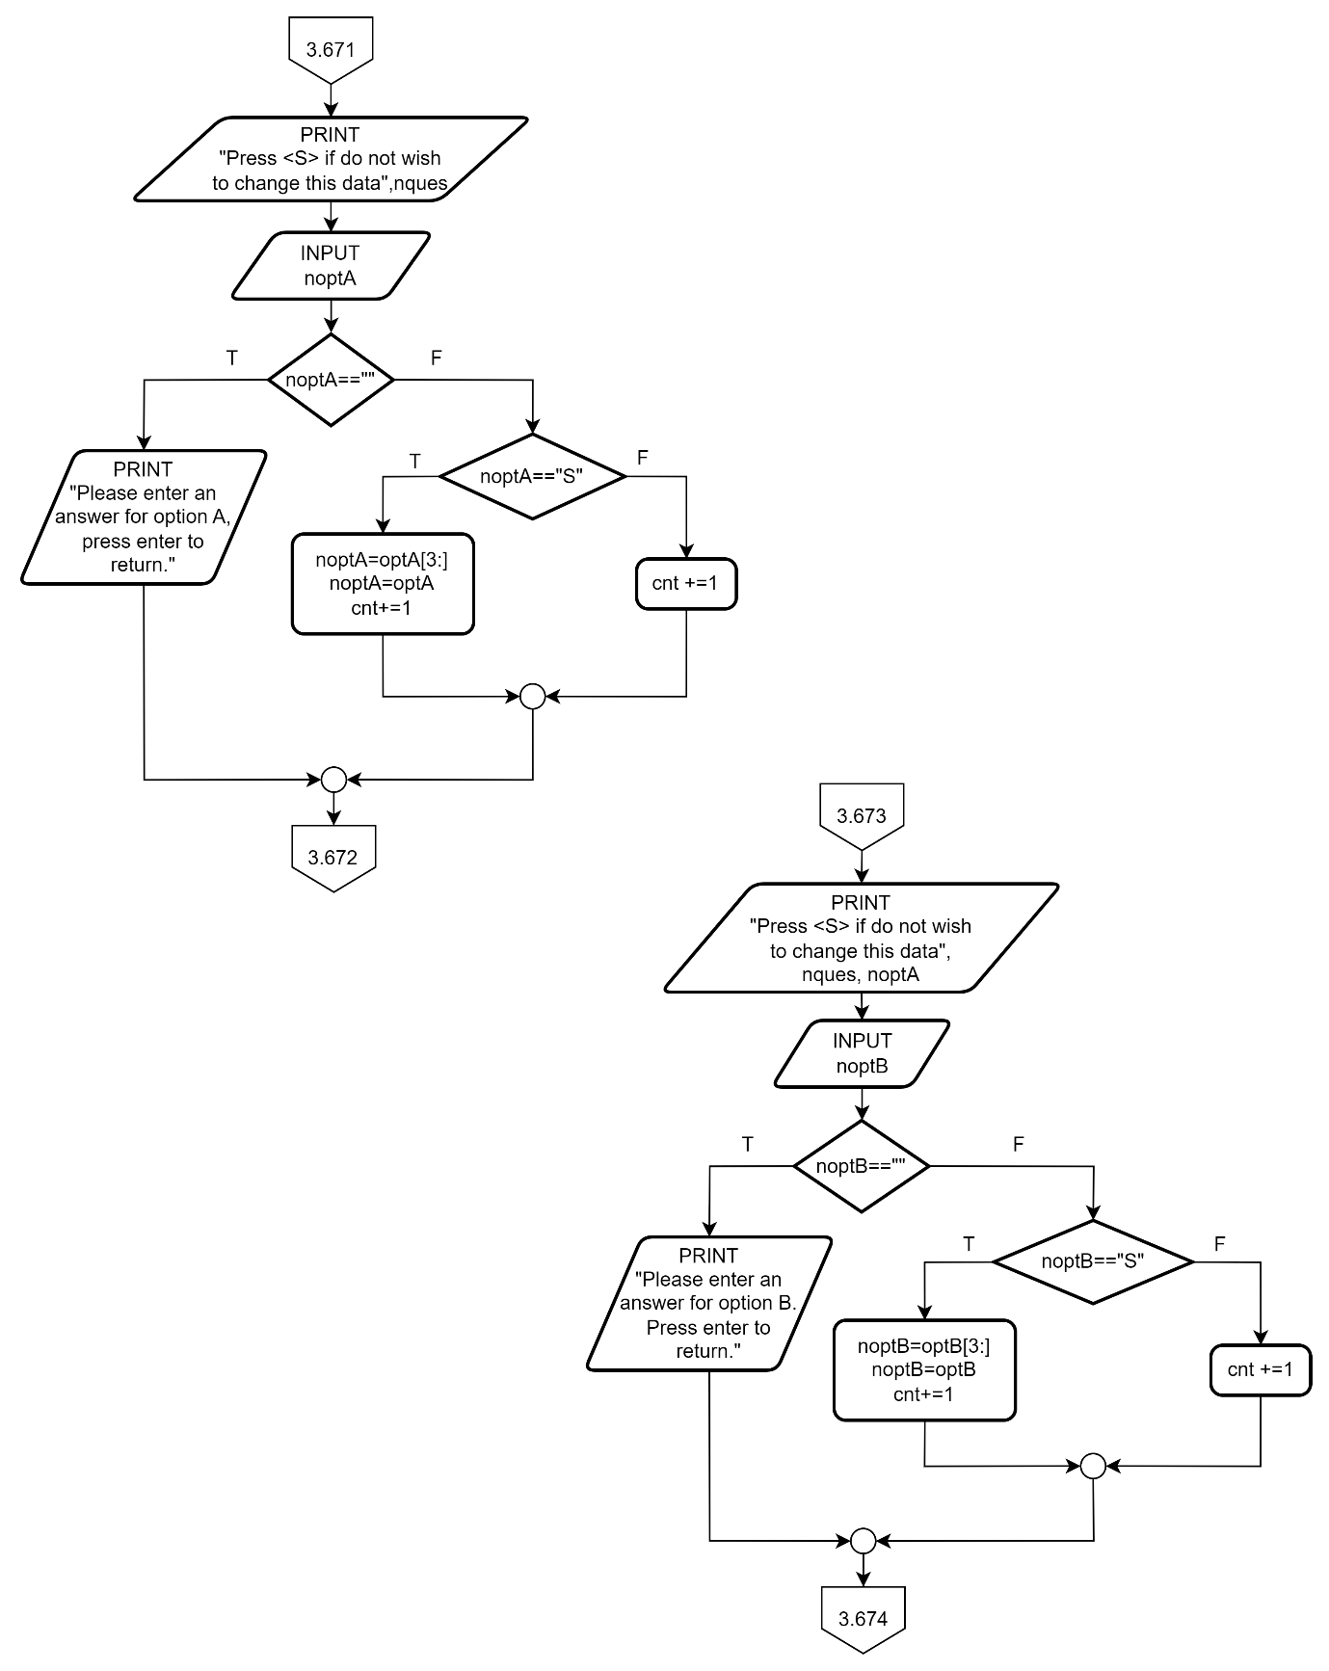

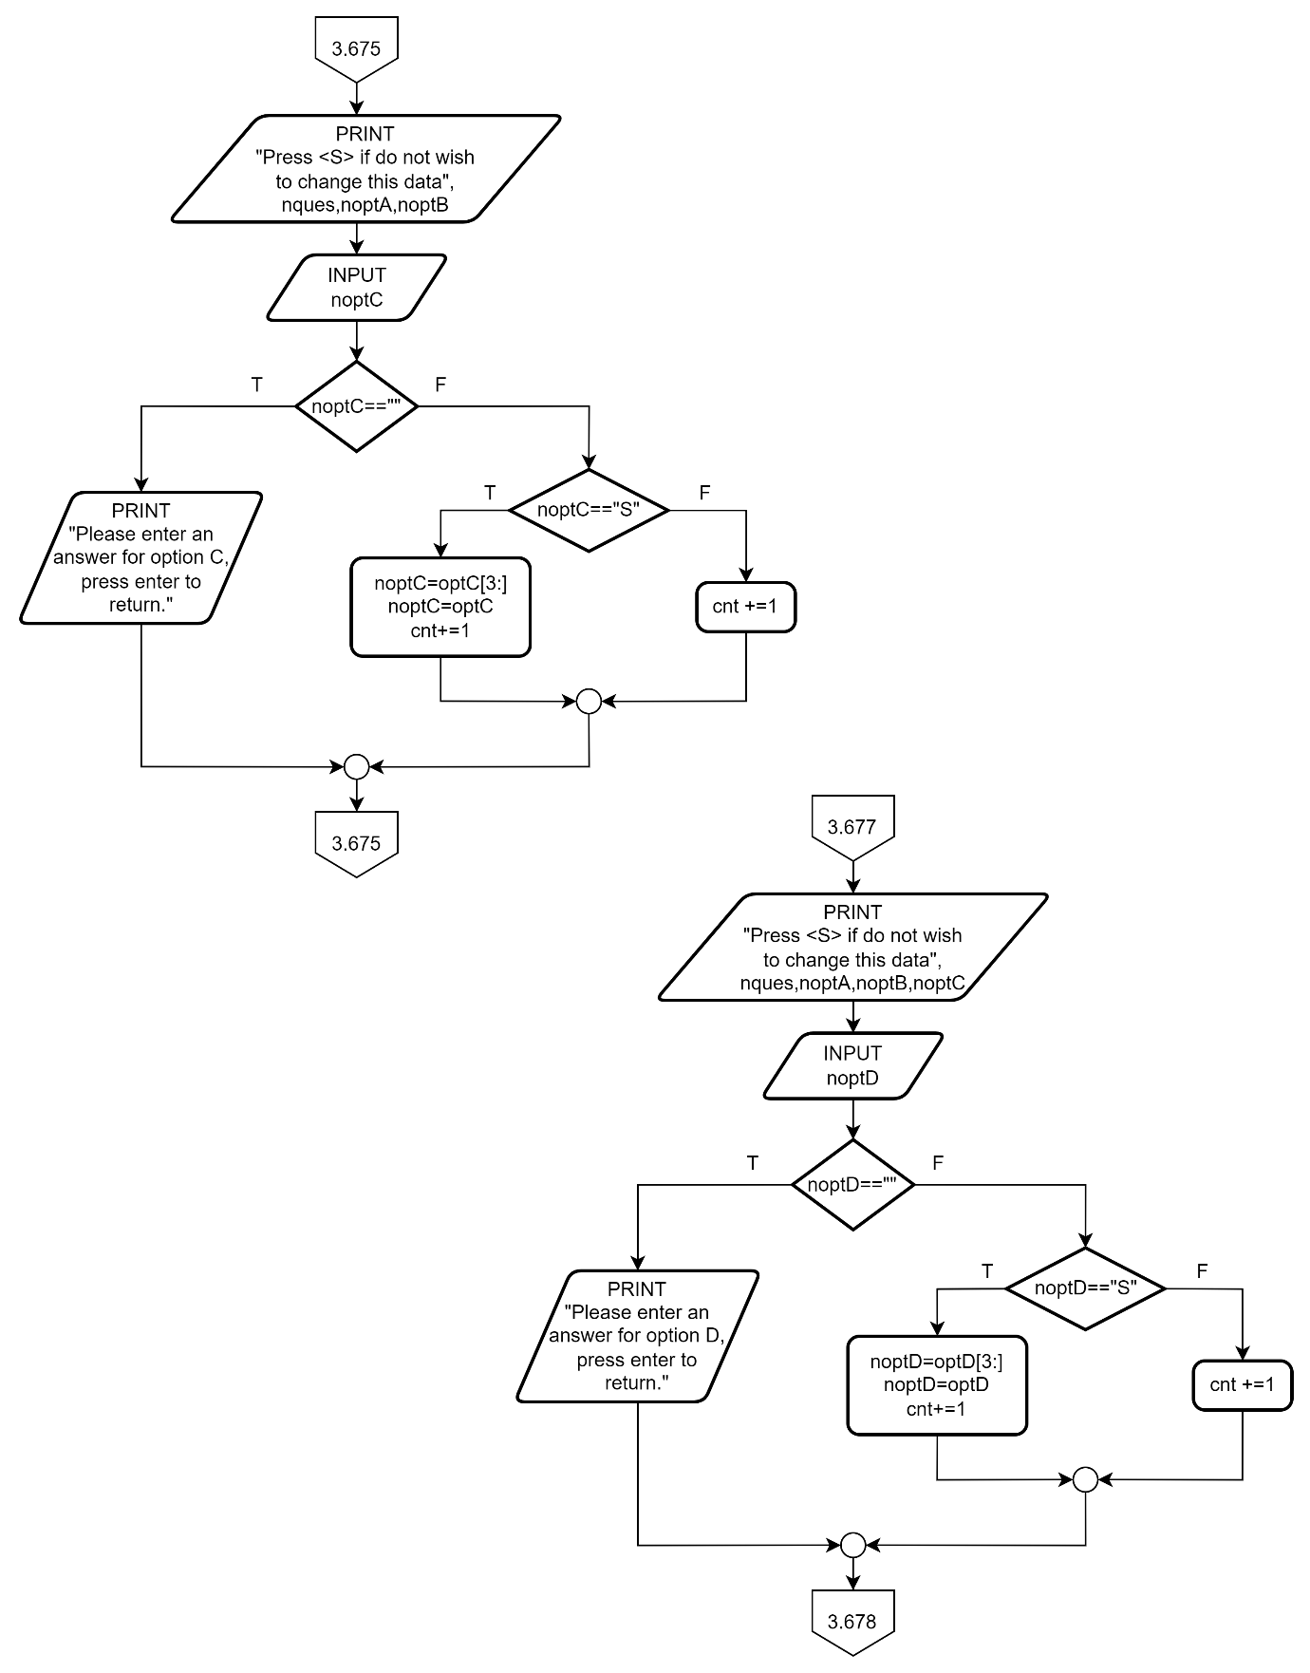

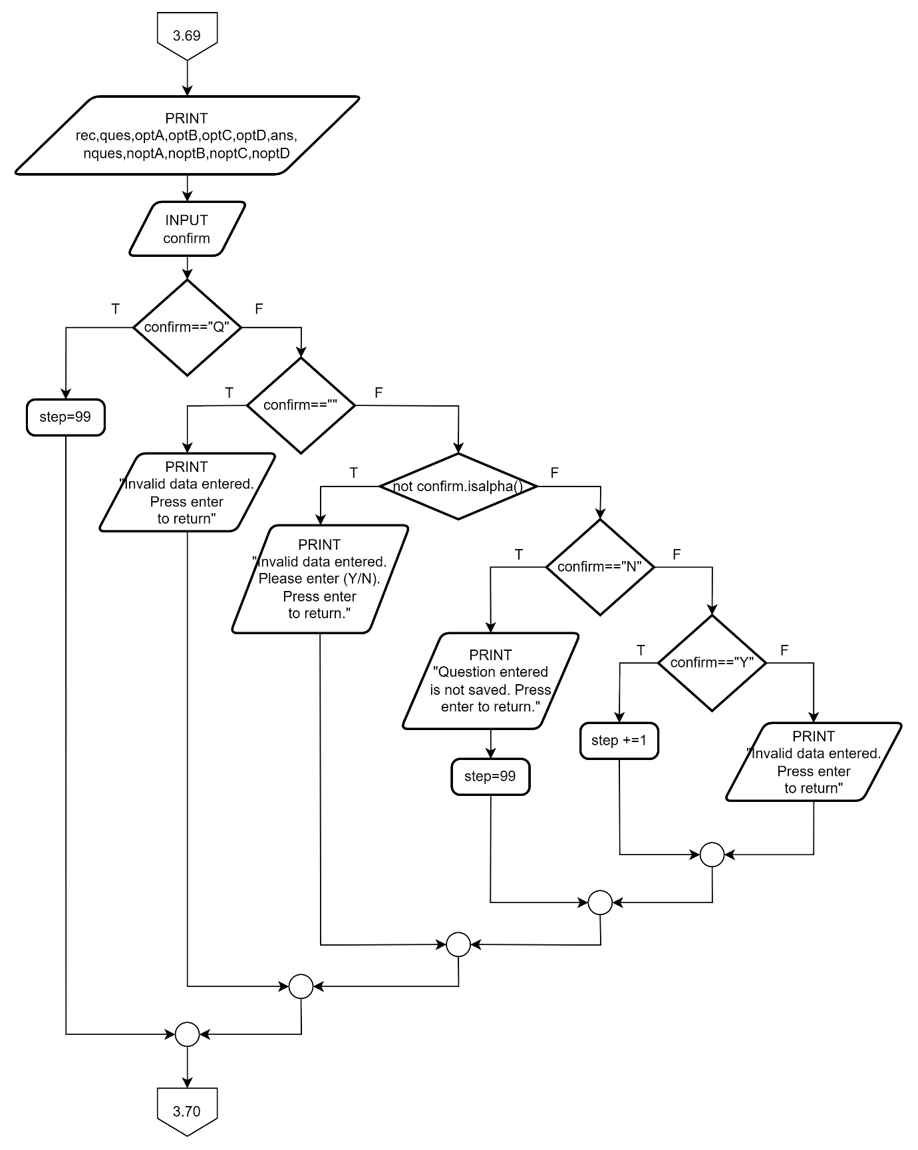

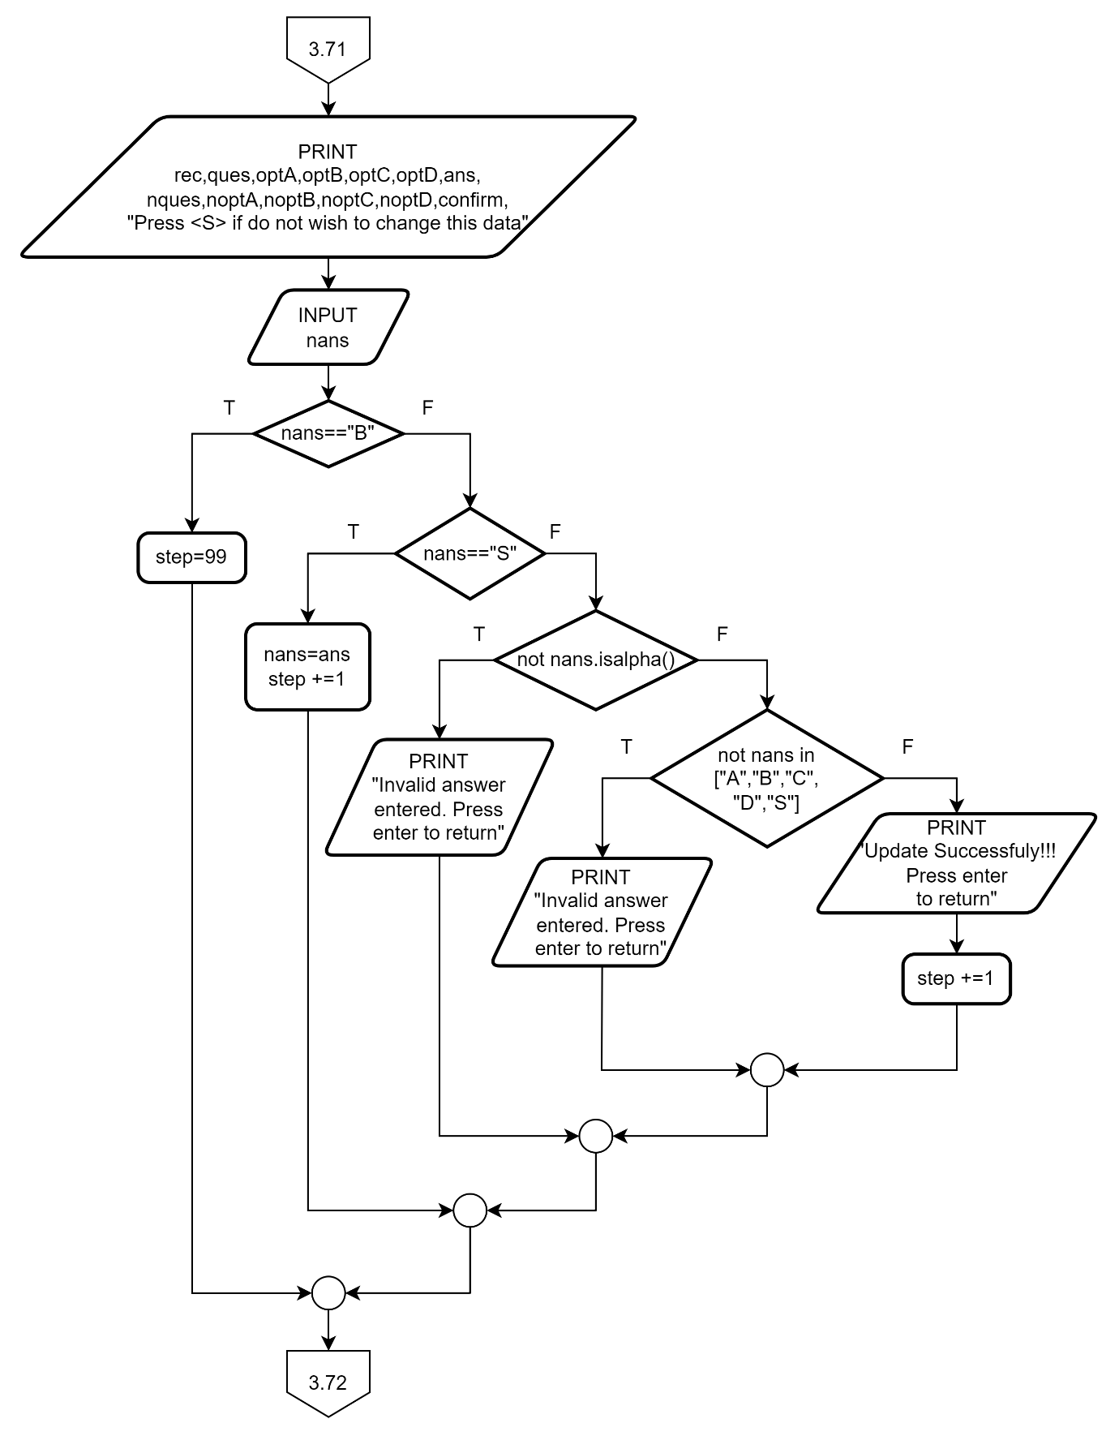

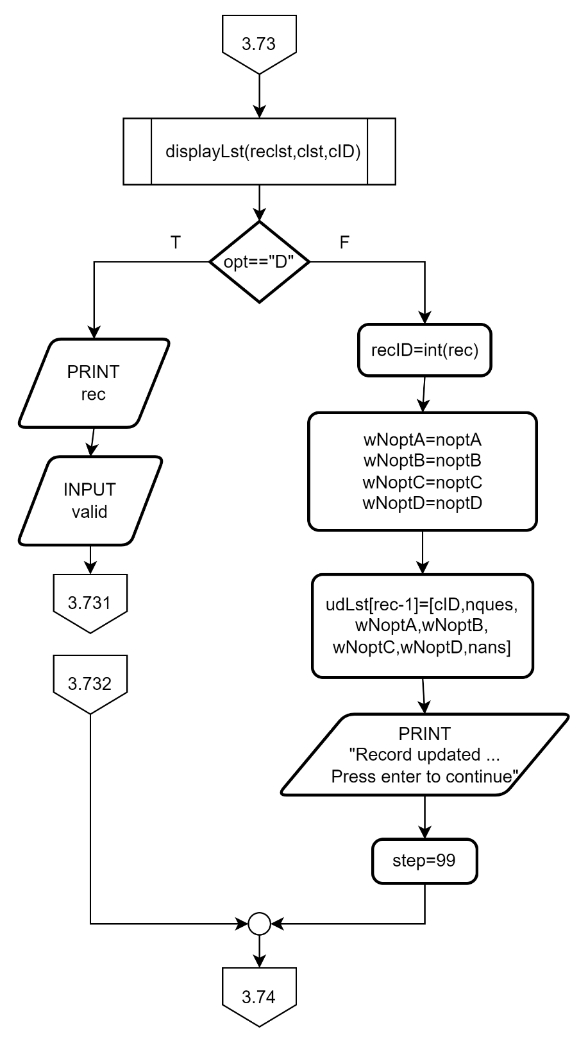

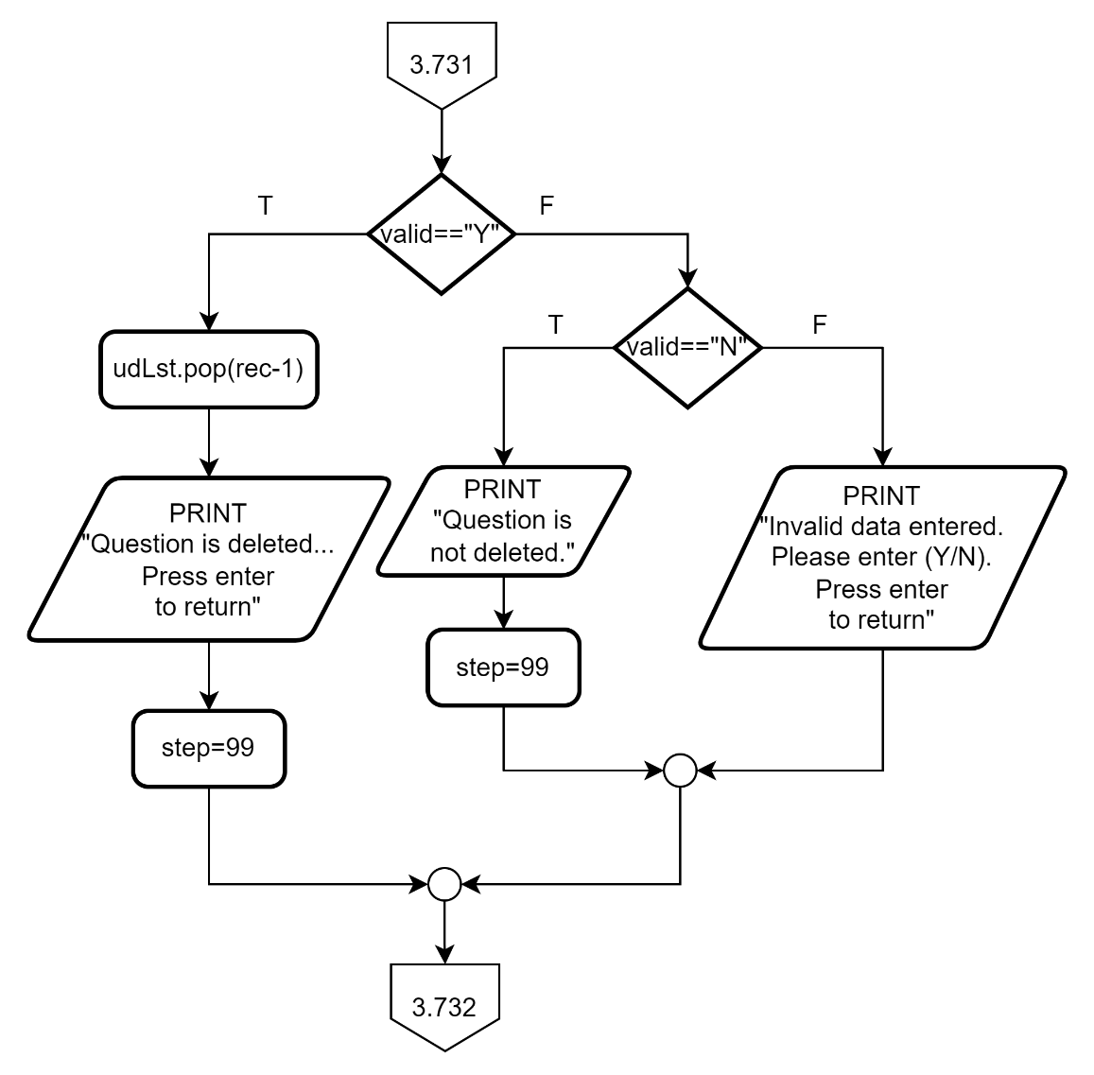

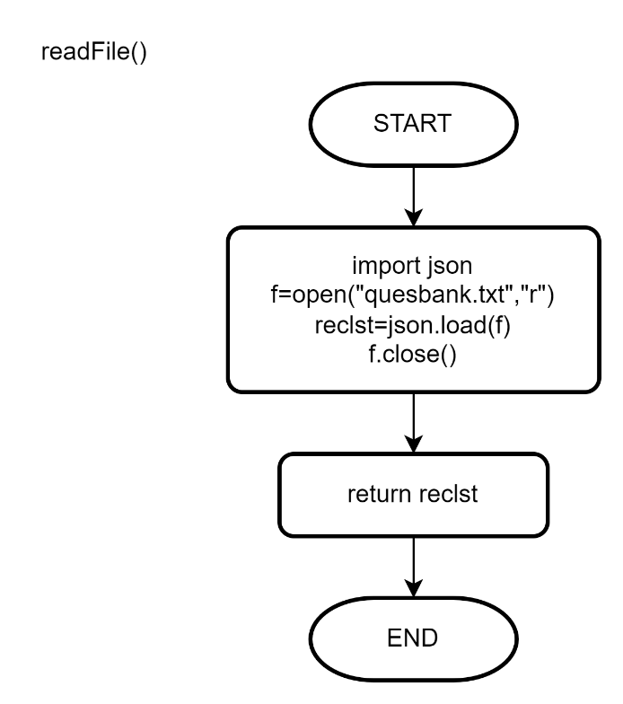

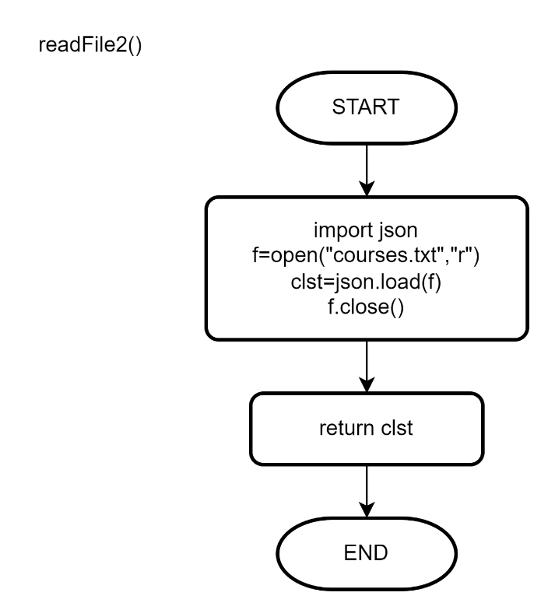

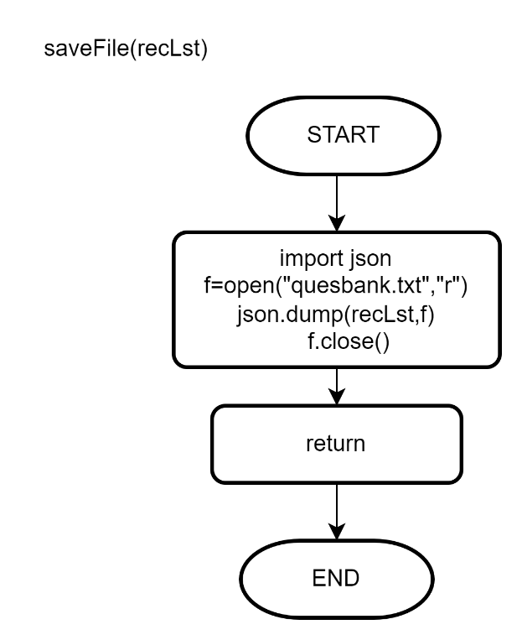

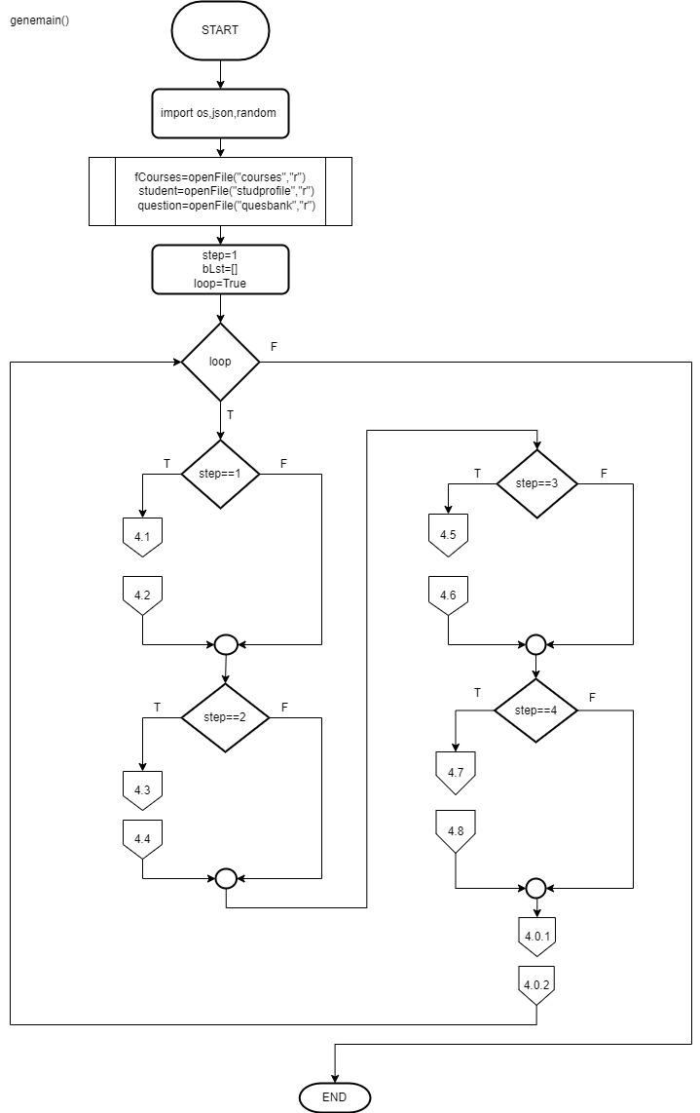**5. Generate Test Paper**

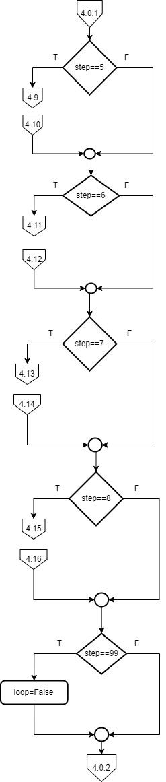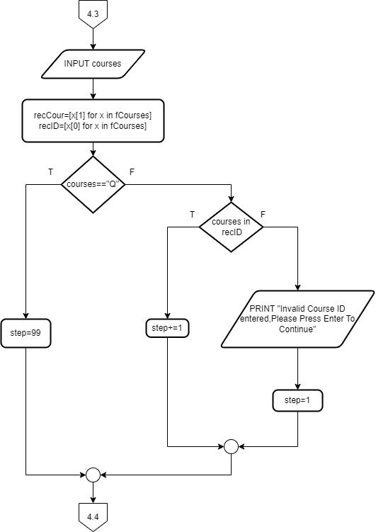

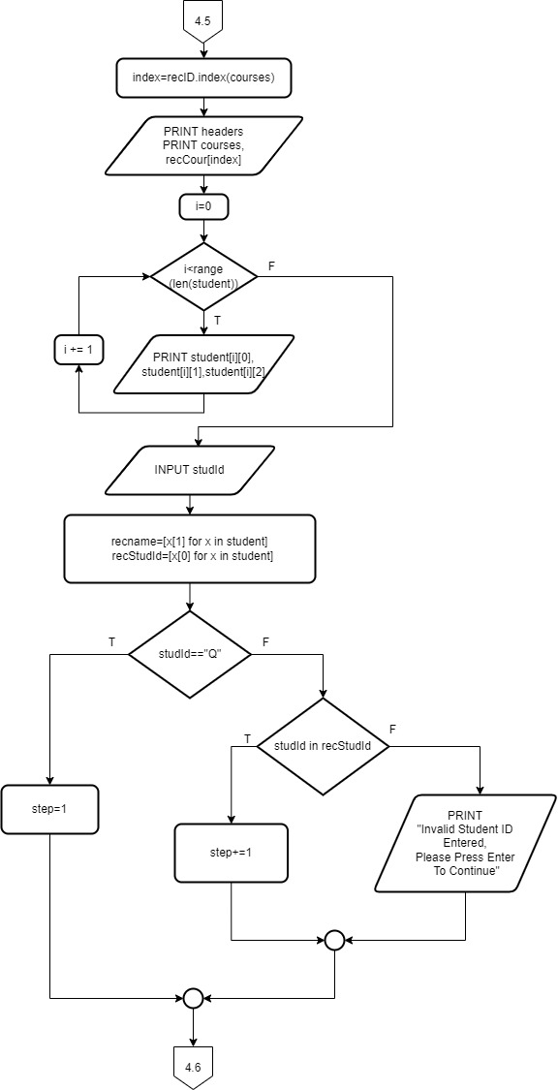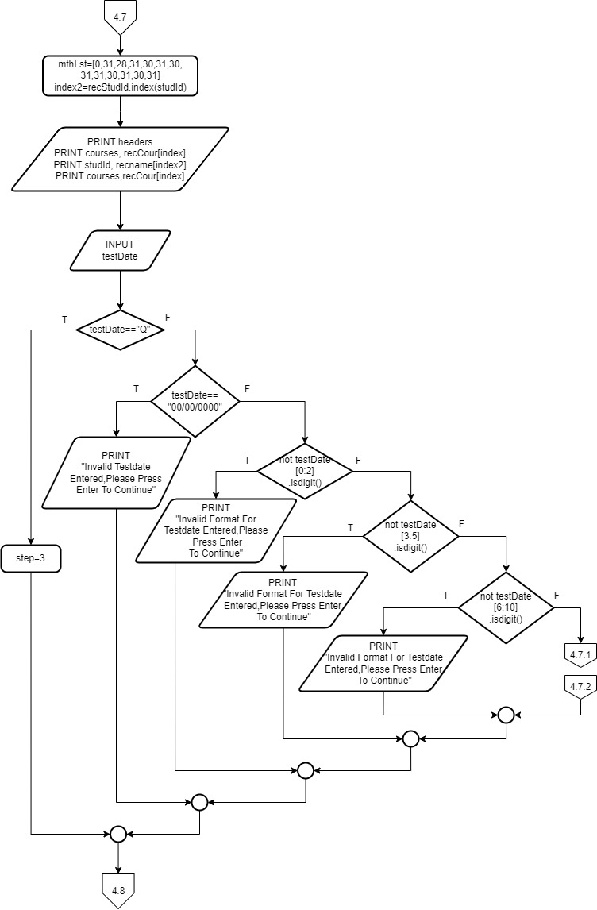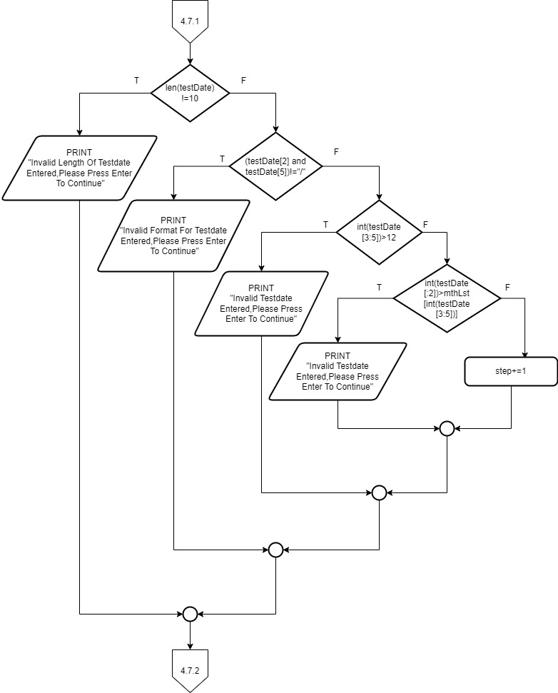

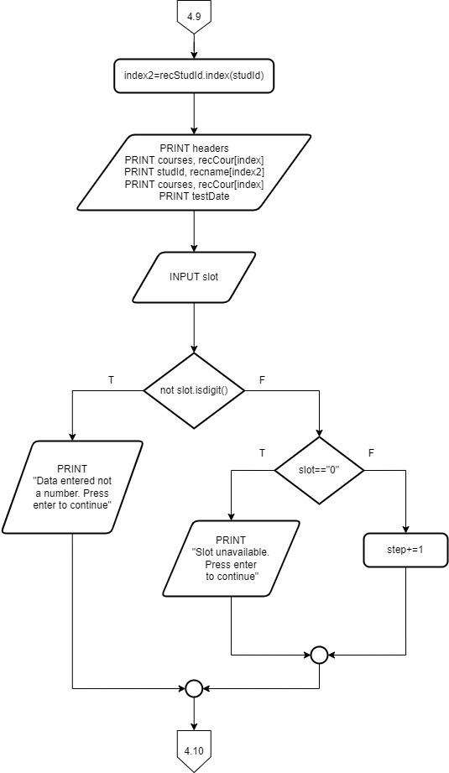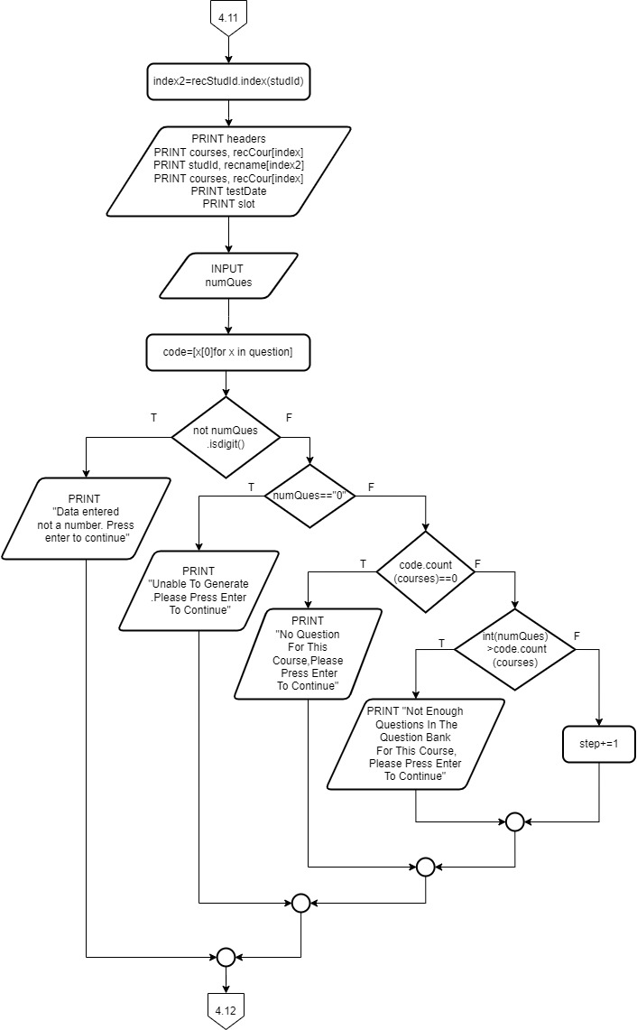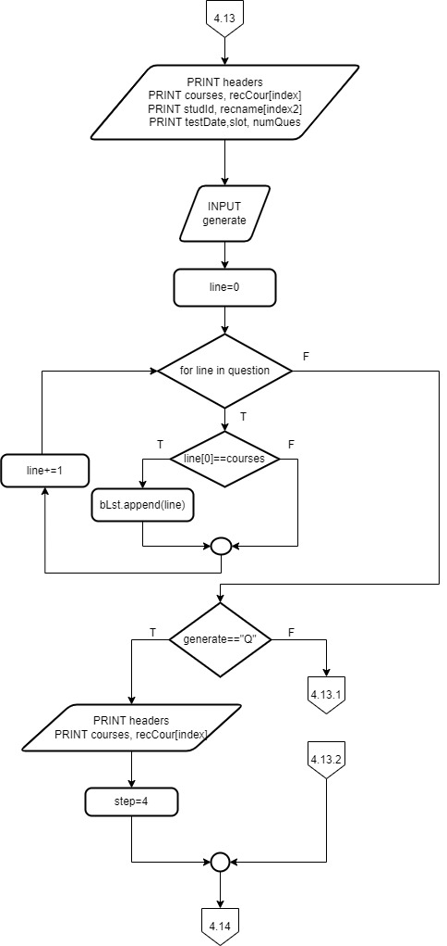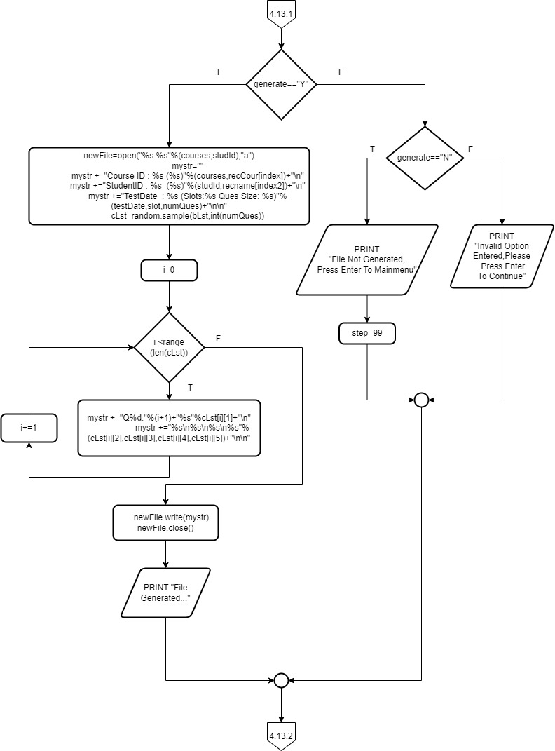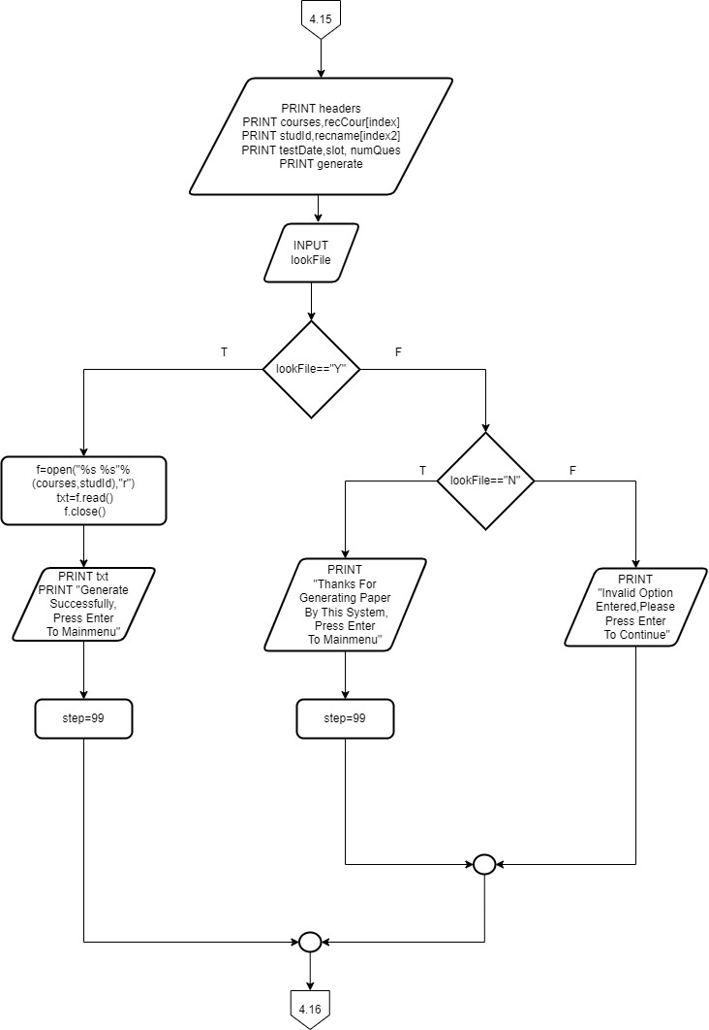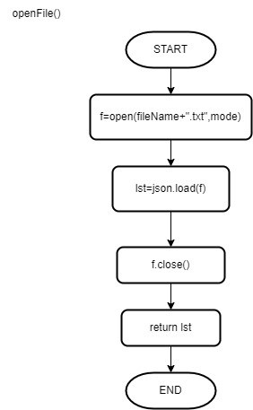

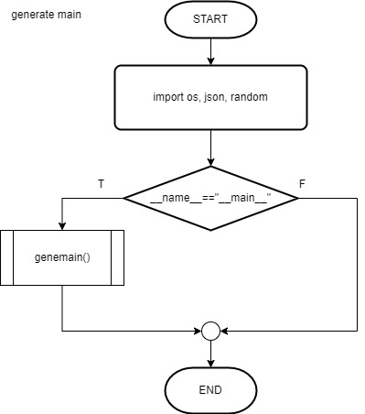

Screenshots

**1. Mainmenu**

**\*Invalid data entered**

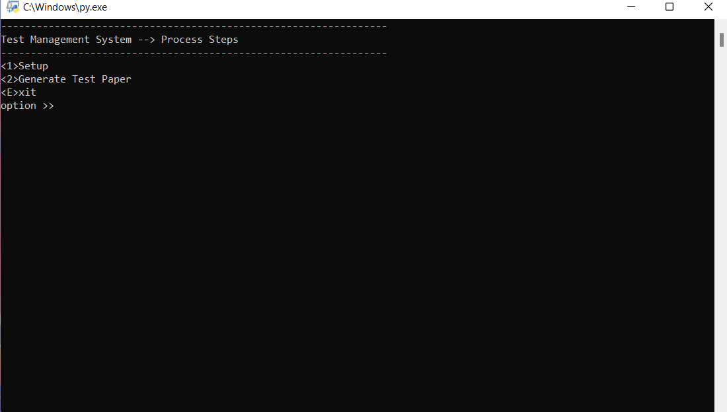

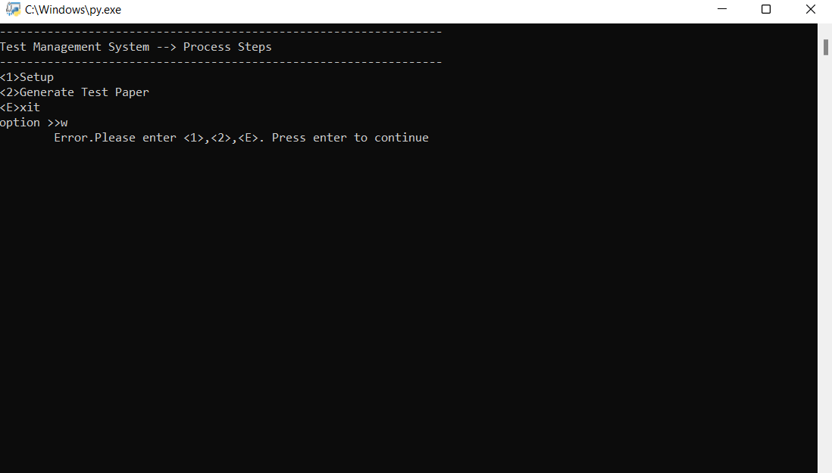

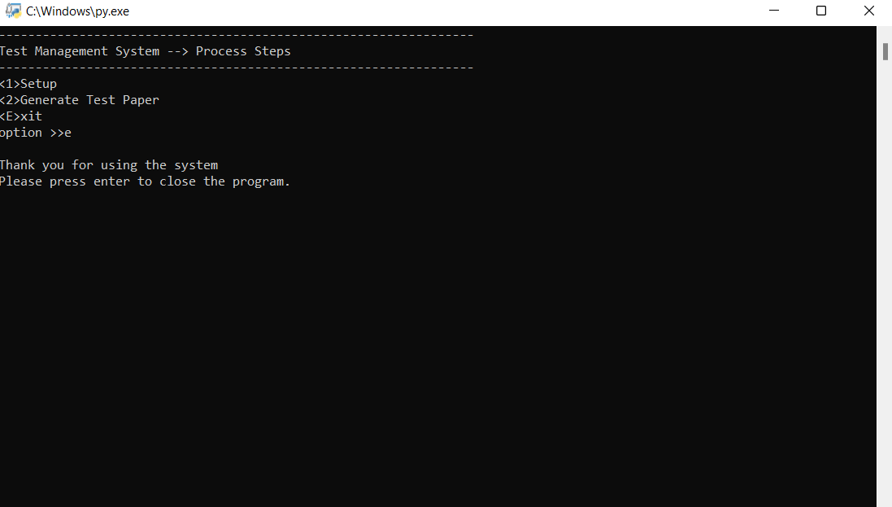**\*Close program**

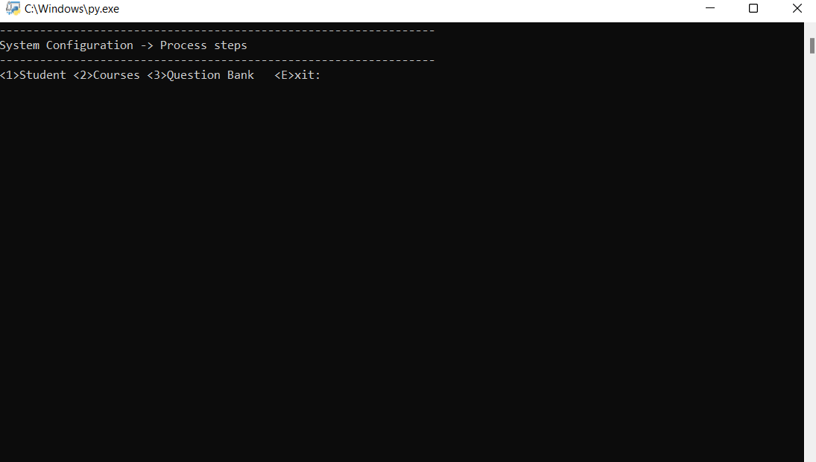

**\*System configuration display**

**2. Student Maintenance**

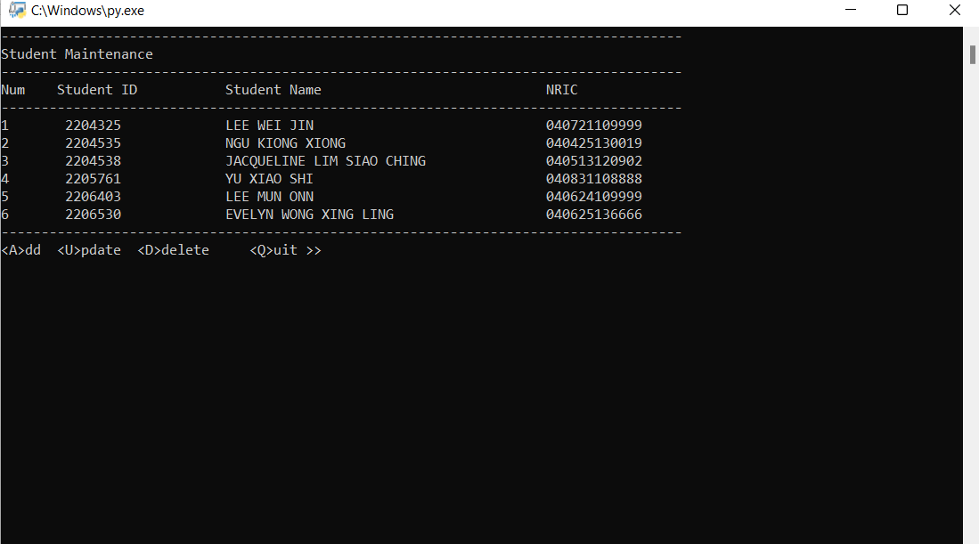

**\*Student maintenance display**

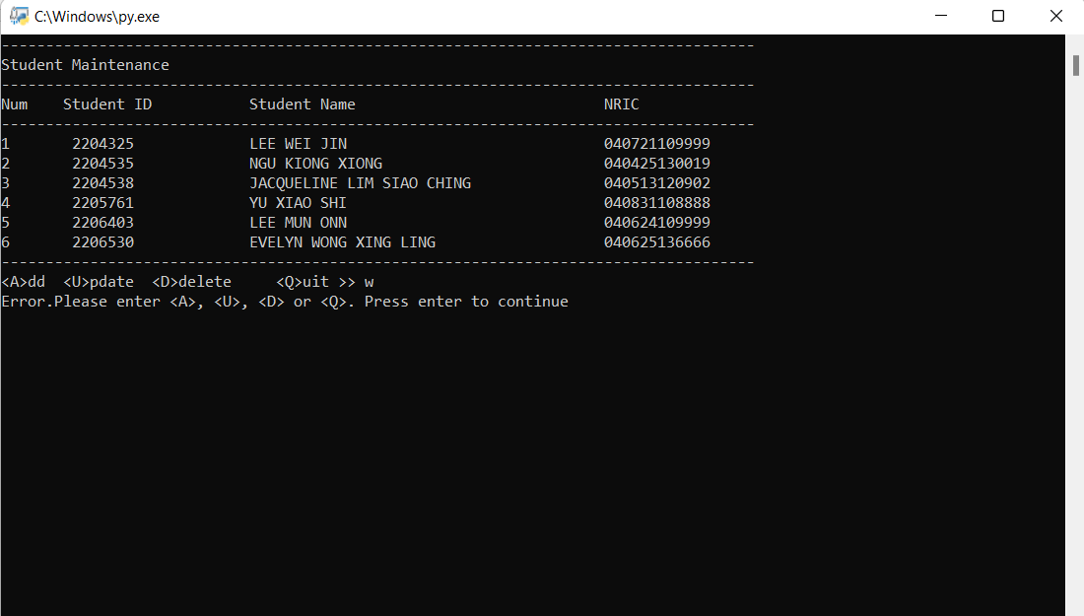

**\*Invalid data entered**

**1.1 ADD**

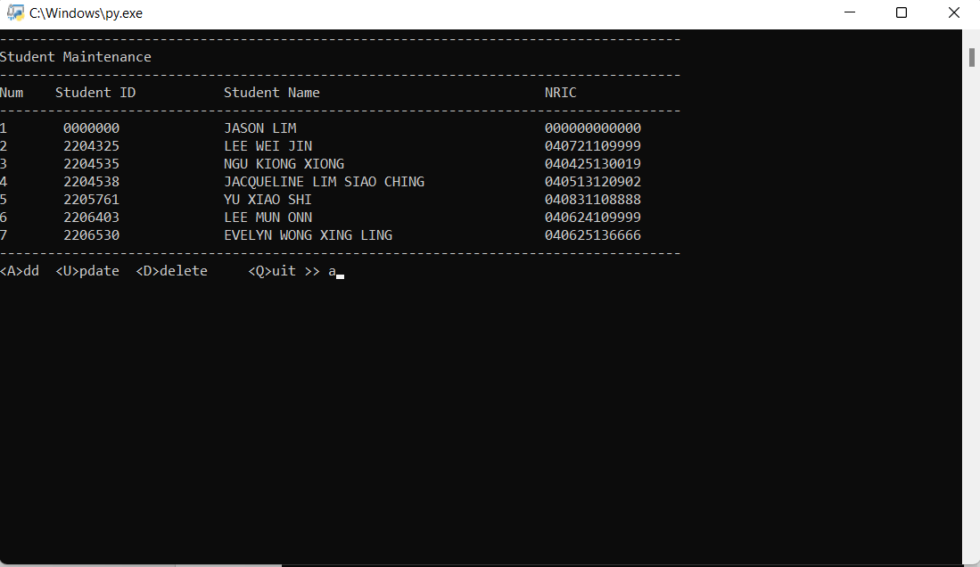

**\*Add student profile**

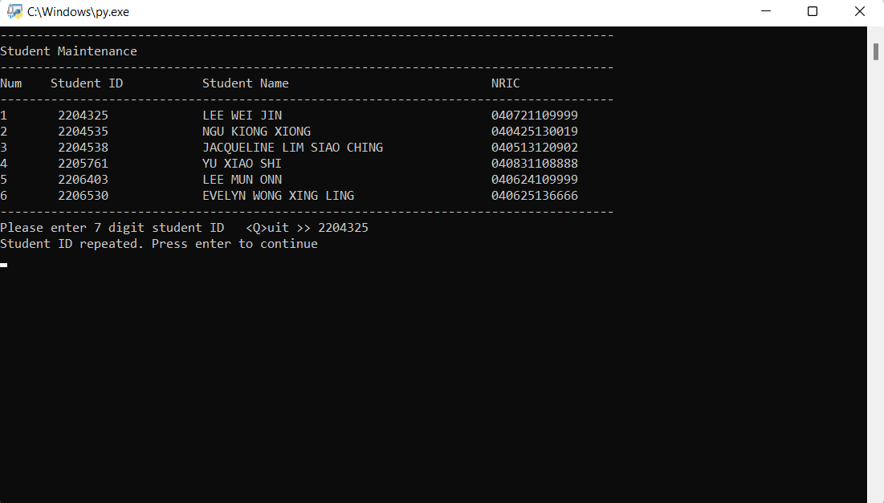

**\*Validation for repeated student ID**

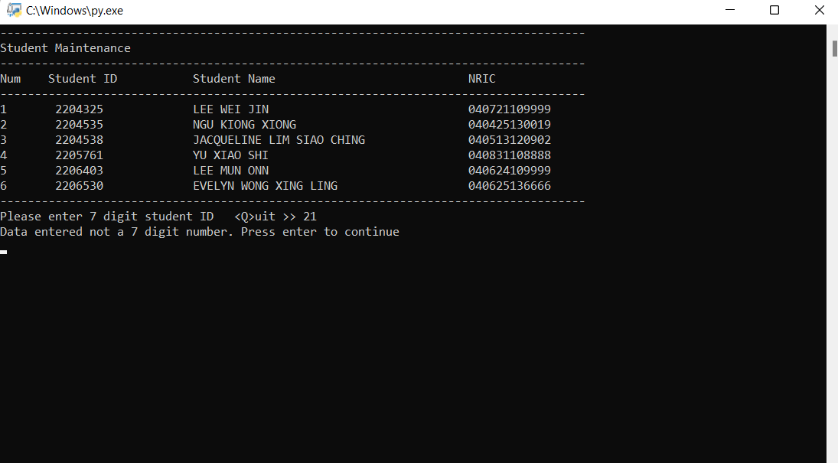

**\*Validation for student ID length**

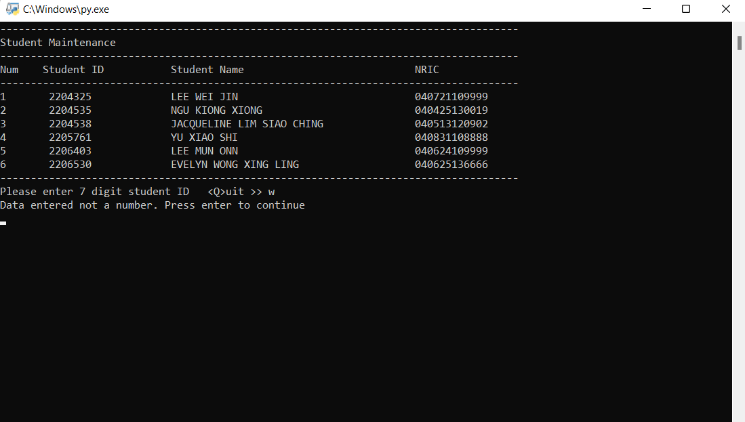

**\*Invalid data entered**

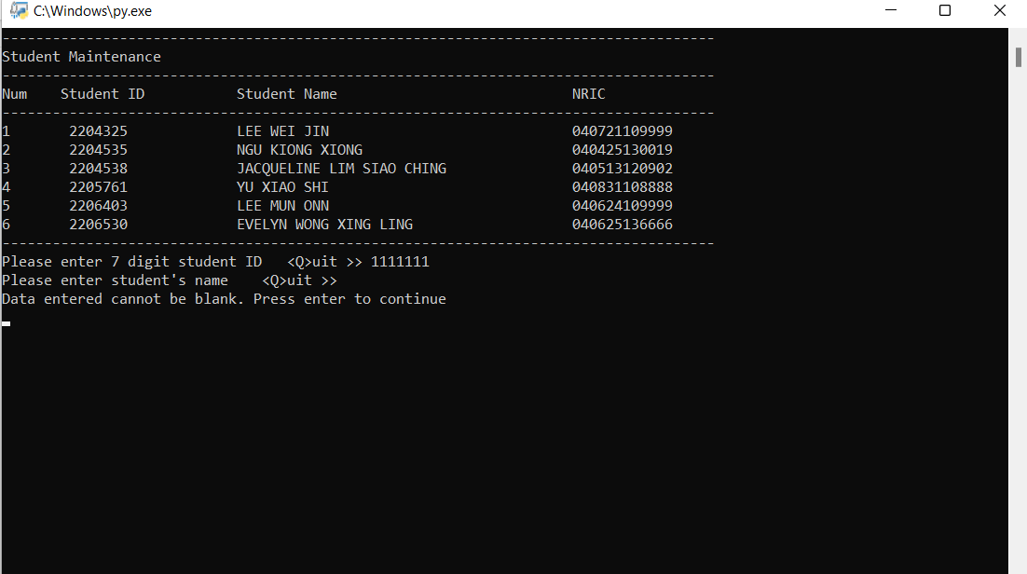

**\*Cannot enter a blank input**

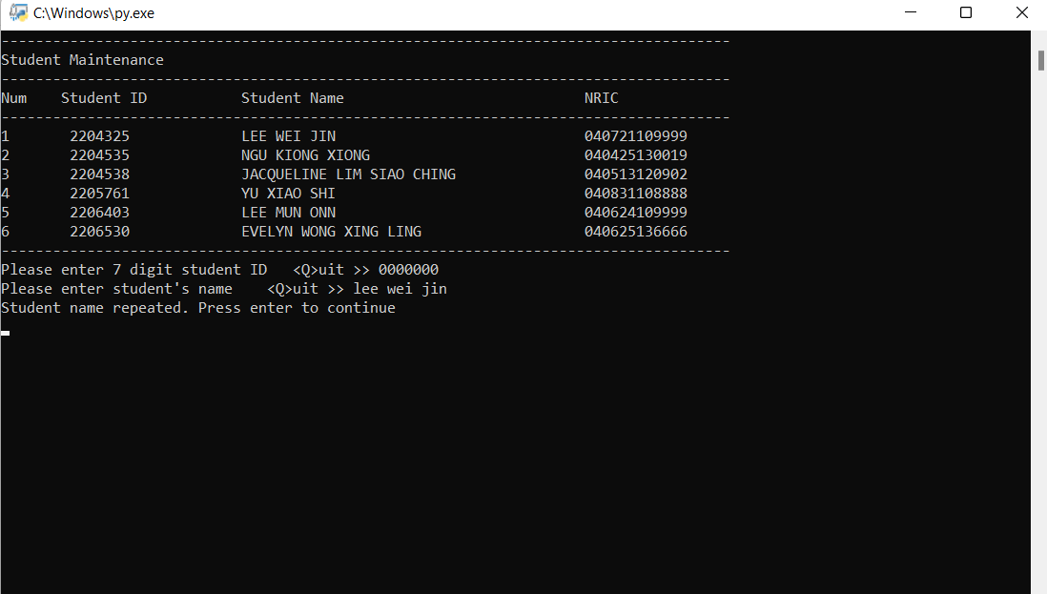

**\*Validation for repeated student name**

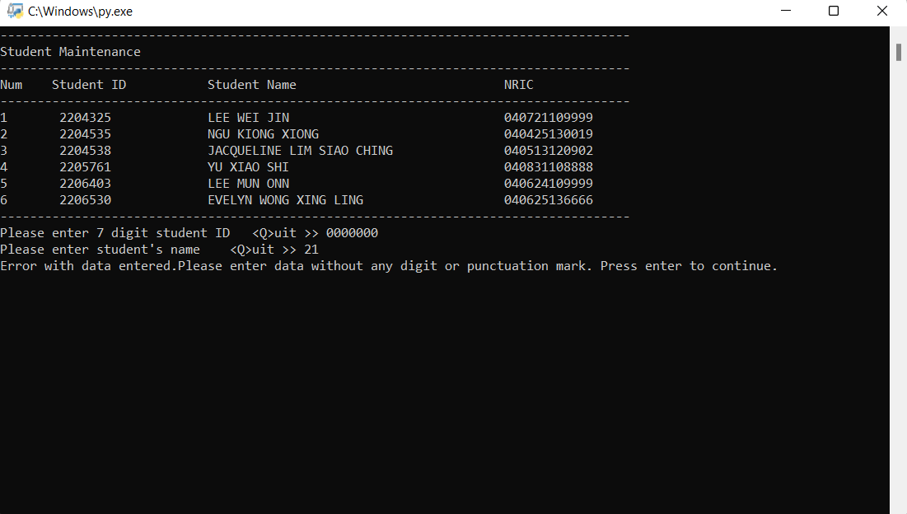

**\*Invalid student name entered**

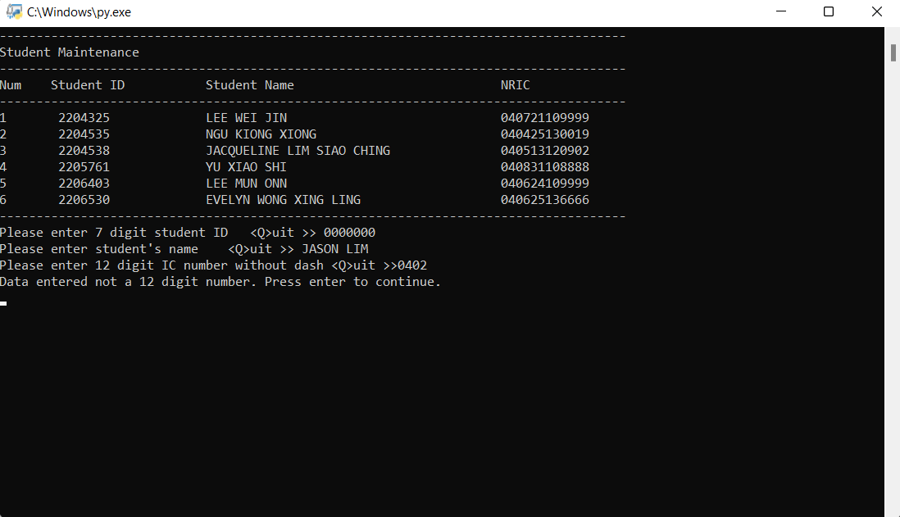

**\*Validation for student NRIC length**

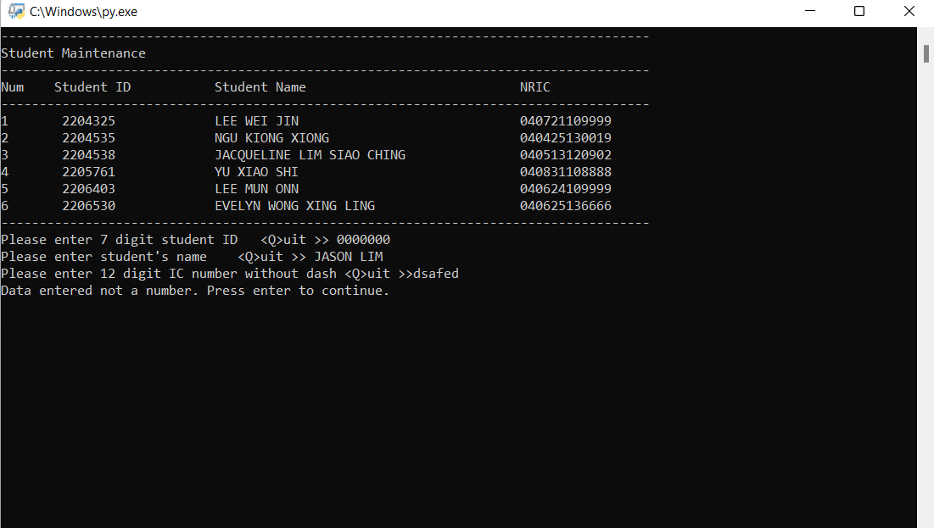

**\*Invalid data entered**

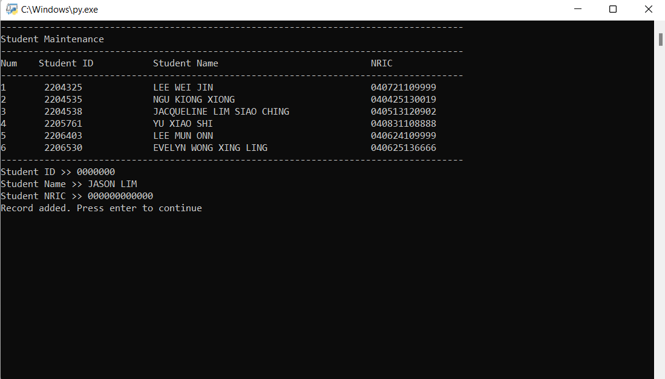

**\*Output of student profile**

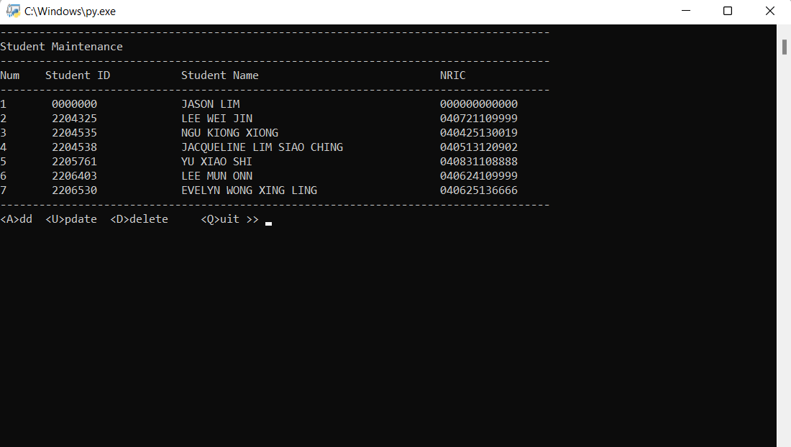

**\*Student added**

**1.2 UPDATE**

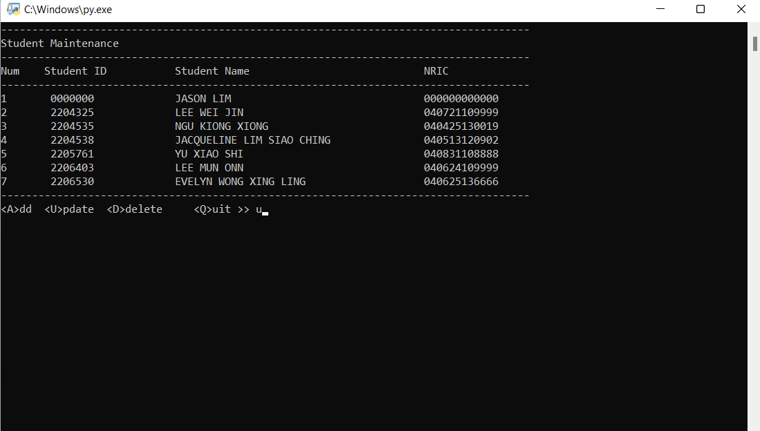

**\*Update student profile**

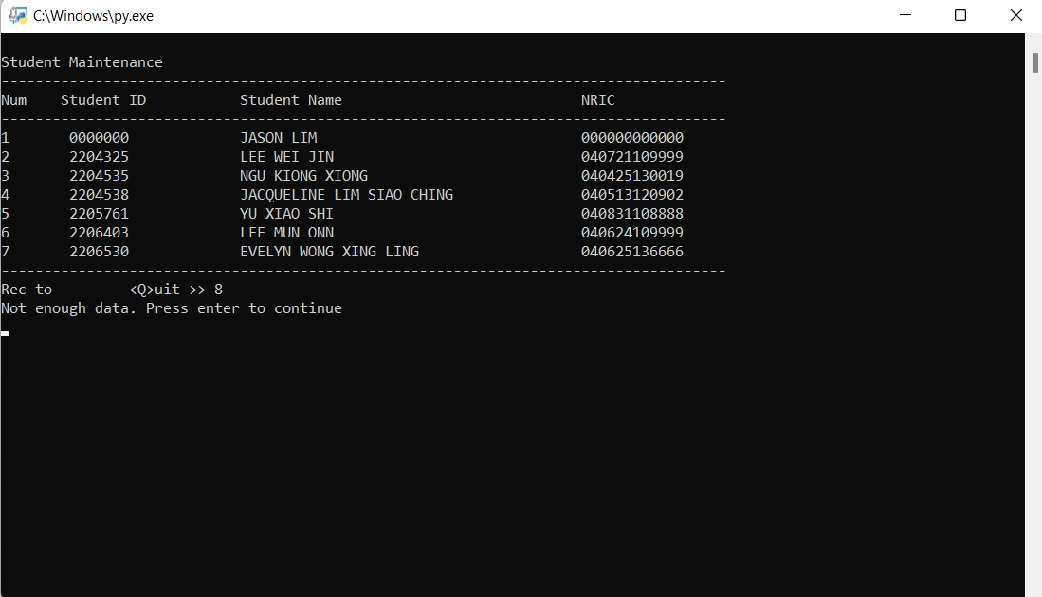

**\*Validation of record number**

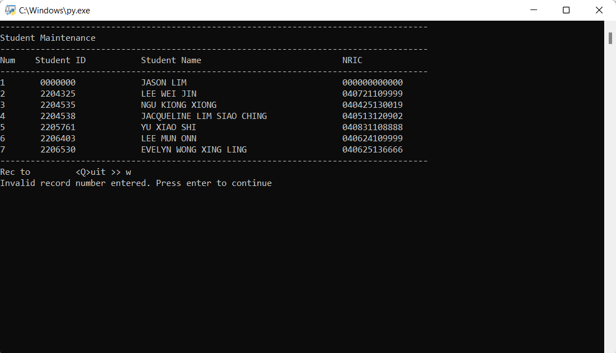

**\*Invalid data entered**

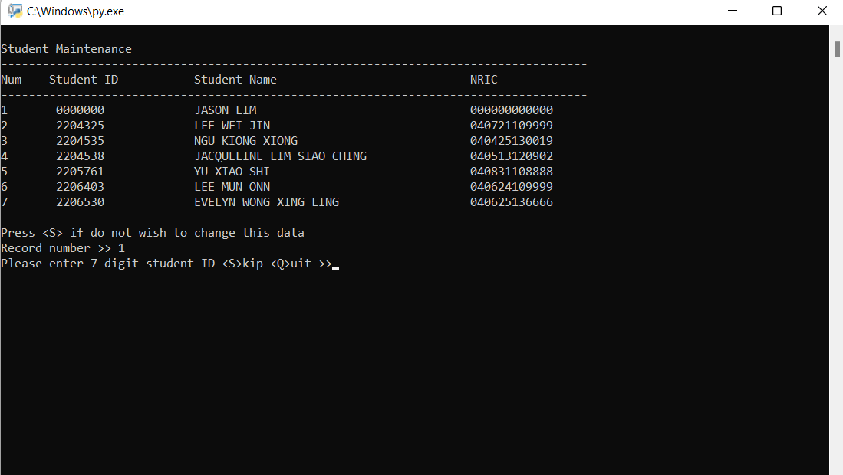

**\*Display of updating student profile**

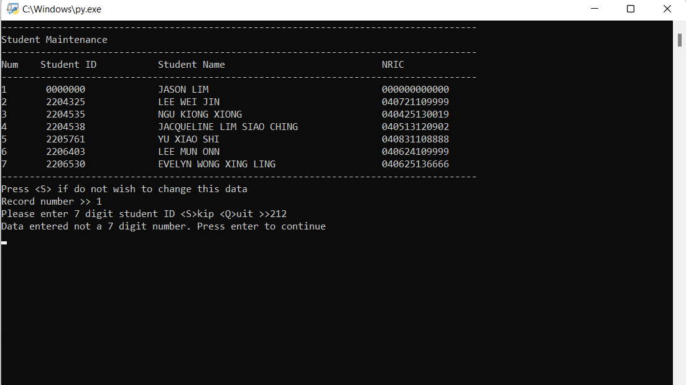

**\*Validation of student ID length**

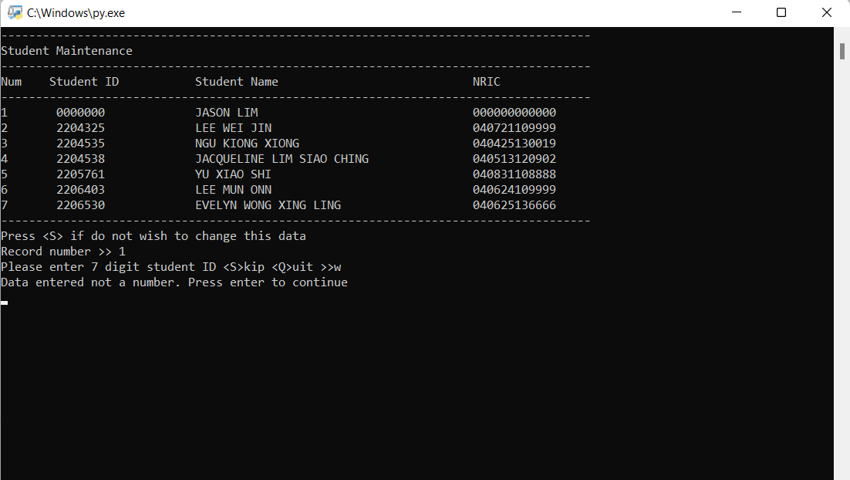

**\*Invalid student ID entered**

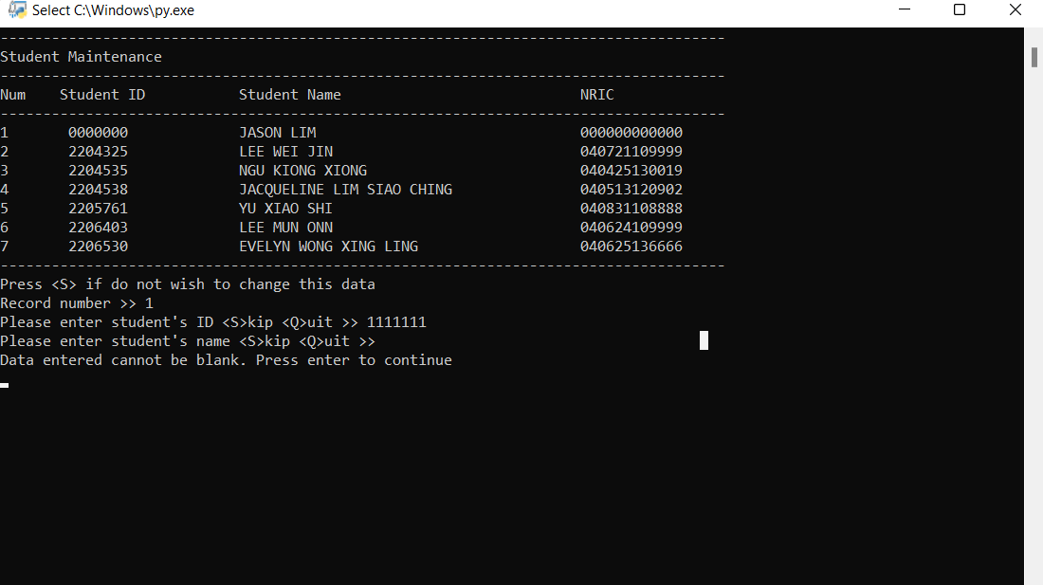

**\*Cannot update a blank student name**

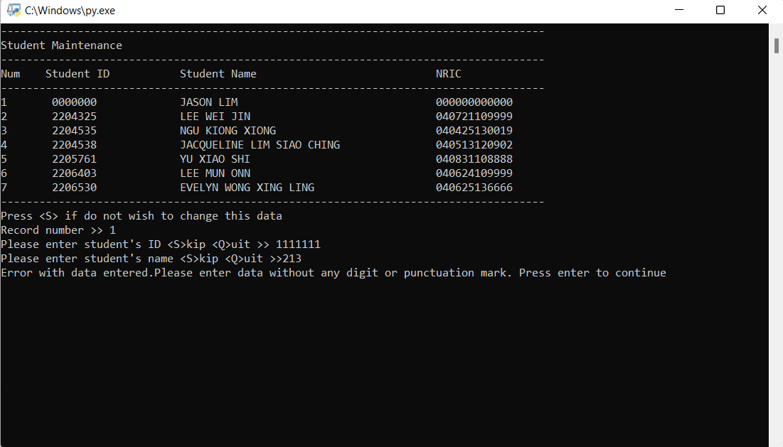

**\*Validation for student name**

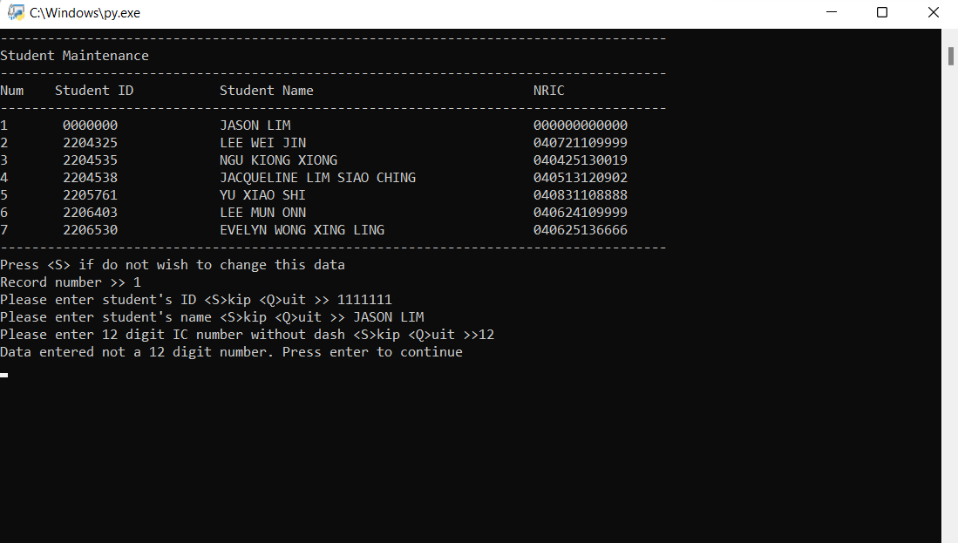

**\*Validation for student IC length**

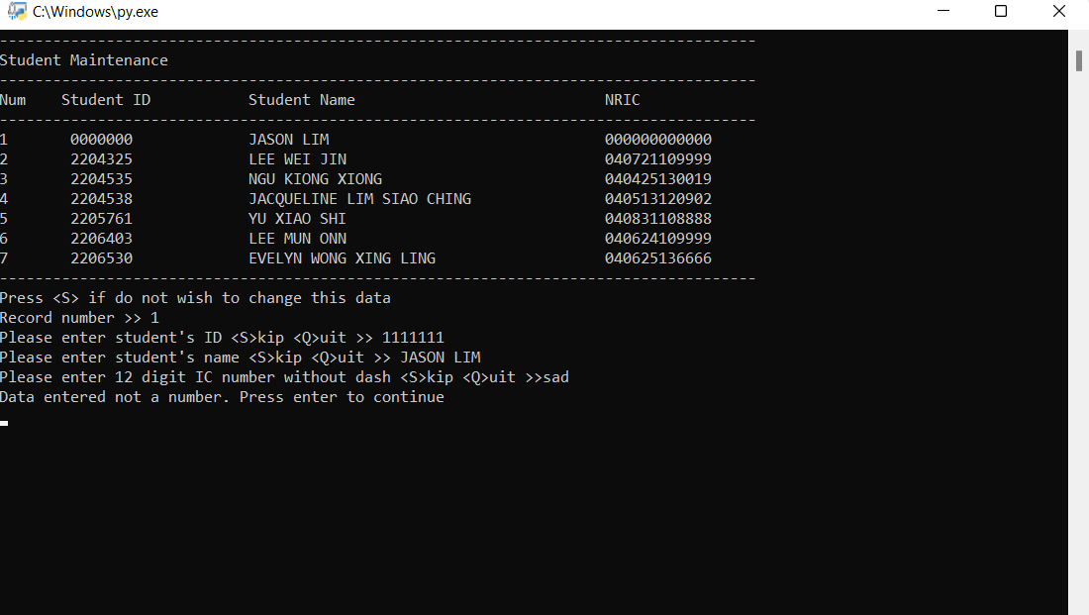

**\*Invalid student IC enter**

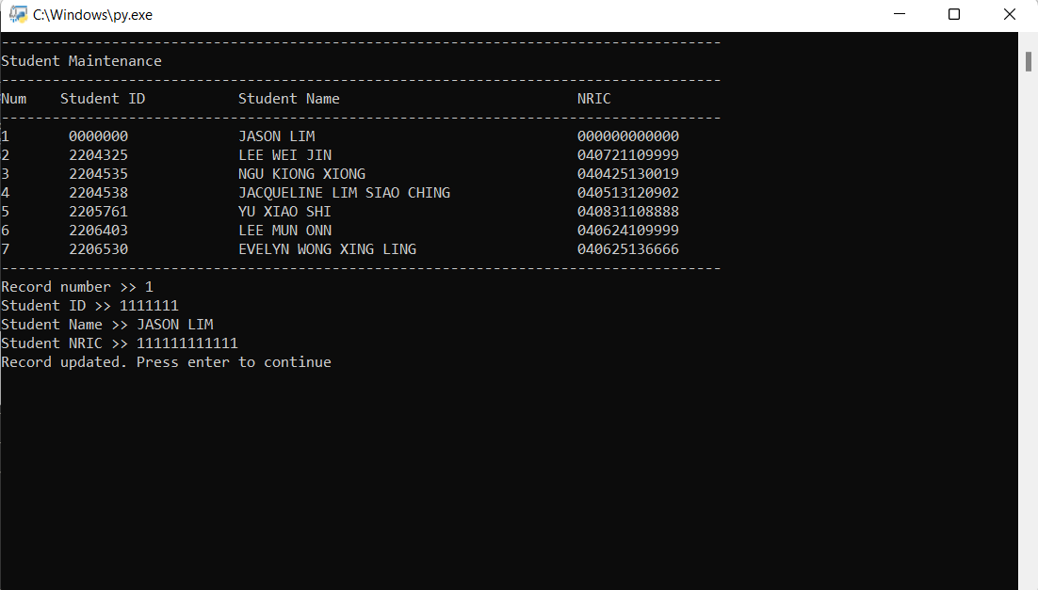

**\*Output of update student profile**

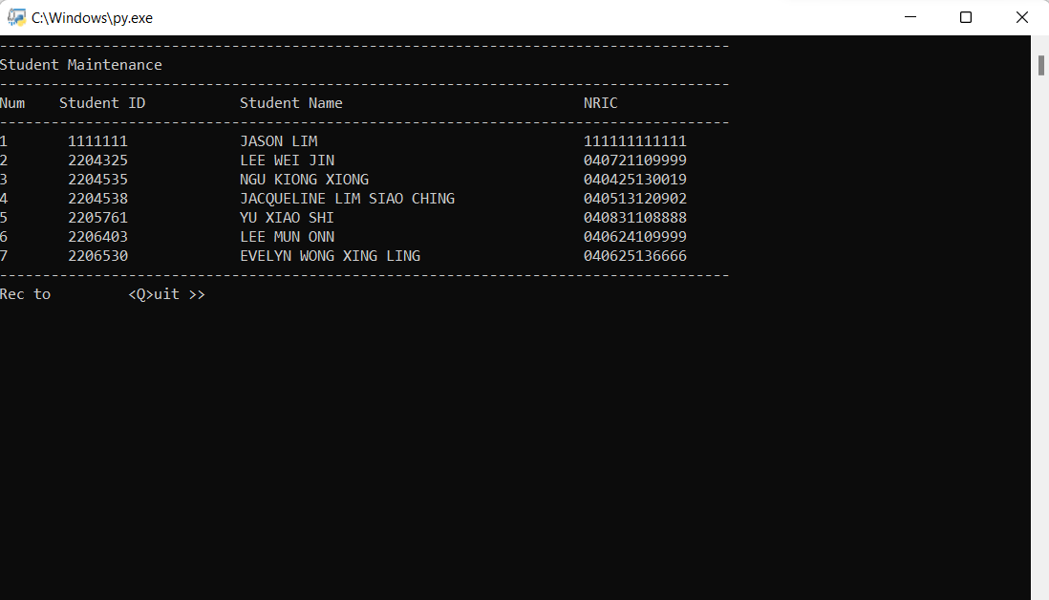

**\*Student profile updated**

**1.3DELETE**

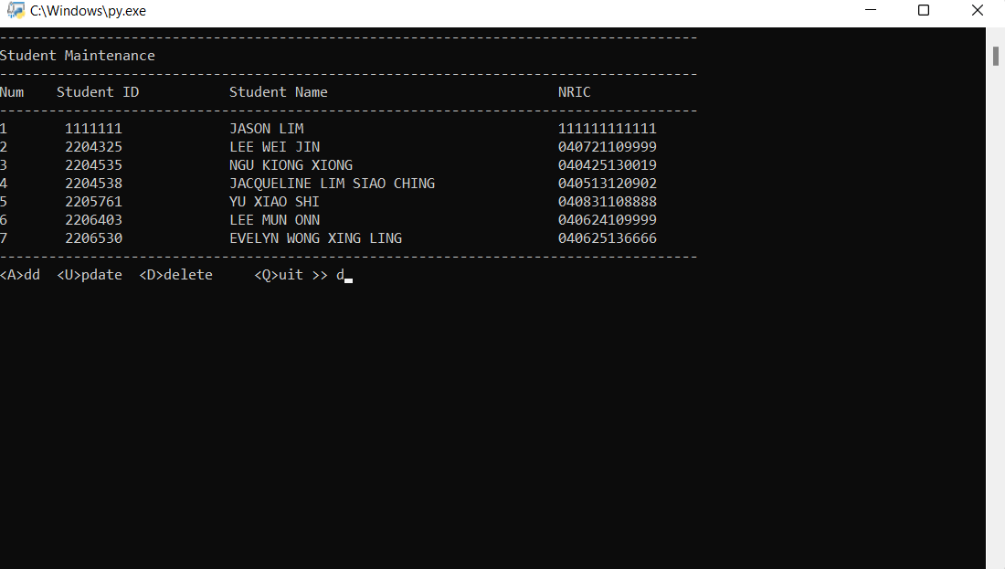

**\*Delete student profile**

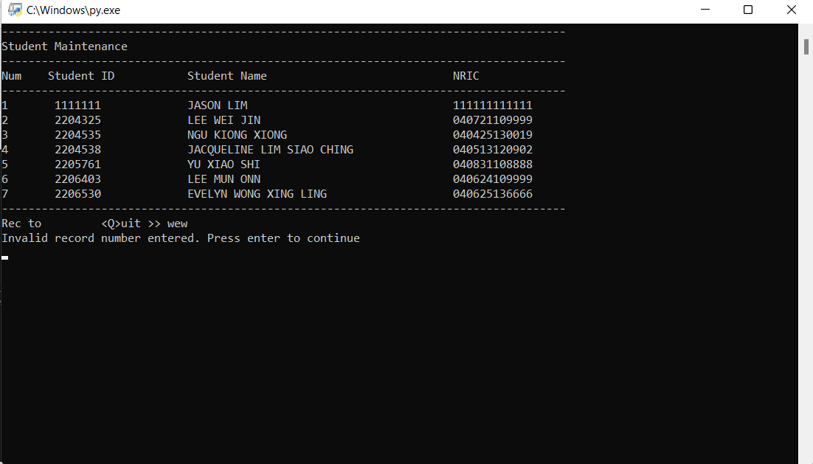

**\*Invalid record number entered**

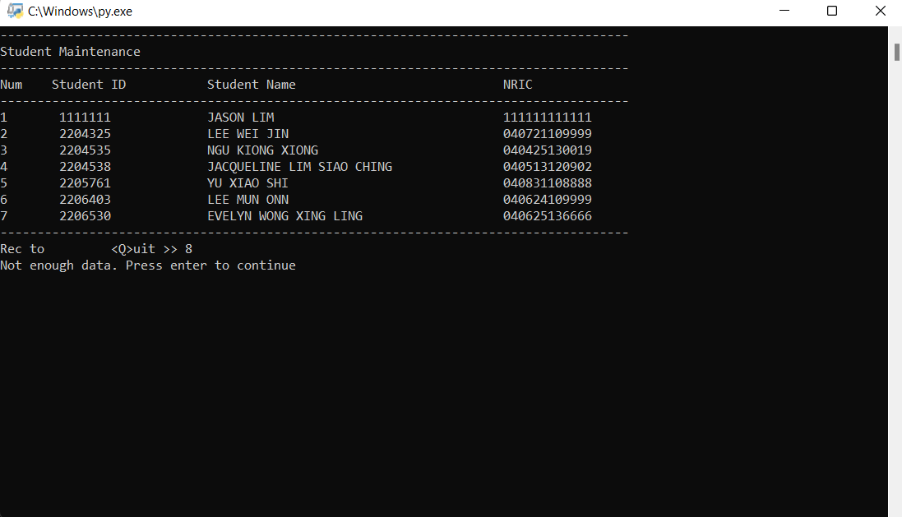

**\*Validation of record number**

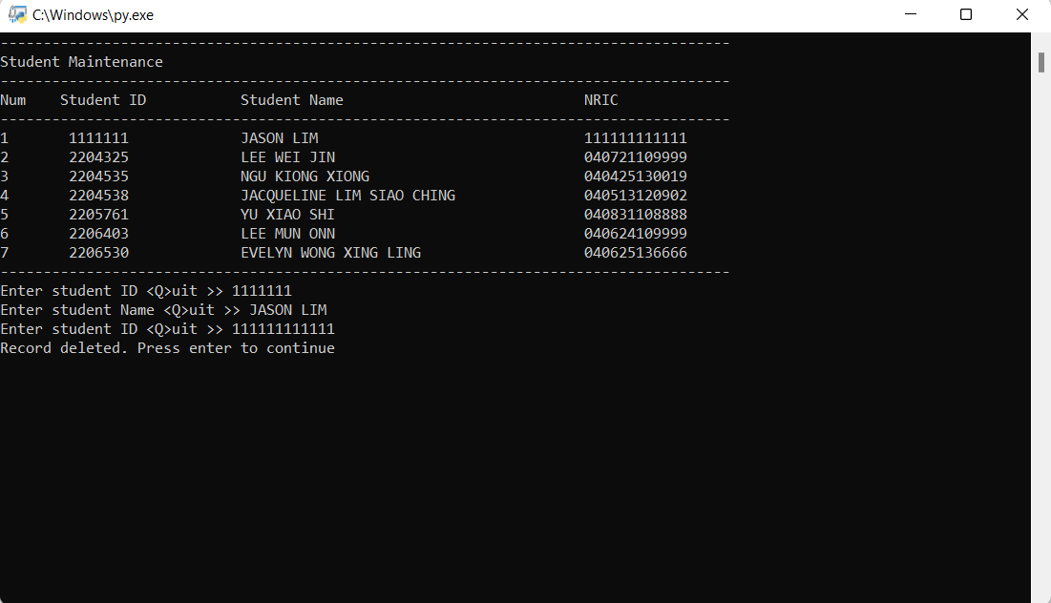

**\*Output of deleted student profile**

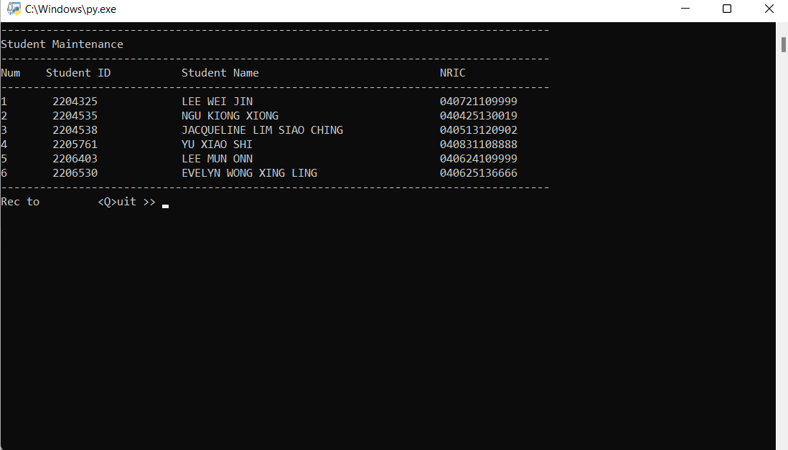

**\*Student deleted**

**3.Course Maintenance**

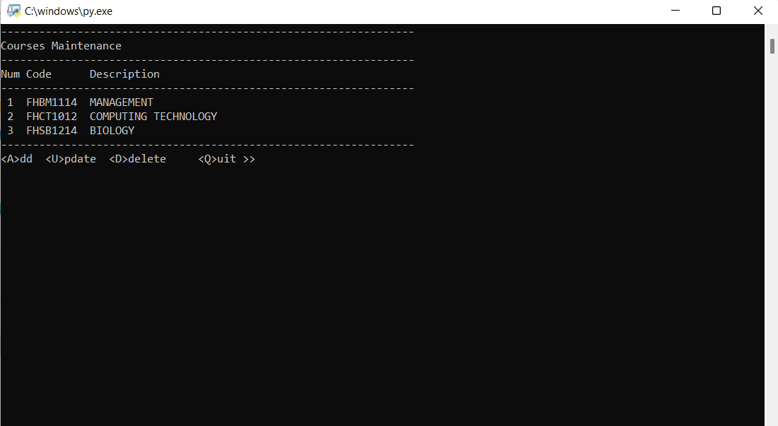

**\*Course maintenance display**

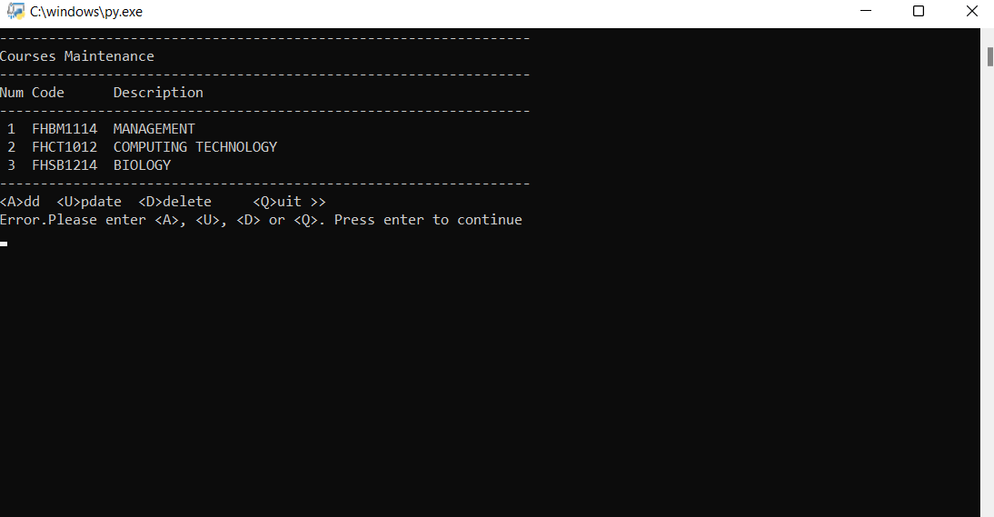

**\*Invalid data entered**

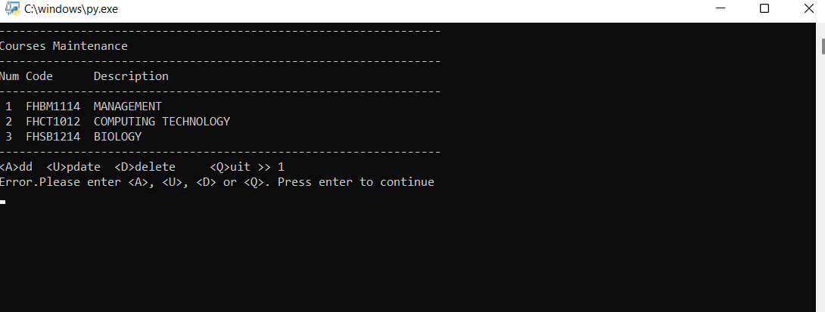

**\*Invalid data entered**

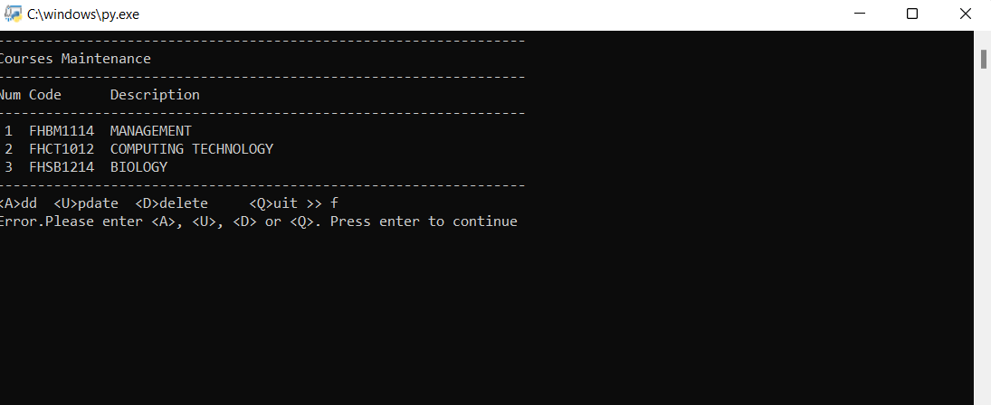

**\*Invalid data entered**

2.1 Adding new course

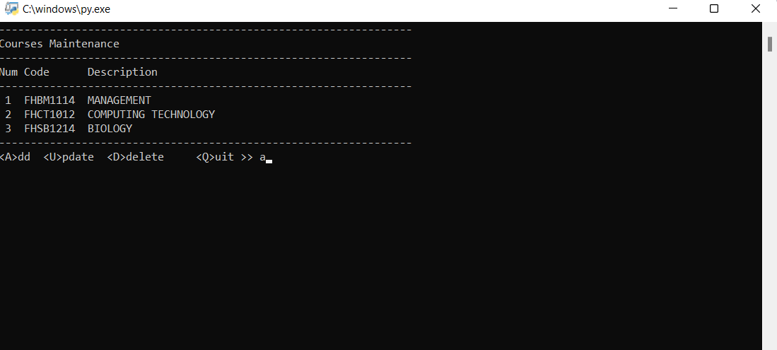

*Add course

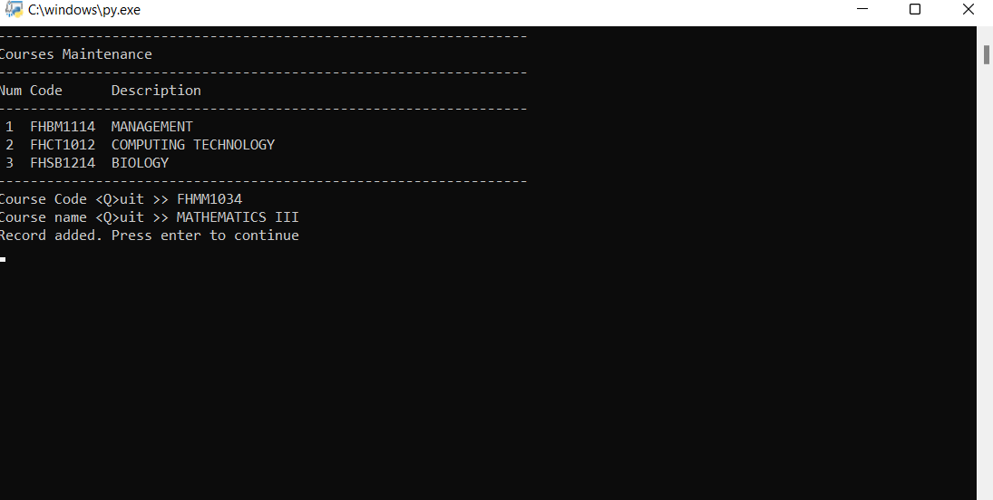

*Output of adding course

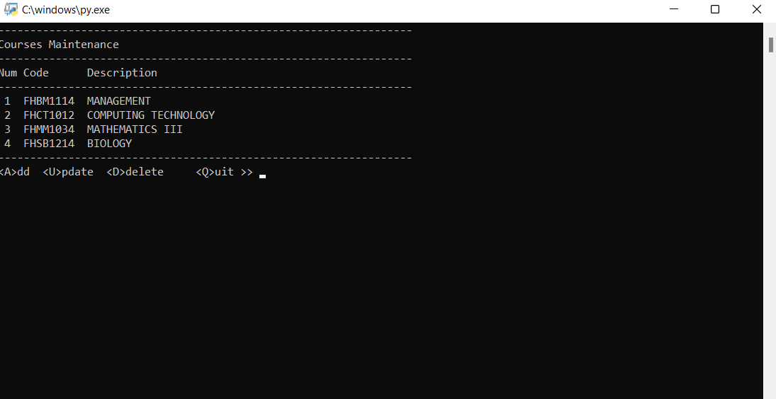

*New course added

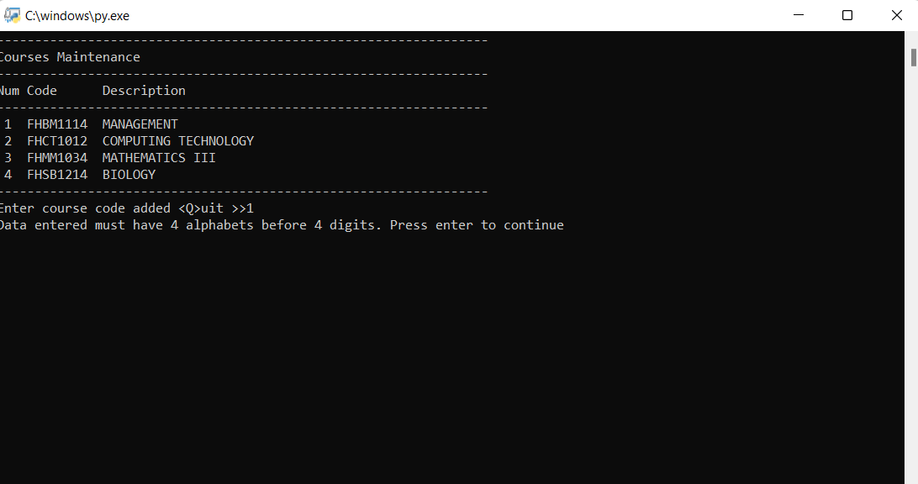

**\*Validation for adding course code(course code must contain 4 alphabets before 4 digits)**

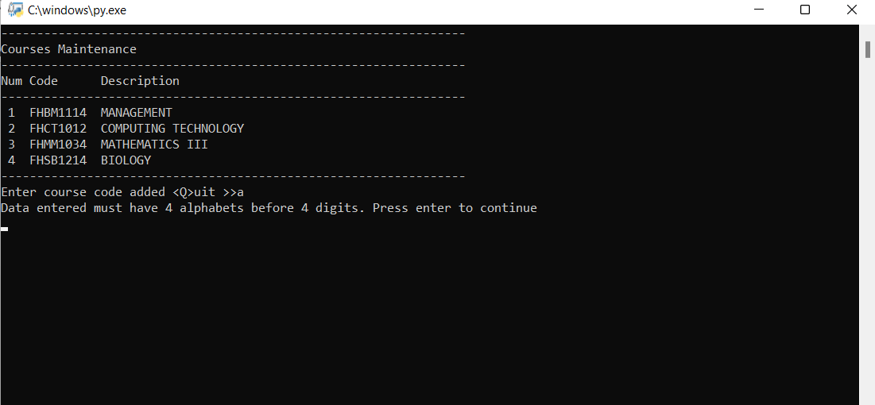

**\*Validation for adding course code(course code must contain 4 alphabets before 4 digits)**

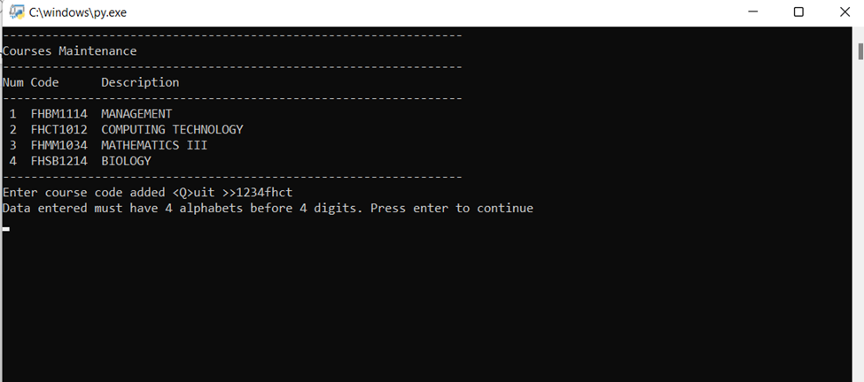

**\*Validation for adding course code(course code must contain 4 alphabets before 4 digits)**

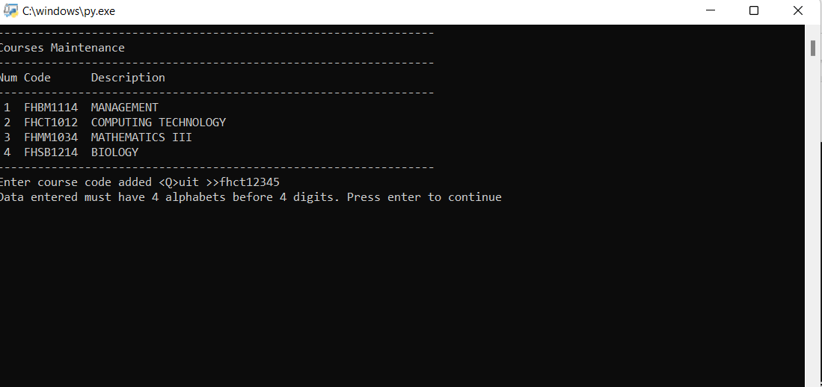

**\*Validation for course code length**

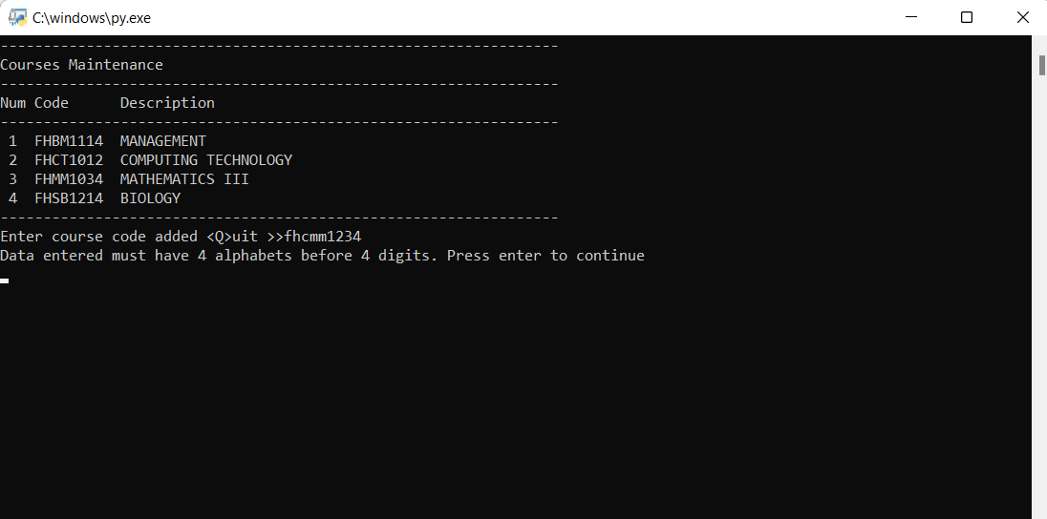

**\*Validation for course code length**

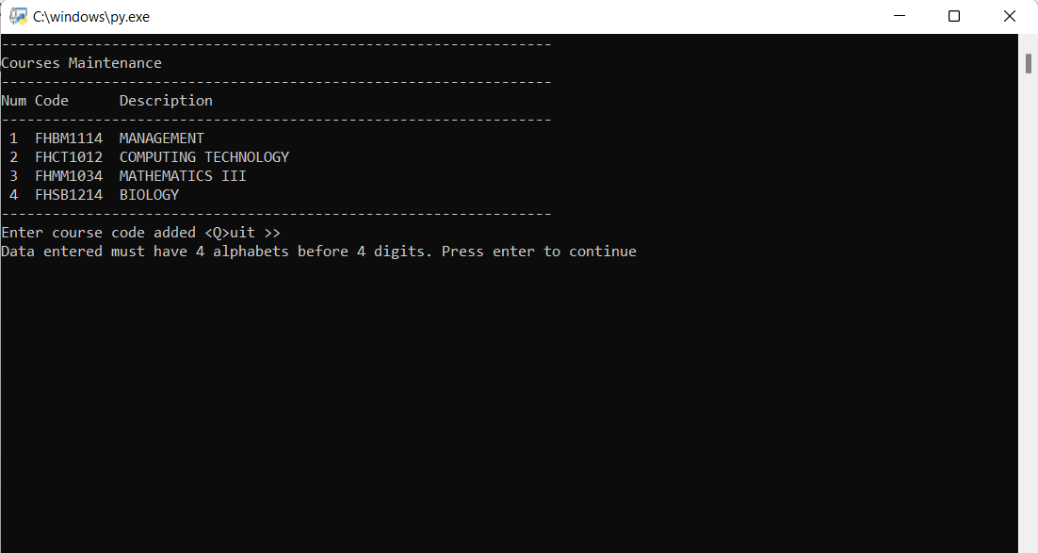

**\*Validation for adding course code**

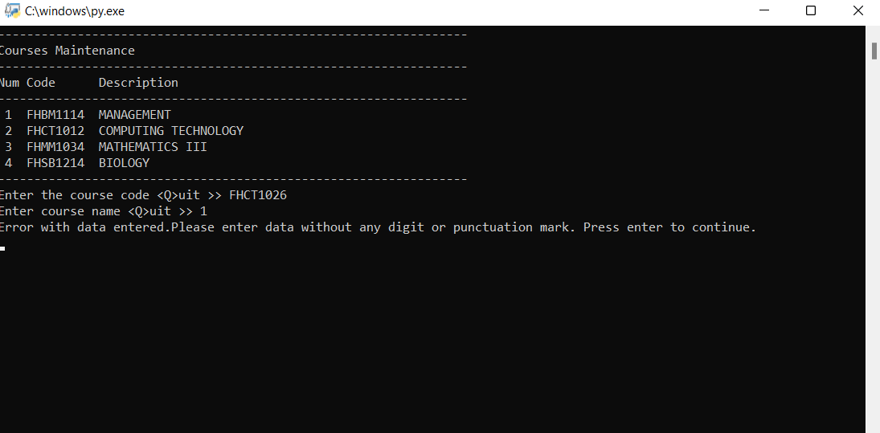

*Validation for adding course name 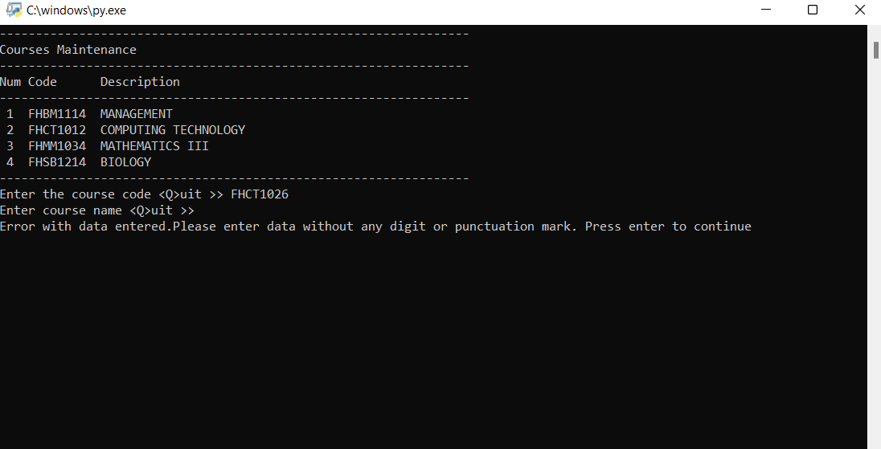

*Validation for adding course name

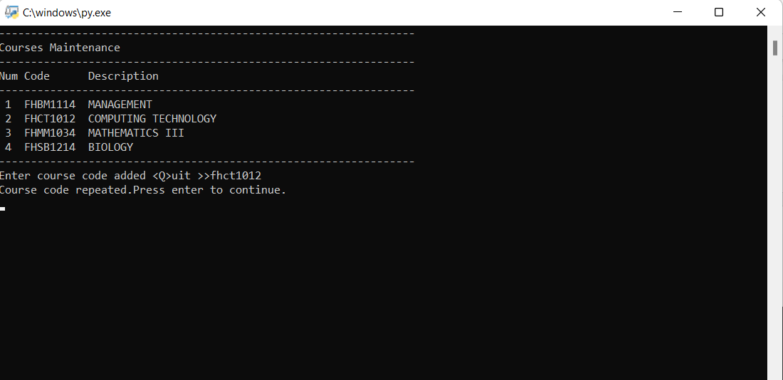

*Validation for repeated course code

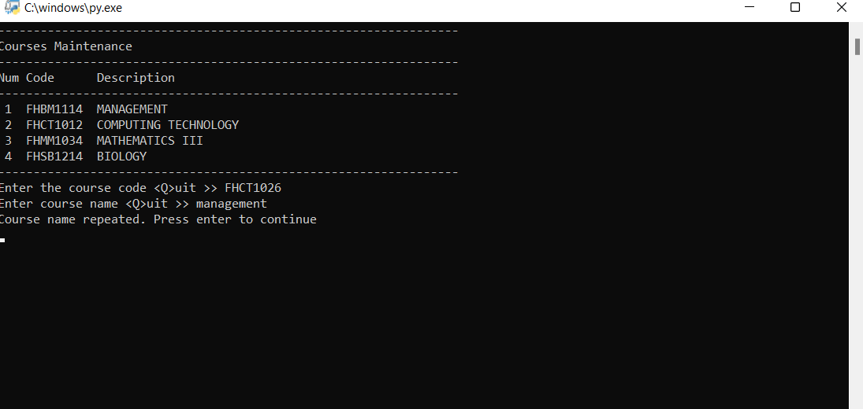

*Validation for repeated course name

* 1. Updating course

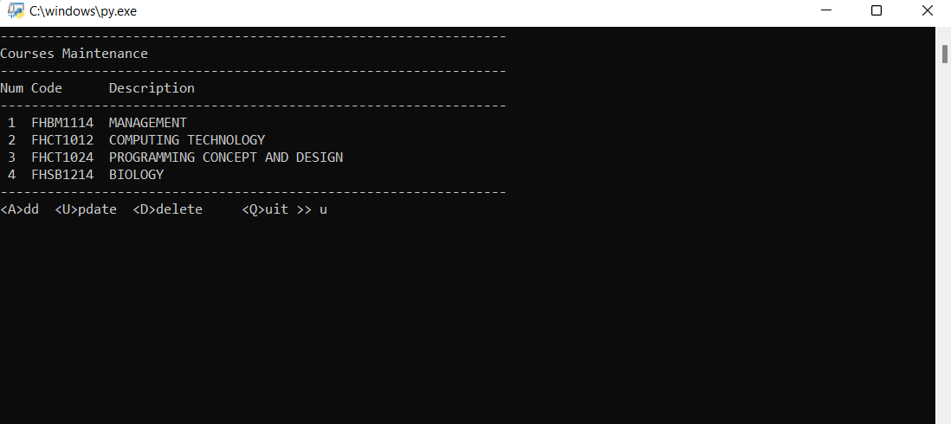

*Update course

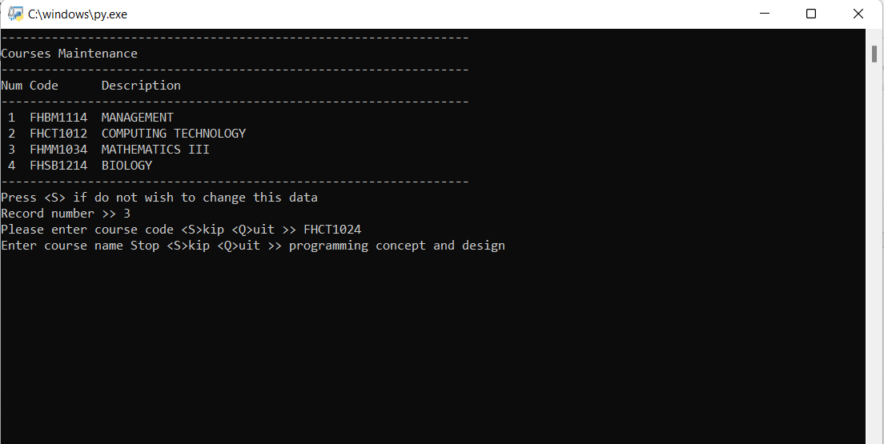

*Output of update course

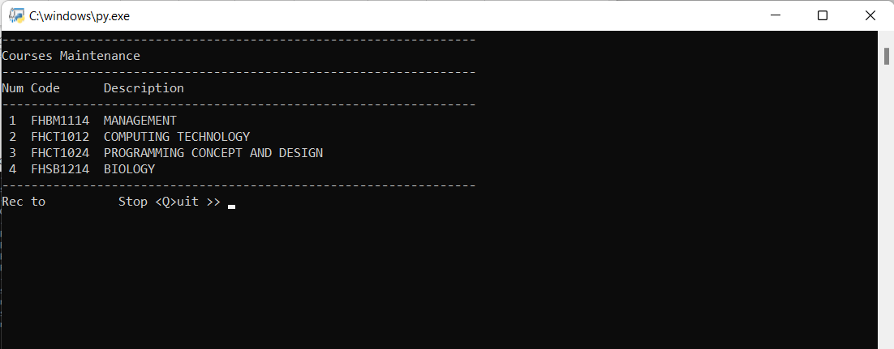

*Course updated

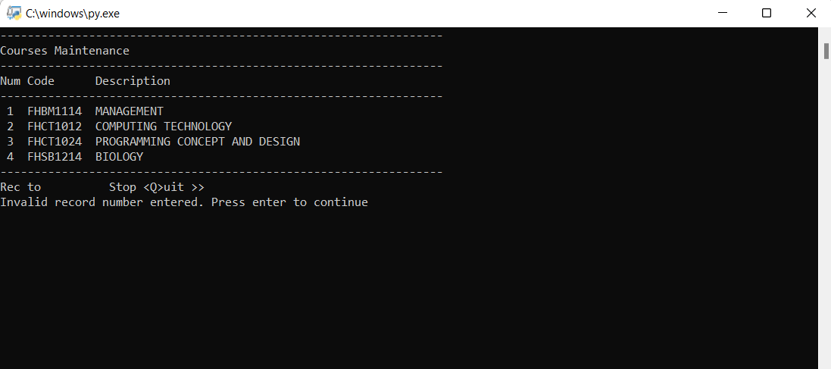

*Validation for record number(update course)

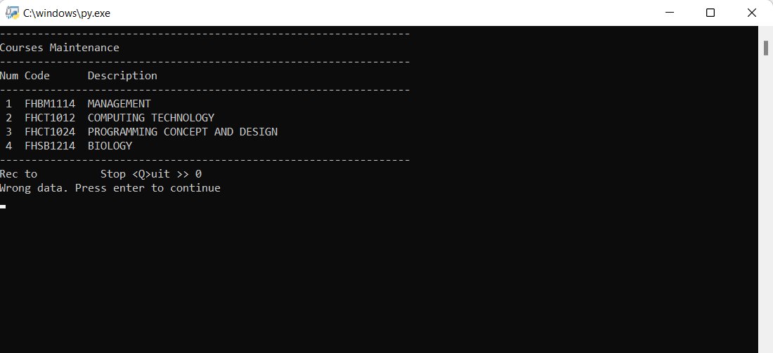

*Validation for record number(update course)

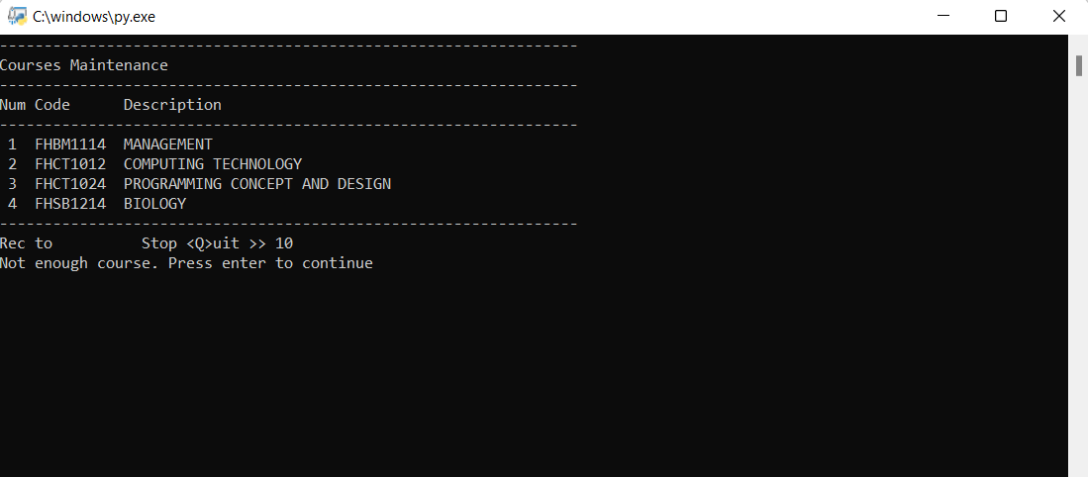

*Validation for record number(update course)

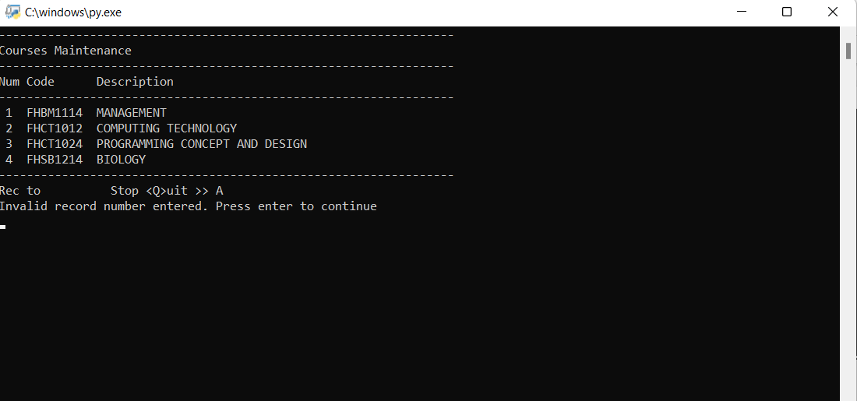

*Validation for record number(update course)

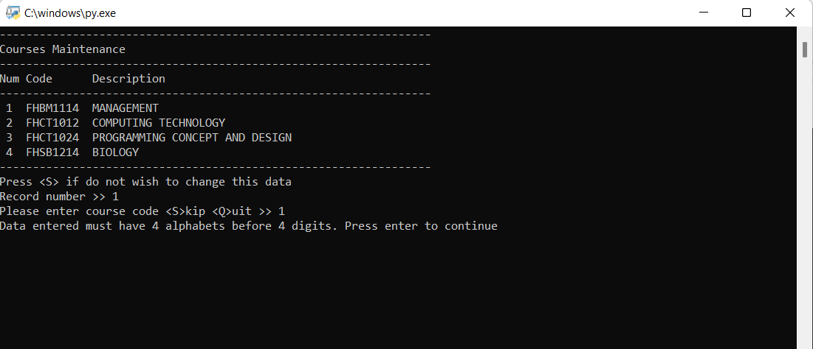

*Validation for course code(course code must 4 alphabets before 4 digits)

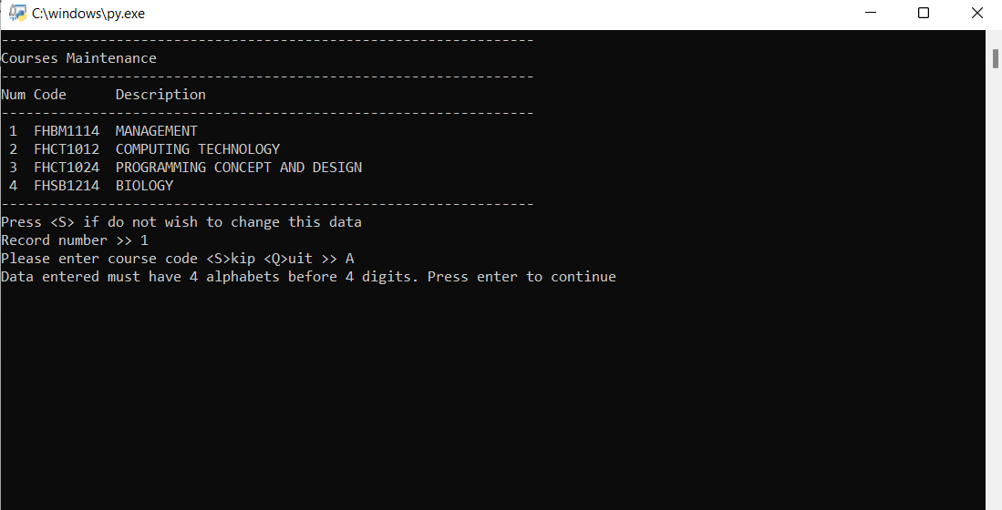

*Validation for course code(course code must 4 alphabets before 4 digits)

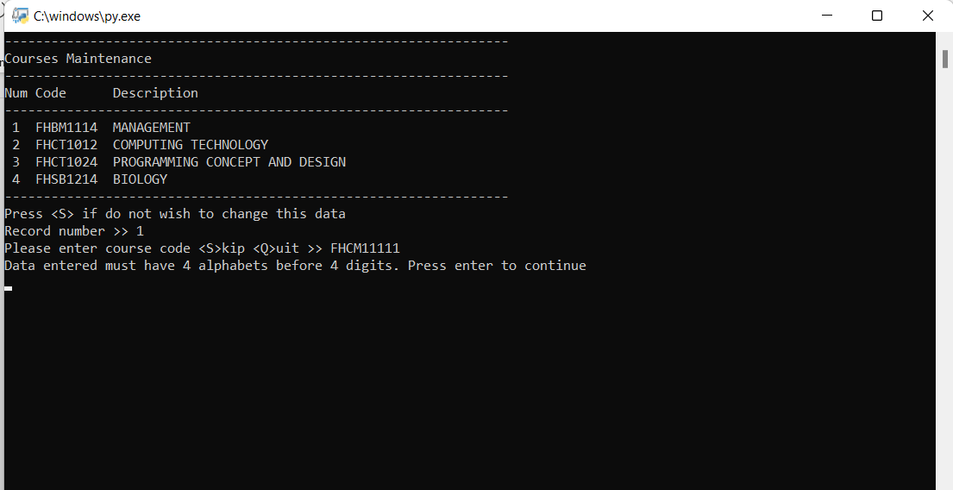

*Validation for course code length

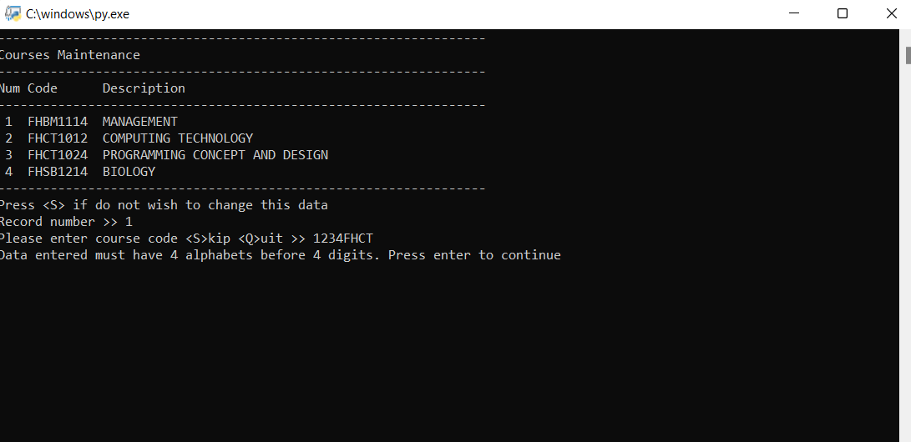

*Validation for course code(course code must 4 alphabets before 4 digits)

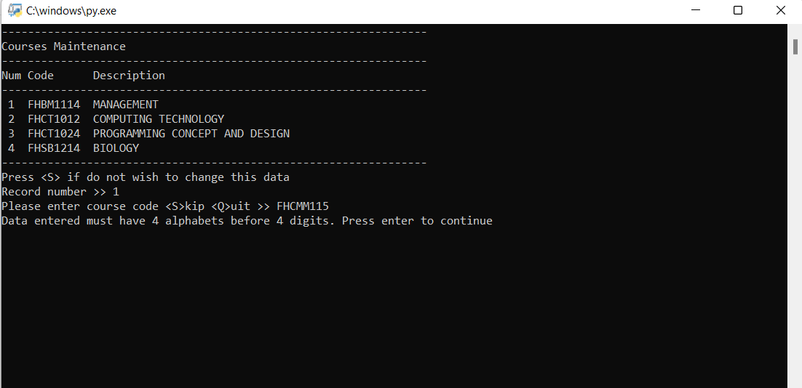

*Validation for course code length

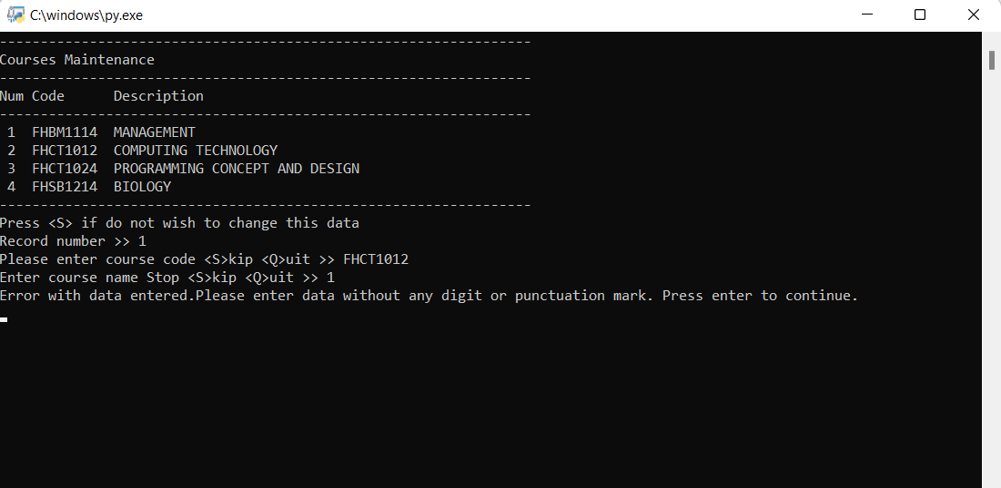

*Validation for course name

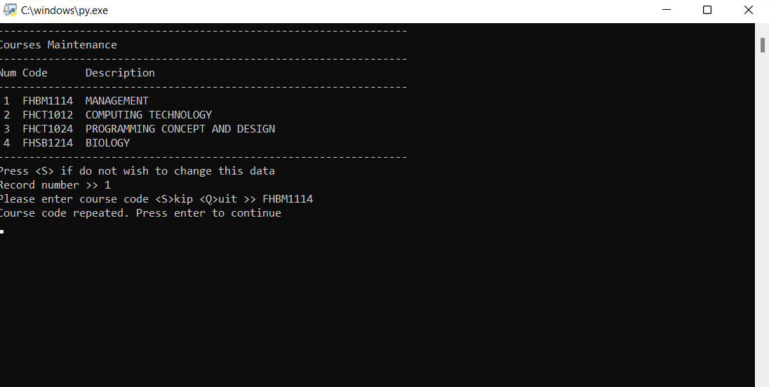

*Validation for repeated course code

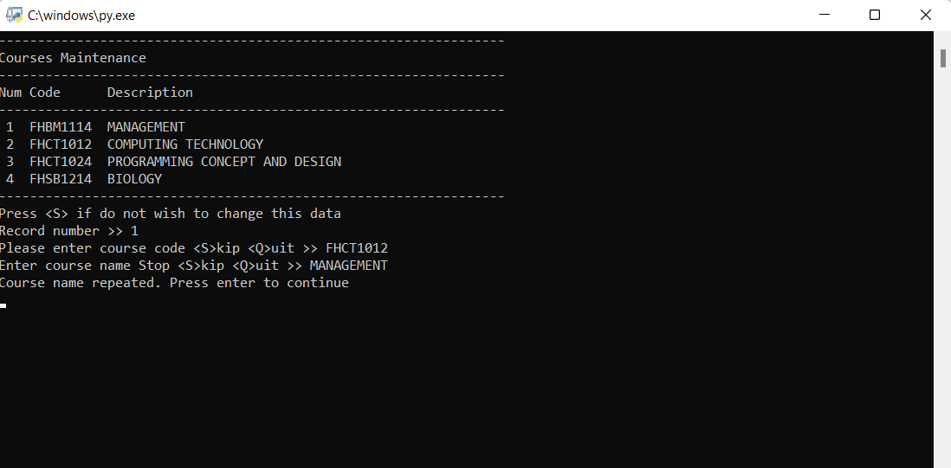

*Validation for repeated course name

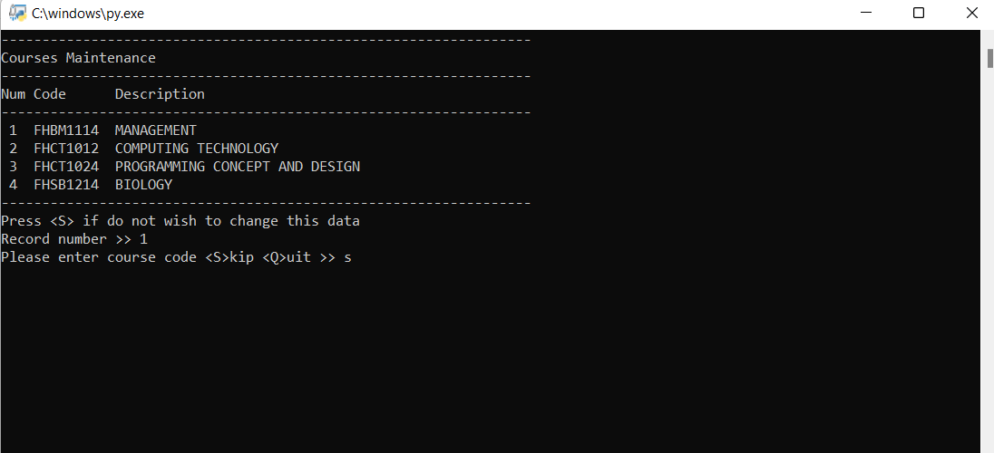

*Skip from updating course code

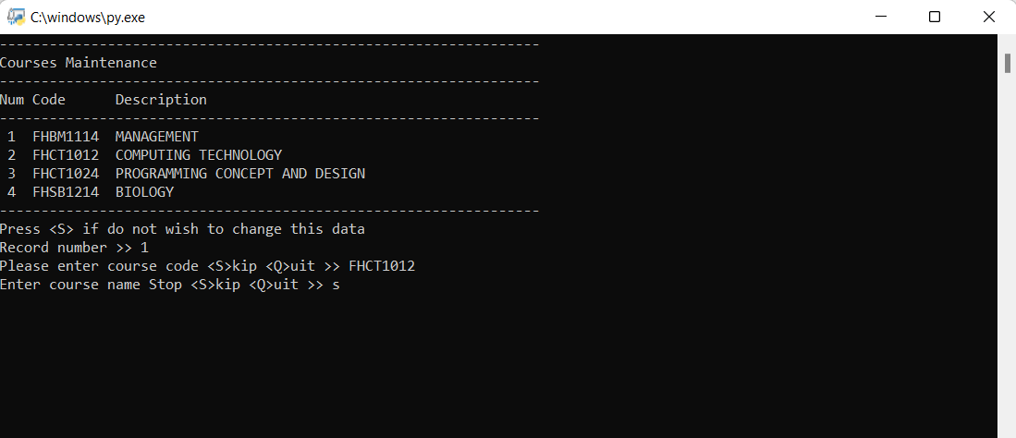

*Skip from updating course name

2.3 Delete course

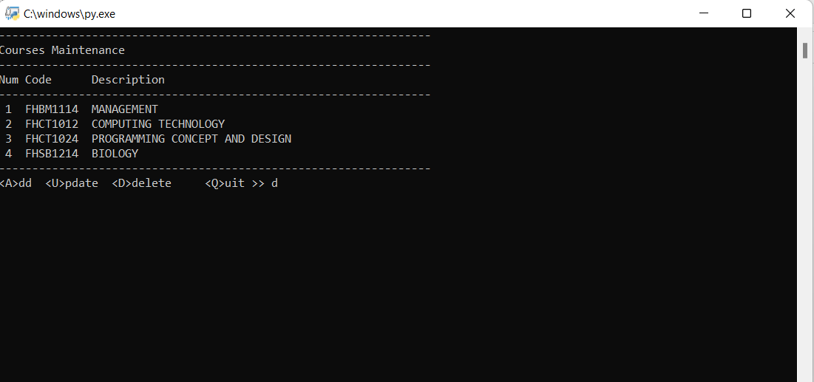

*Delete course

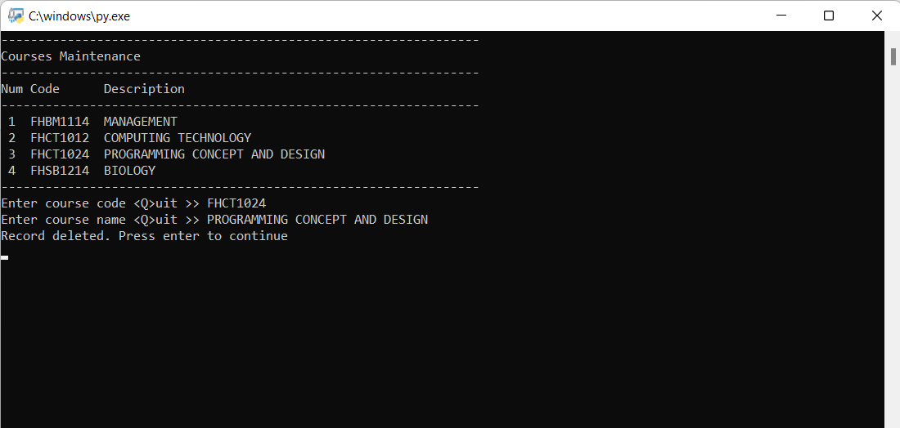

*Output of delete course

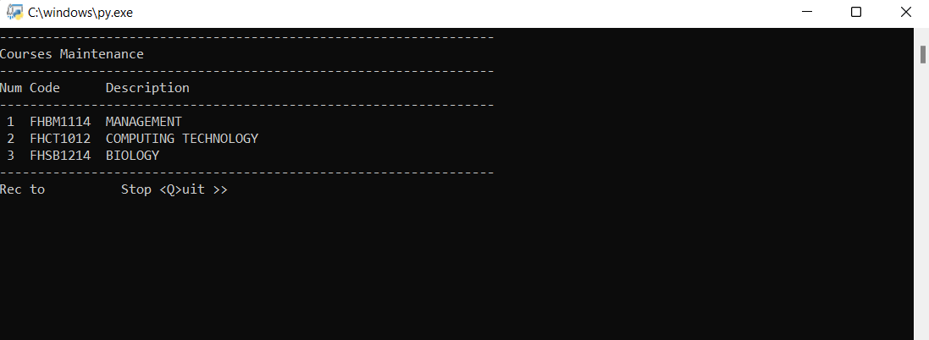

*Course deleted

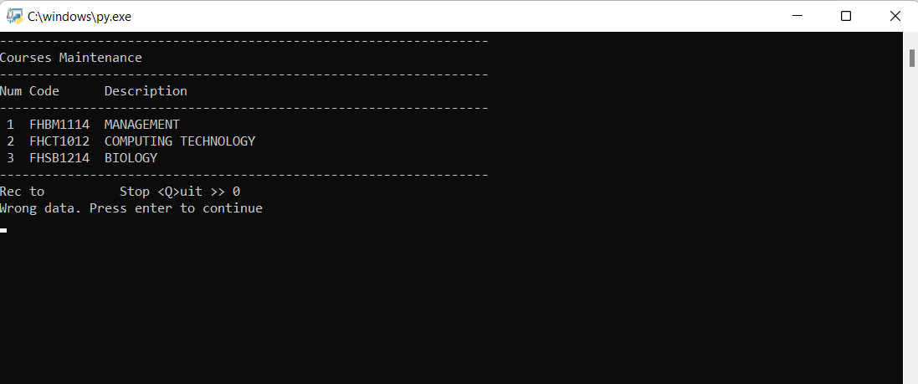

*Validation for record number(delete course)

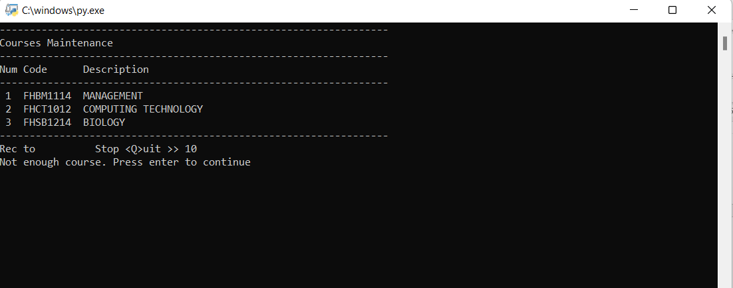

*Validation for record number(delete course)

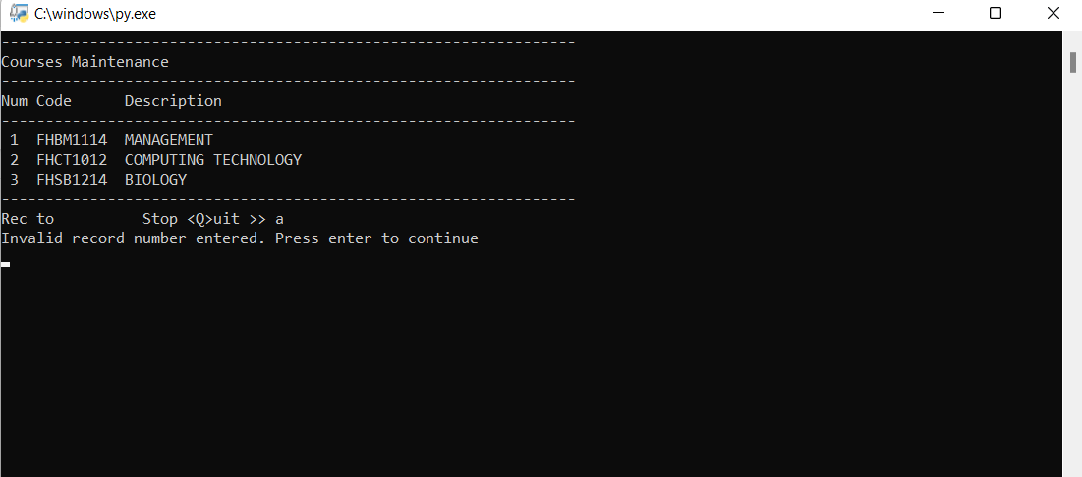

*Validation for record number(delete course)

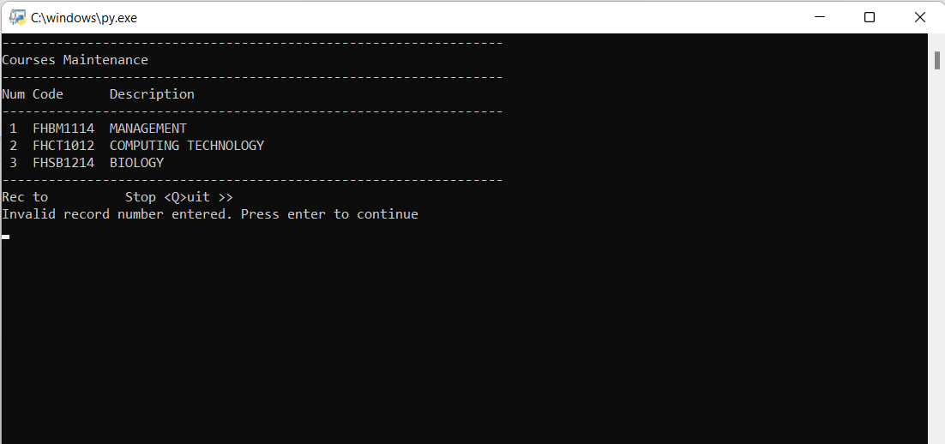

*Validation for record number(delete course)

4. Question Bank Maintenance

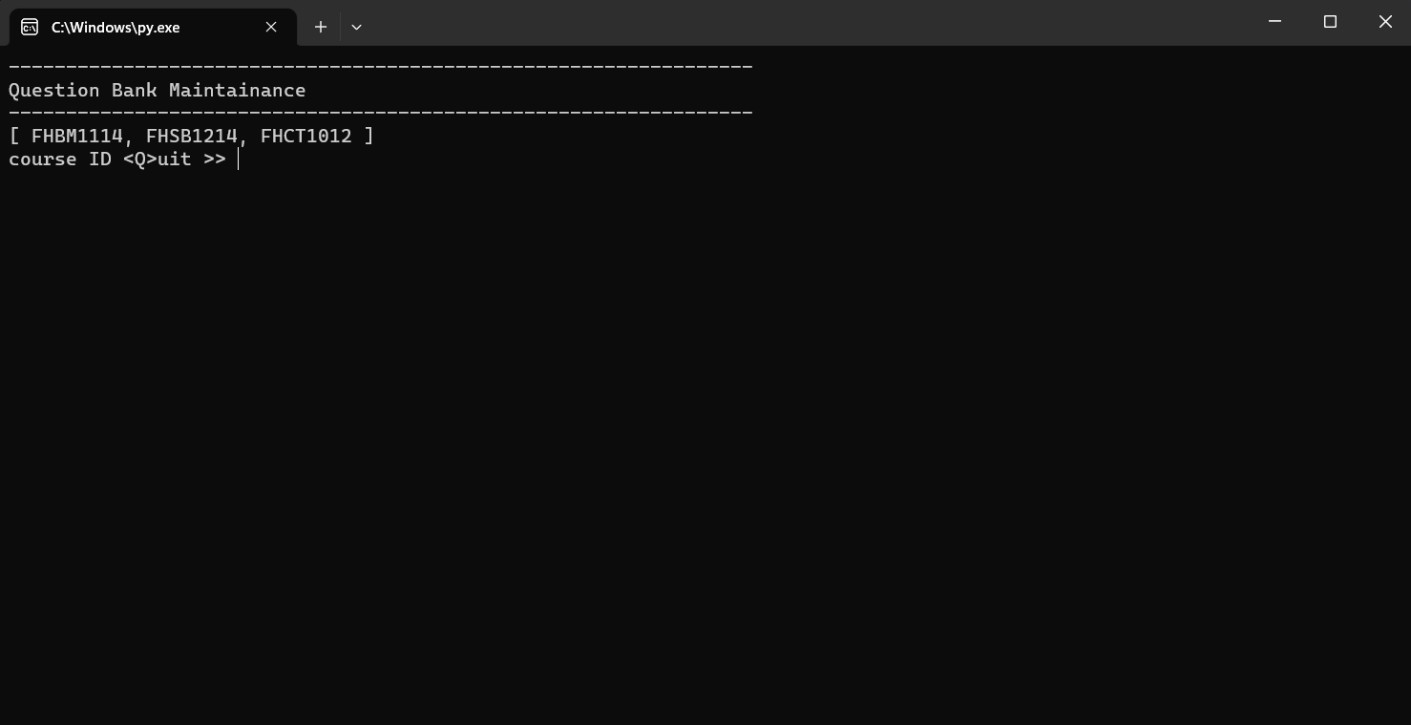

*Main page of the question bank maintenance

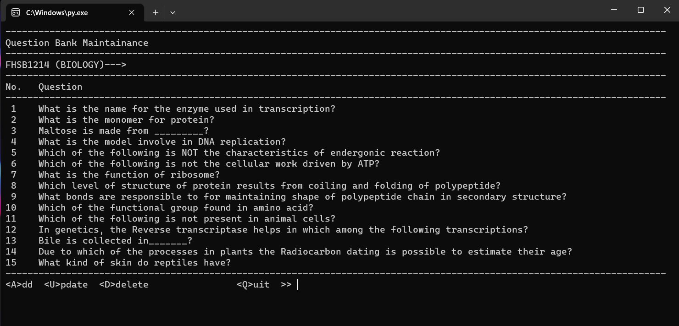

*Add, update, delete page of the question bank maintenance

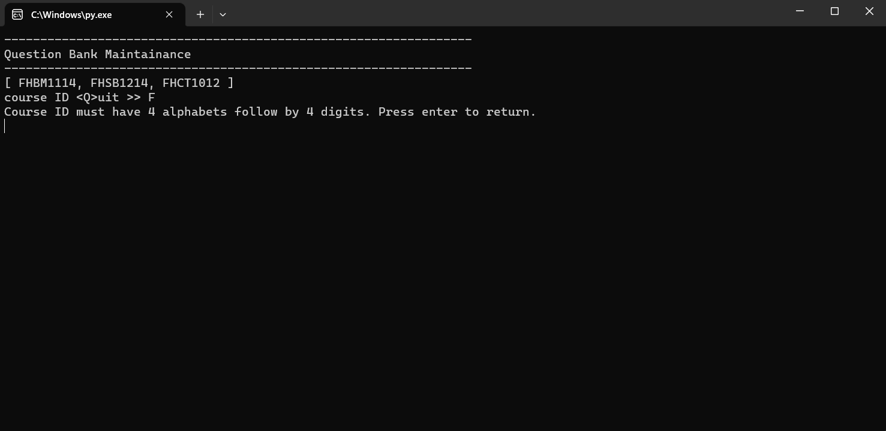

*Invalid course code entered (Validation for the main page of question bank maintenance)

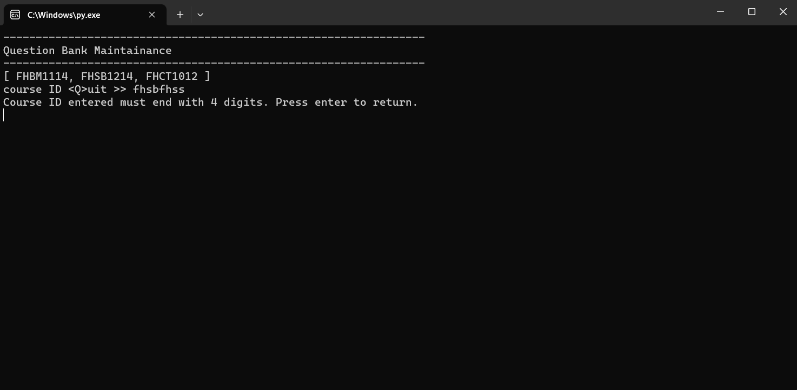

*Invalid course code entered (Validation for the main page of question bank maintenance)

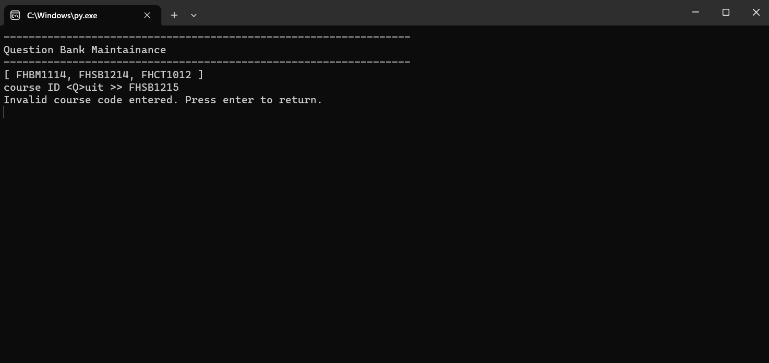

*Invalid course code entered (Validation for the main page of question bank maintenance)

4.1 Adding Question

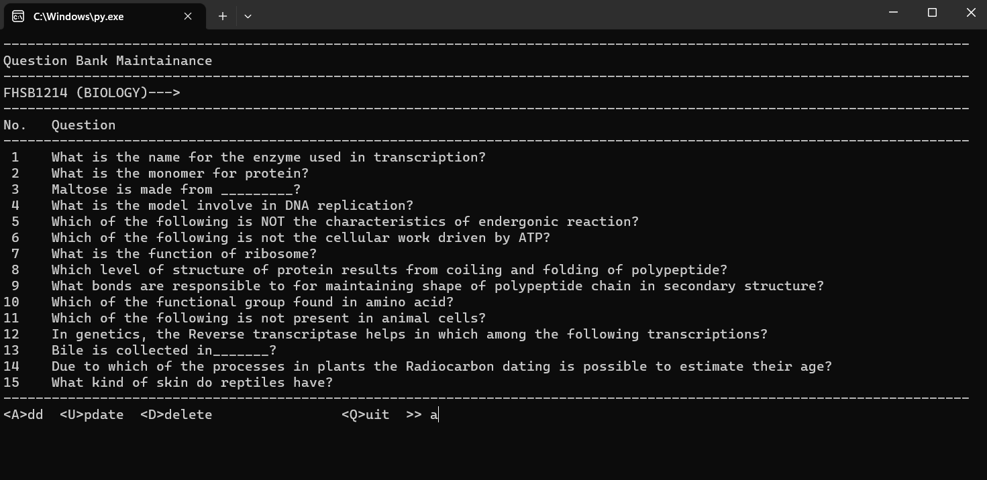

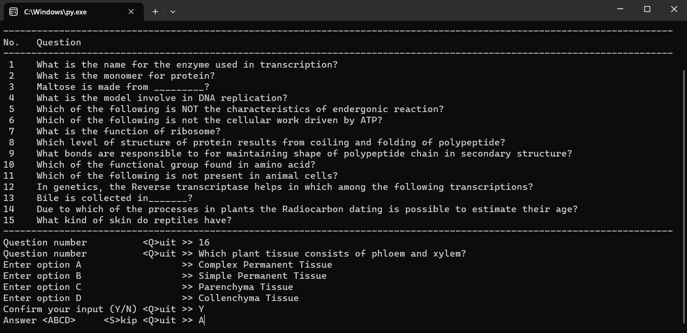

4.1.1 Question Added

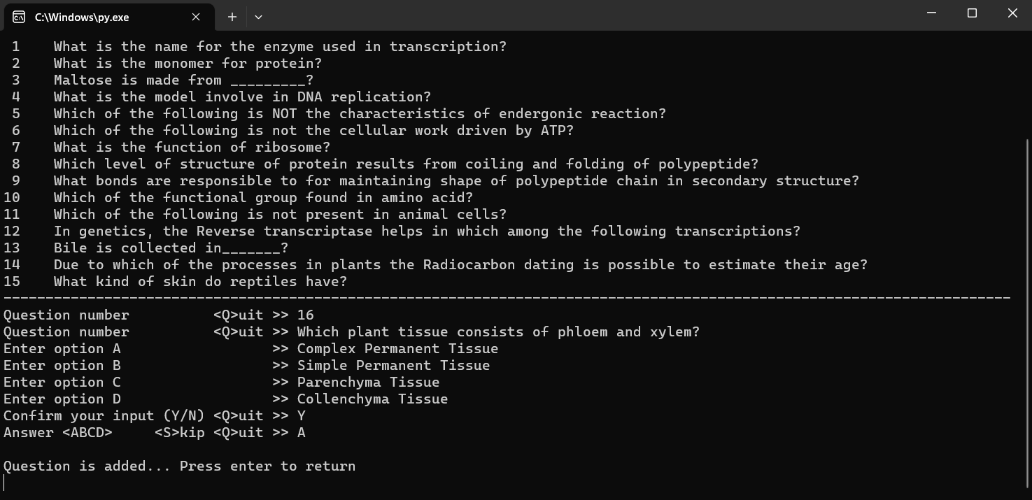

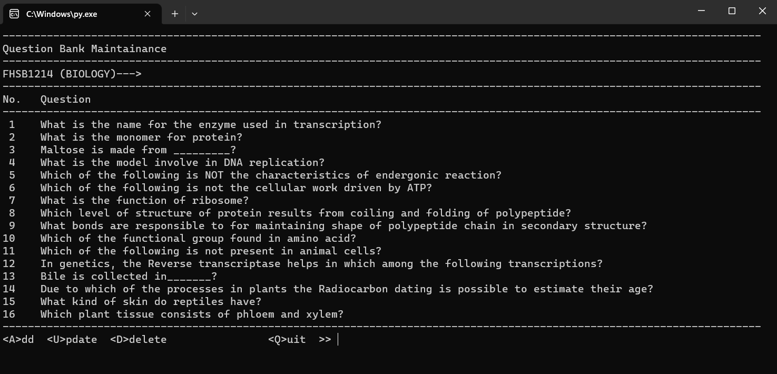

4.1.2 Validation for Adding Question

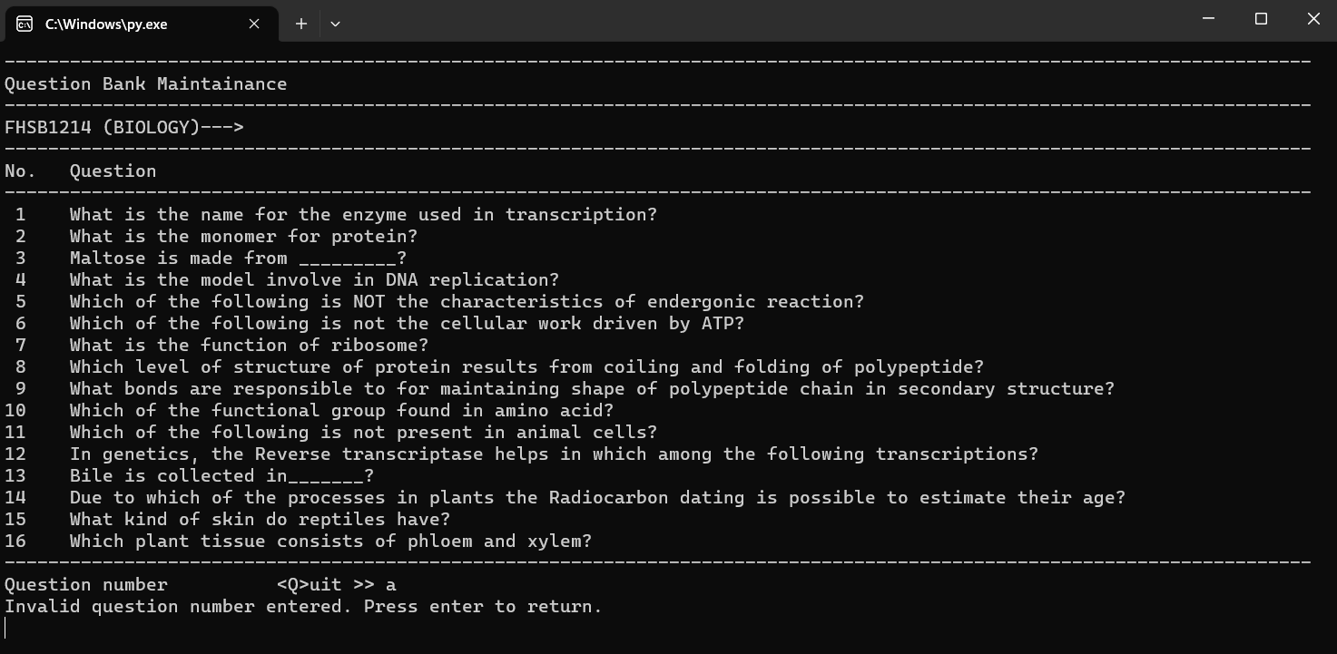

*Invalid question number entered.

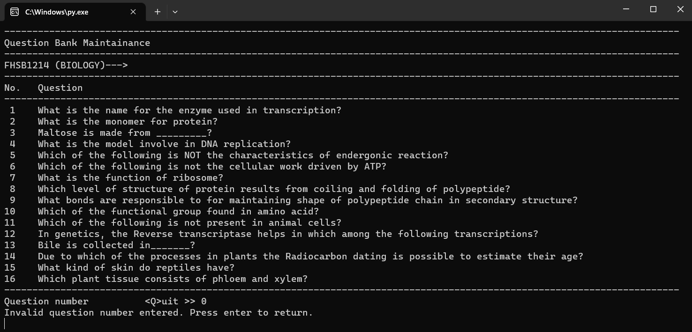

*Invalid question number entered. (0 should not be a question number)

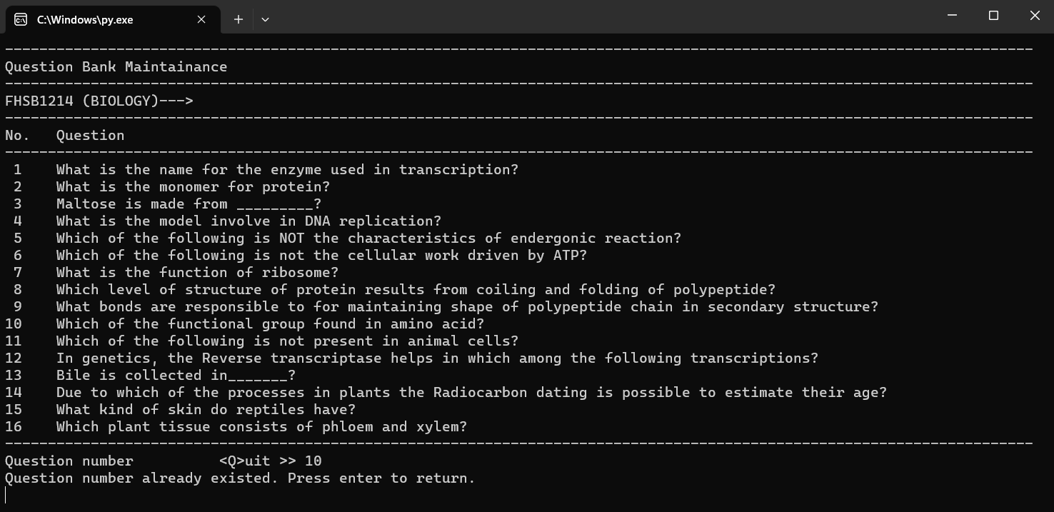

*Invalid question number entered (Question number already existed)

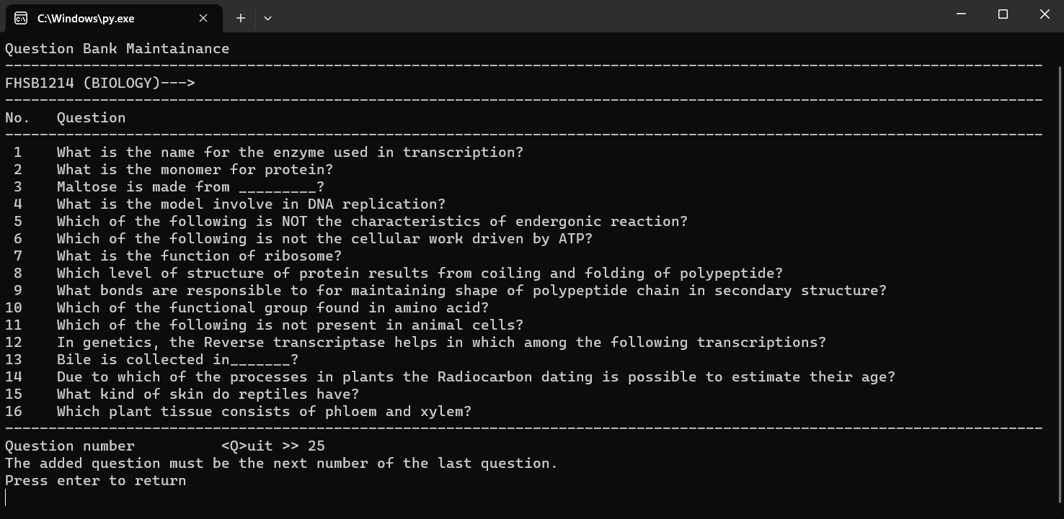

*Invalid question number entered (The question number entered is not the next number from the last question number)

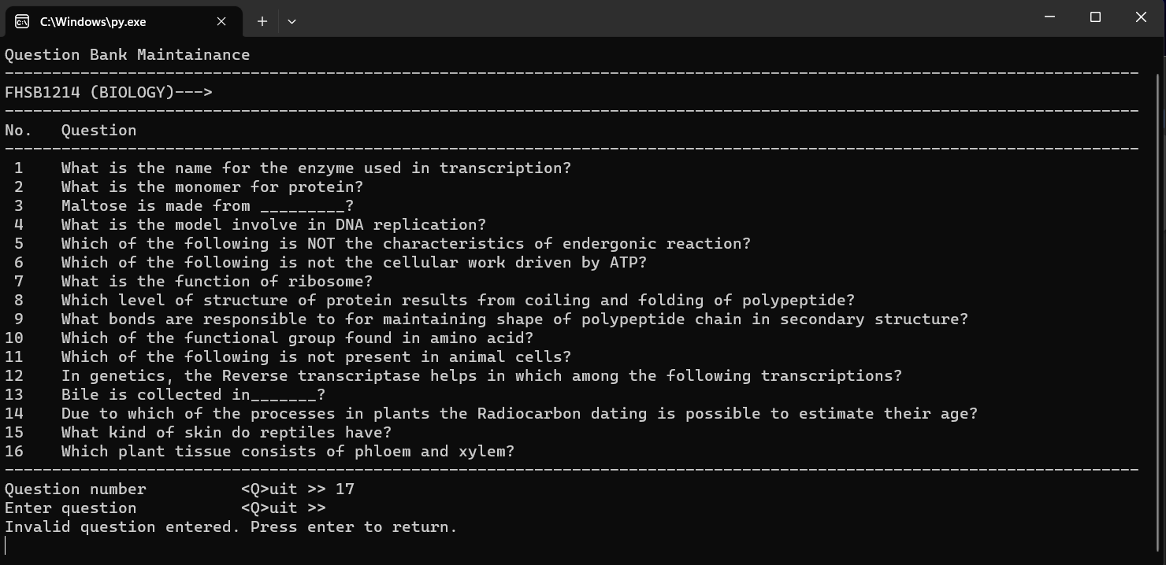

*Invalid question entered. (Question should not be blank)

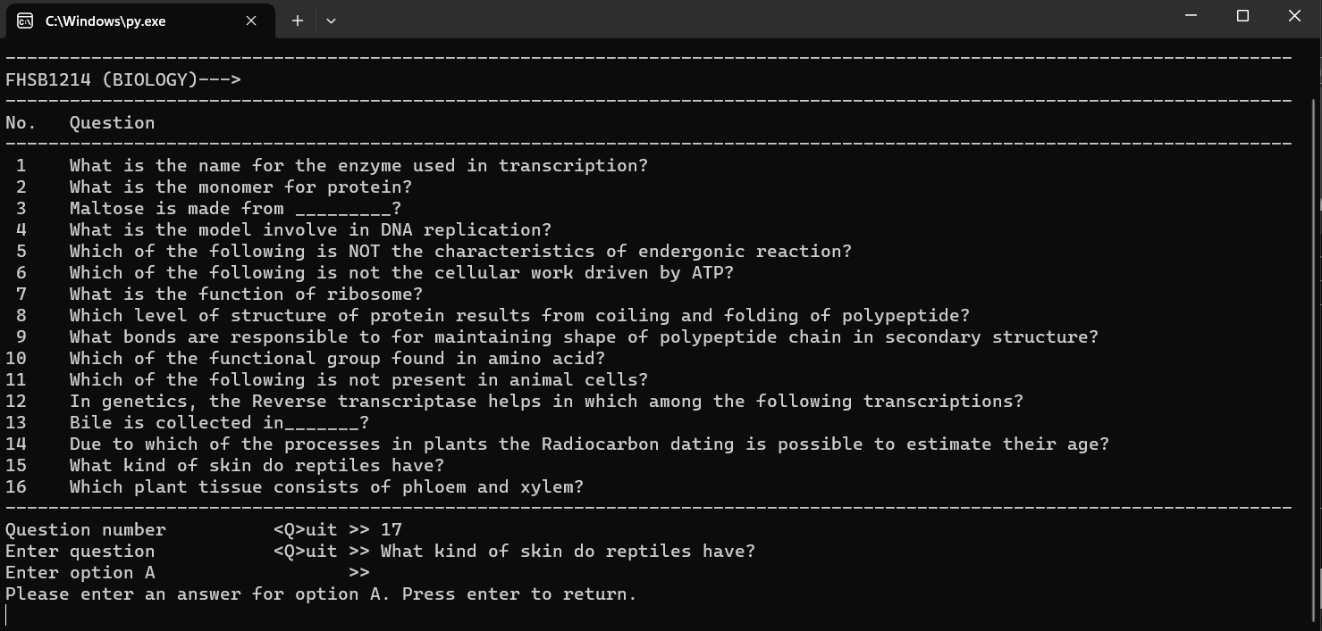

*Invalid answer option entered (Answer for option A,B,C,D entered should not be blank)

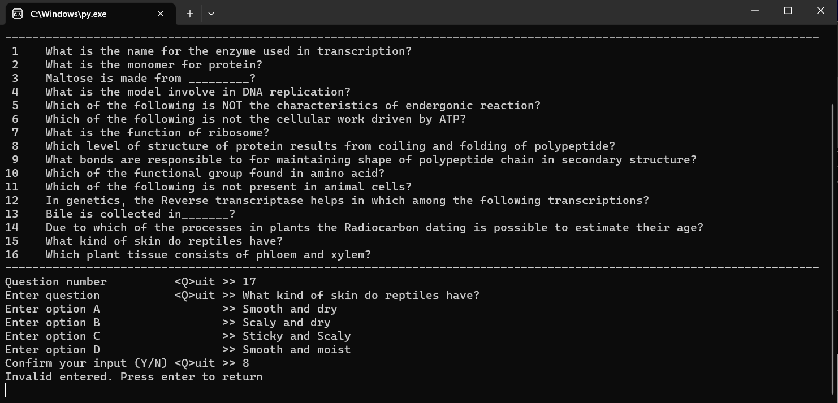

*Invalid confirmation entered (Confirmation entered should not be a digit)

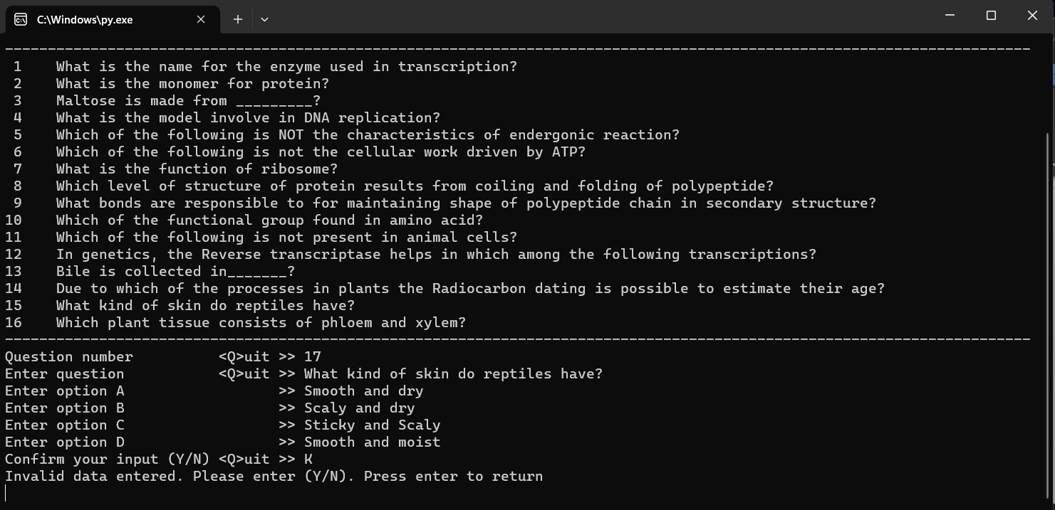

*Invalid confirmation entered (Confirmation entered should not be other than “Y”, “N” or “Q”)

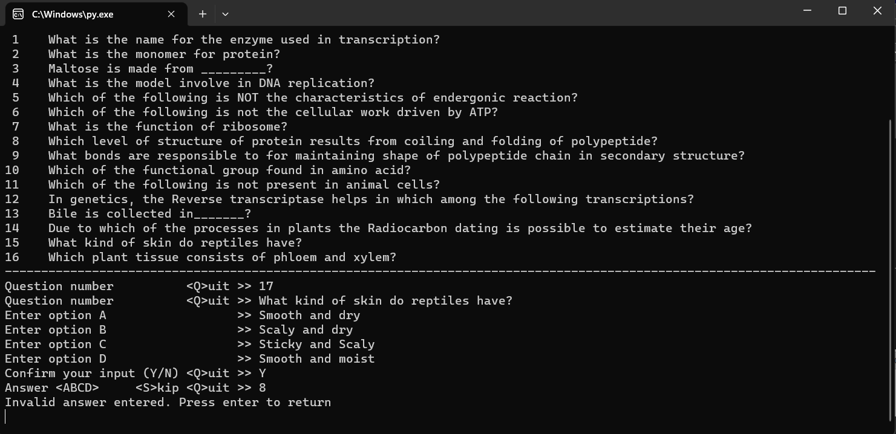

*Invalid answer entered (Answer entered should not be a digit)

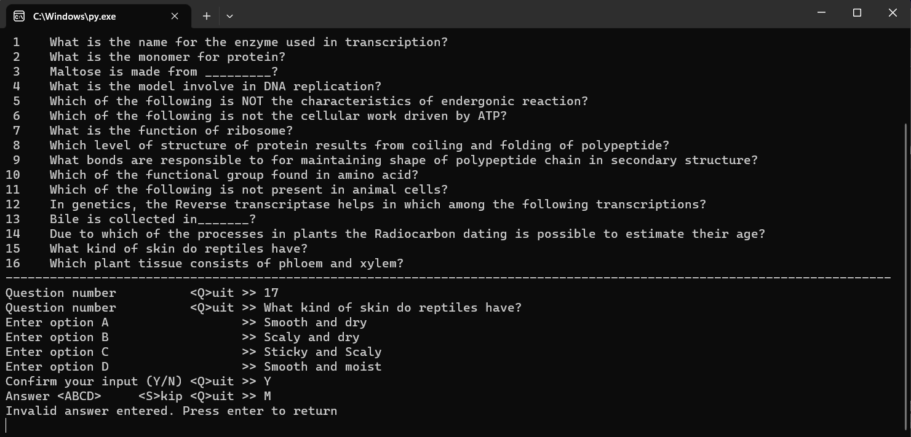

*Invalid answer entered. (Answer entered should not be other than “A”, “B”, “C”, “D”, “S” or “Q”)

4.2 Updating Question

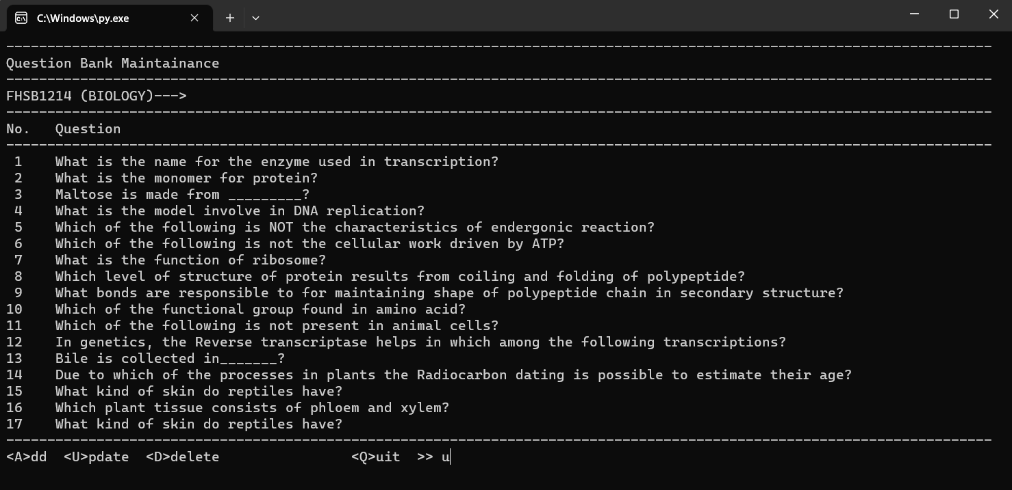

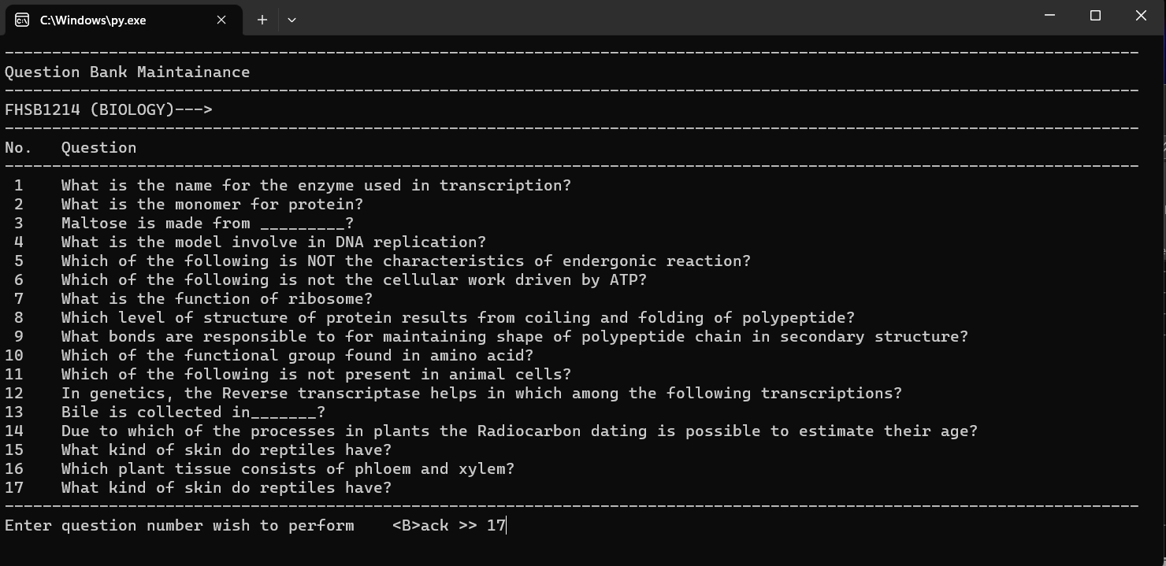

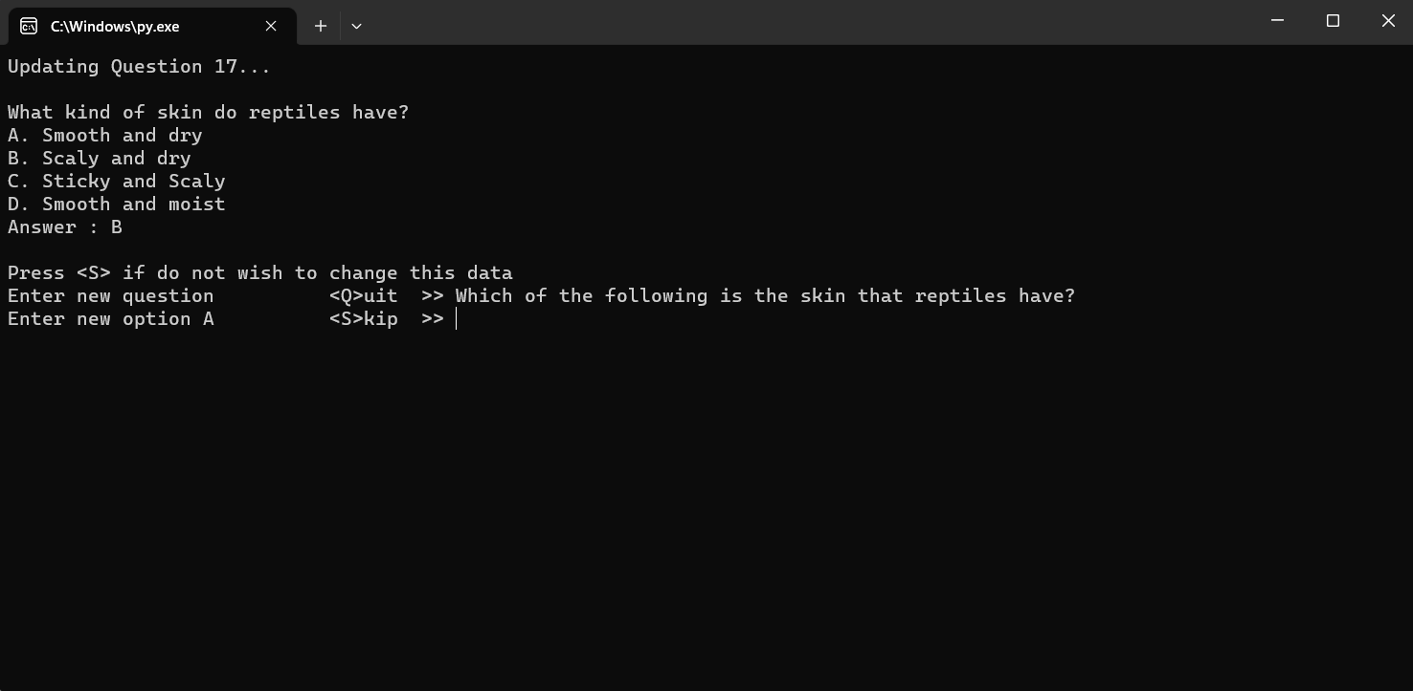

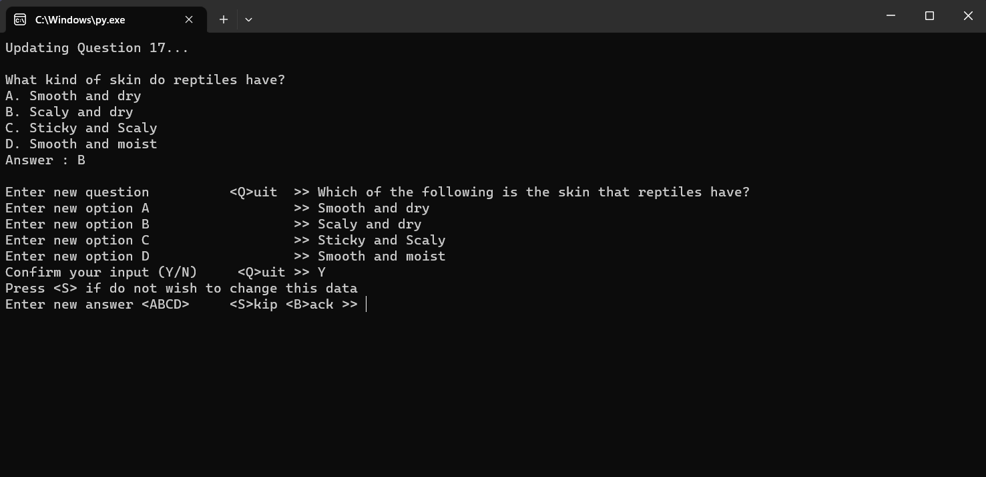

4.2.1 Question Updated

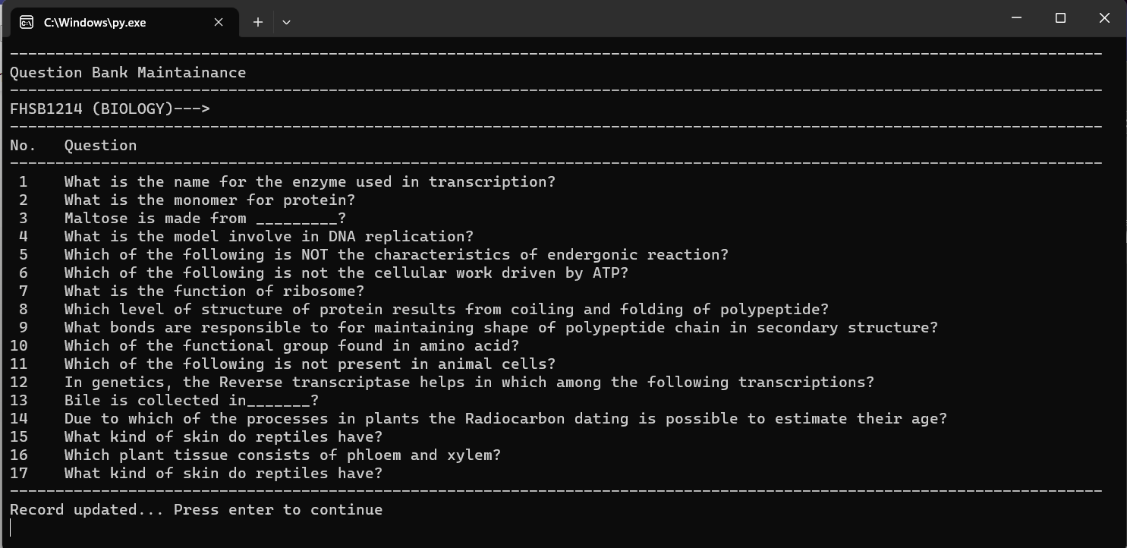

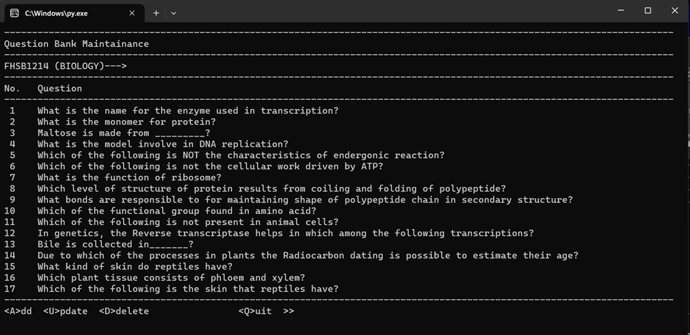

4.2.2 Validation for Updating Question

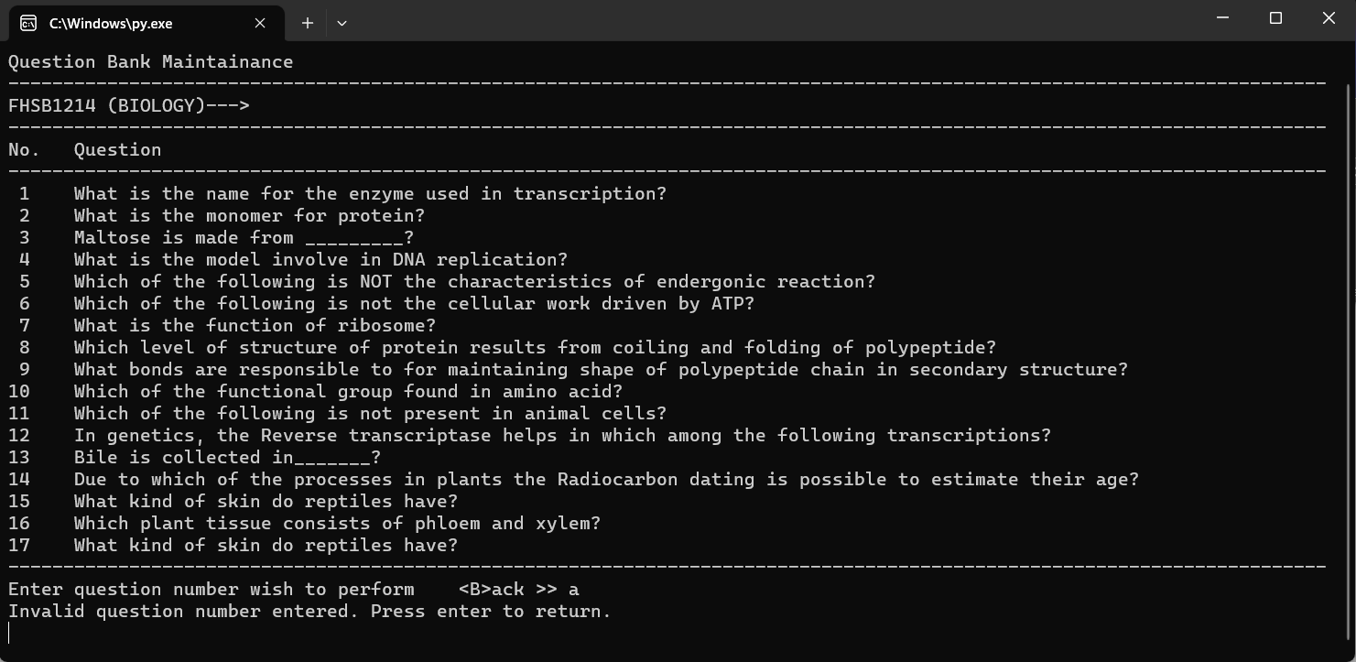

*Invalid question number entered (Question number entered wish to update should be a digit)

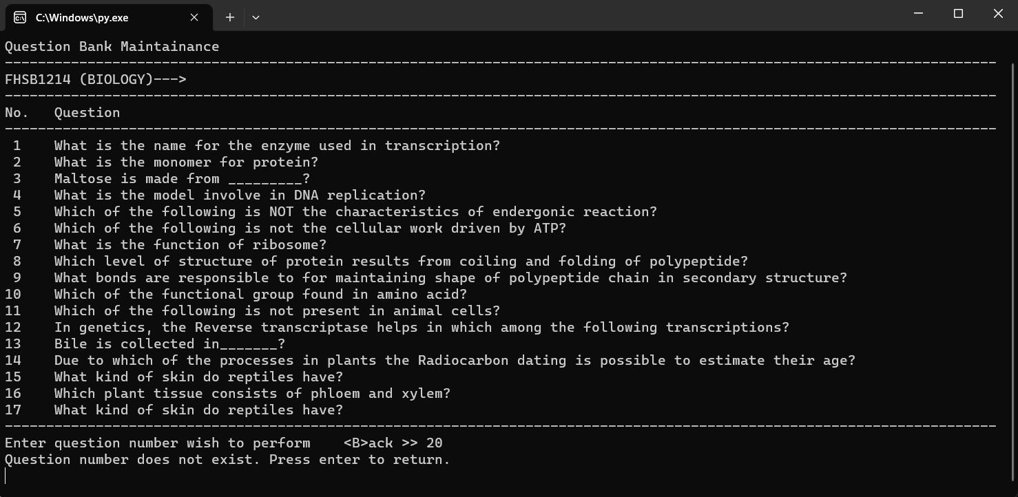

*Invalid question number entered (Question number entered update to delete should be existed)

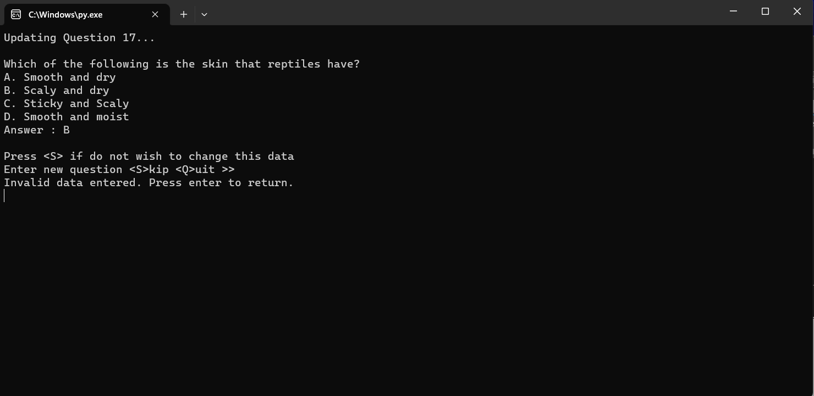

*Invalid question entered (Question wish to update should not be blank)

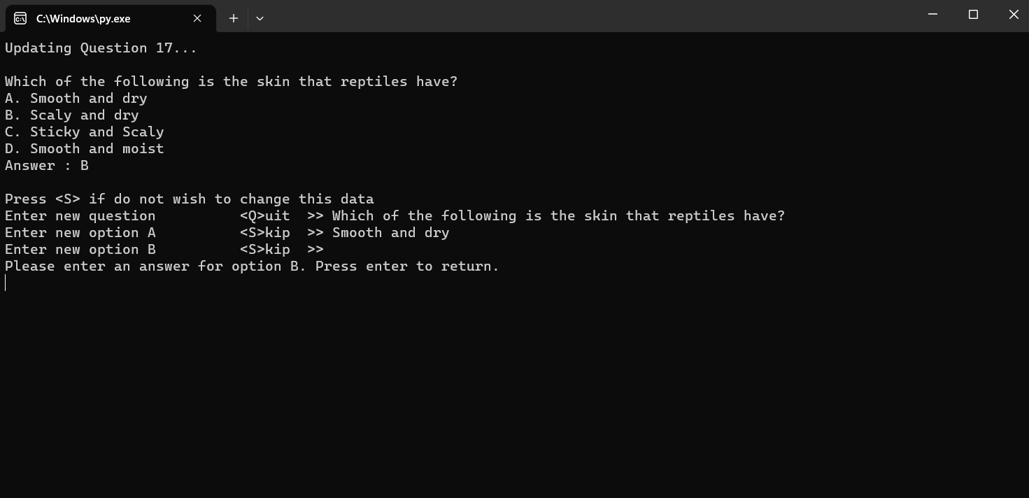

*Invalid answer option entered (Answer for option A, B, C, D entered should not be blank)

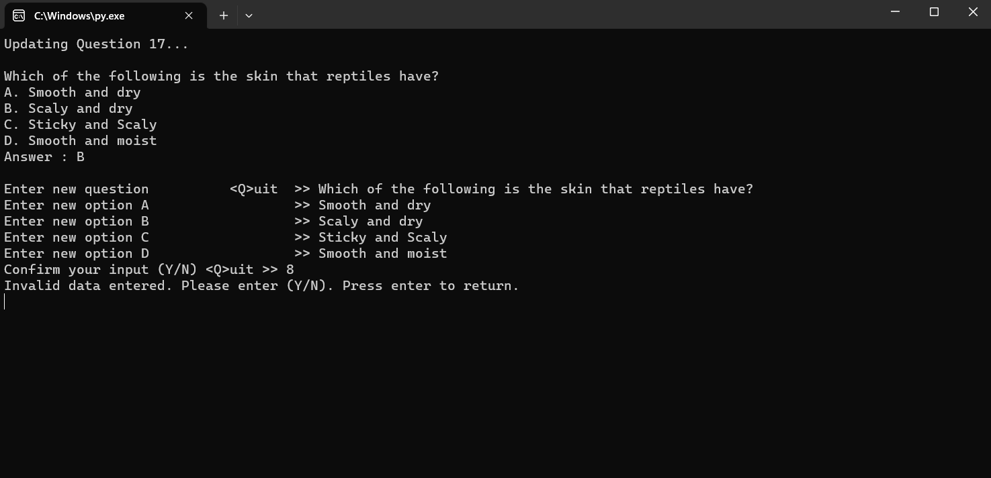

*Invalid confirmation entered (Confirmation entered should not be a digit)

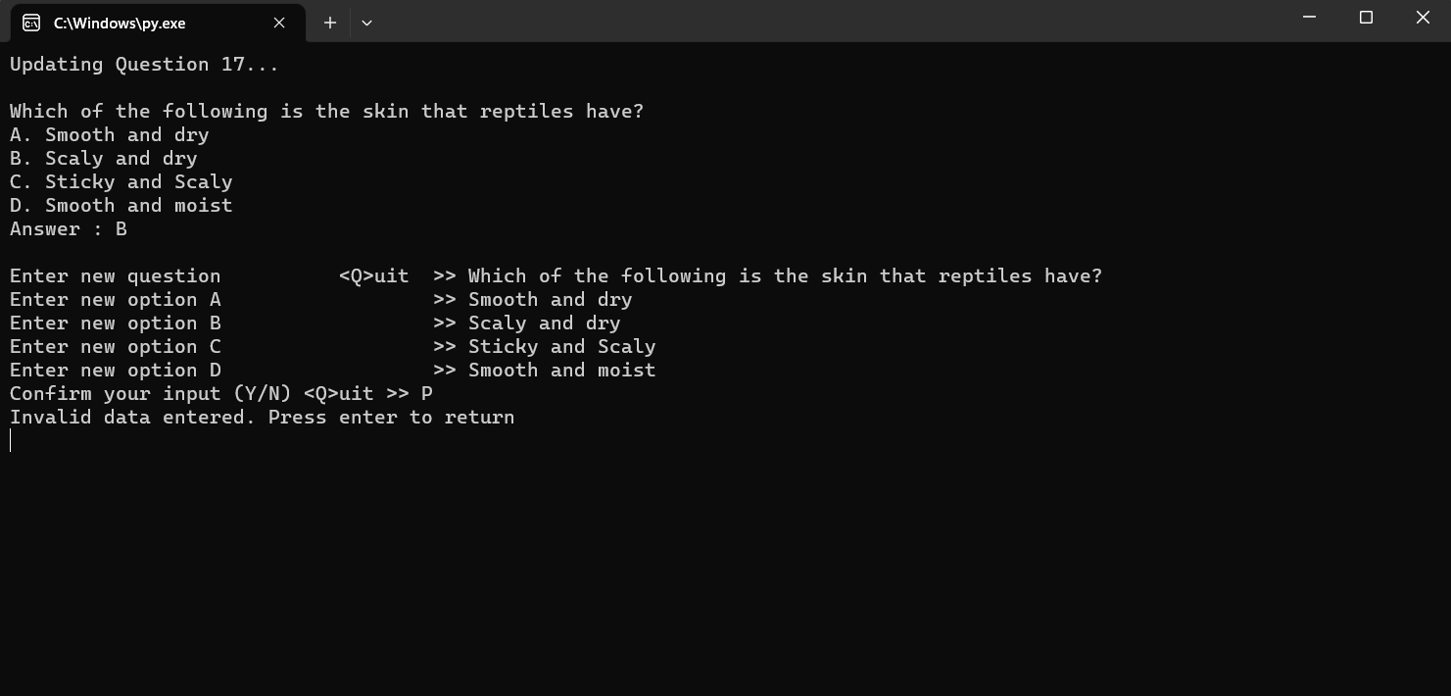

*Invalid confirmation entered (Confirmation entered should not be other than “Y”, “N” or “Q”)

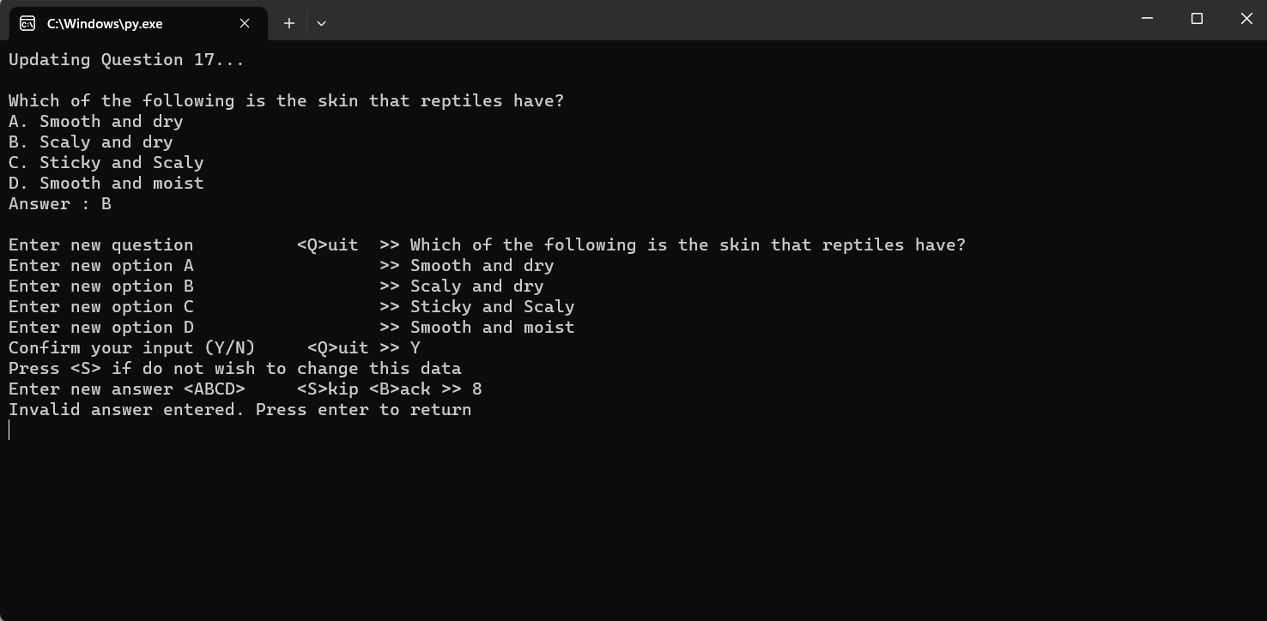

*Invalid answer entered (Answer entered should not be a digit)

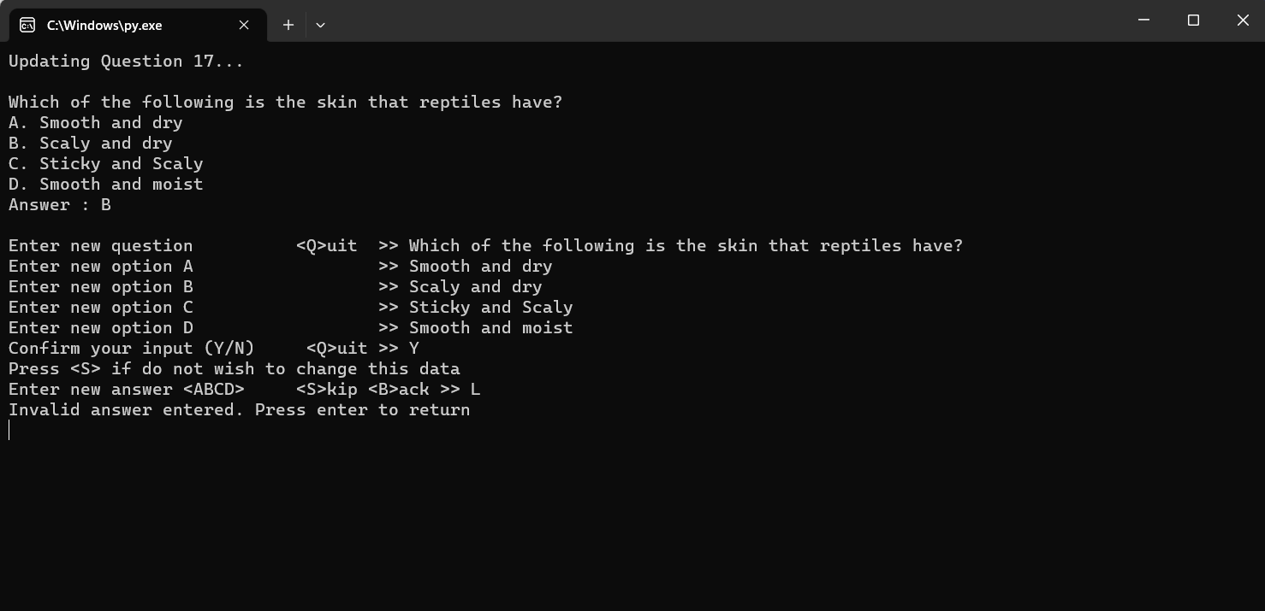

*Invalid answer entered (Answer entered should not be other than “A”, “B”, “C”, “D” or “S” or “B”)

4.3 Deleting Question

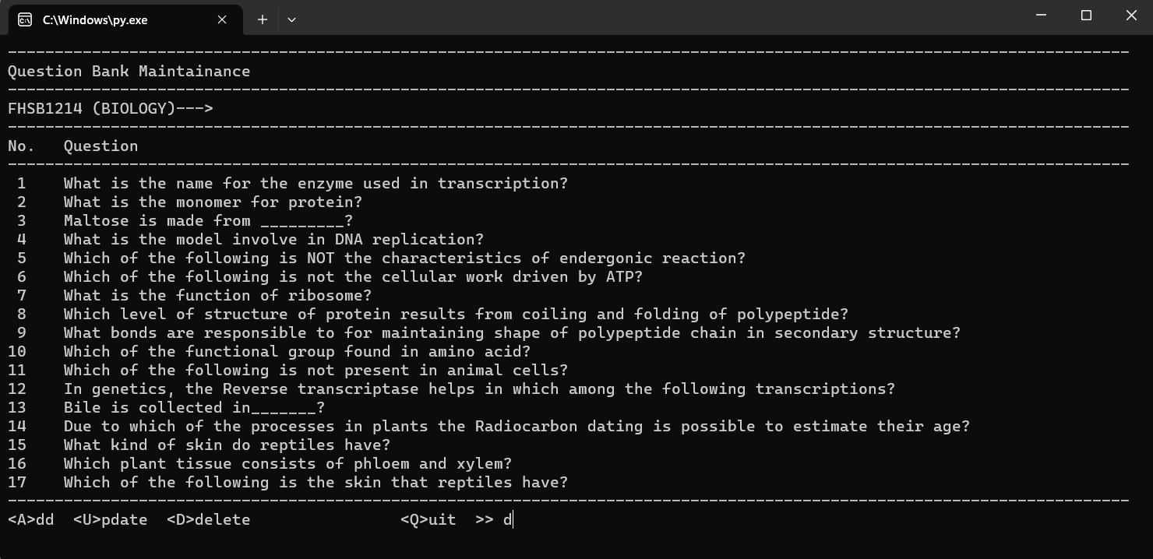

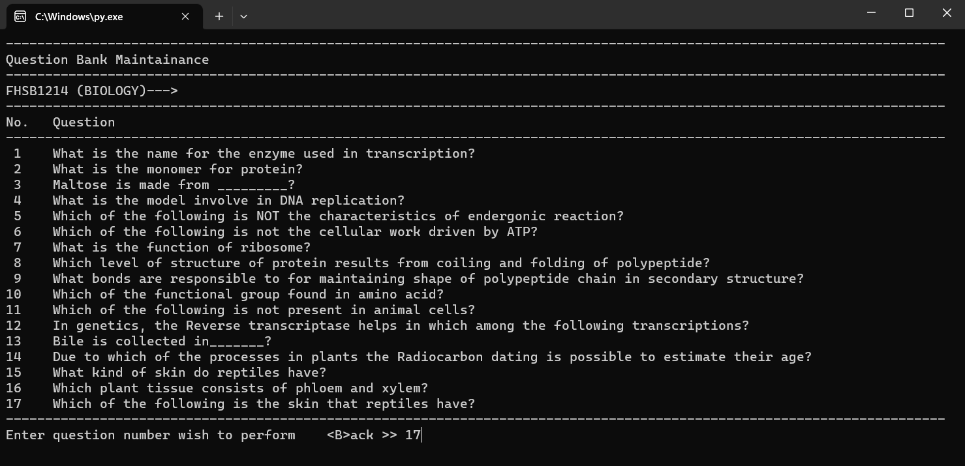

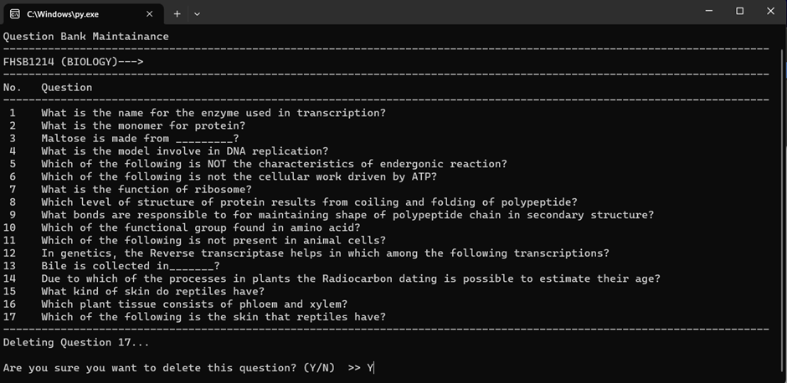

4.3.2 Question Deleted

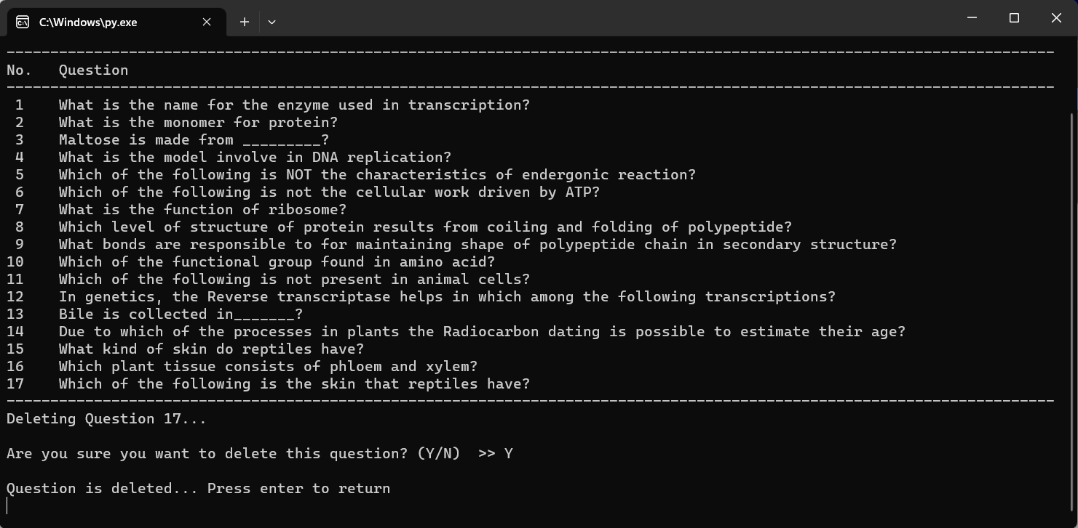

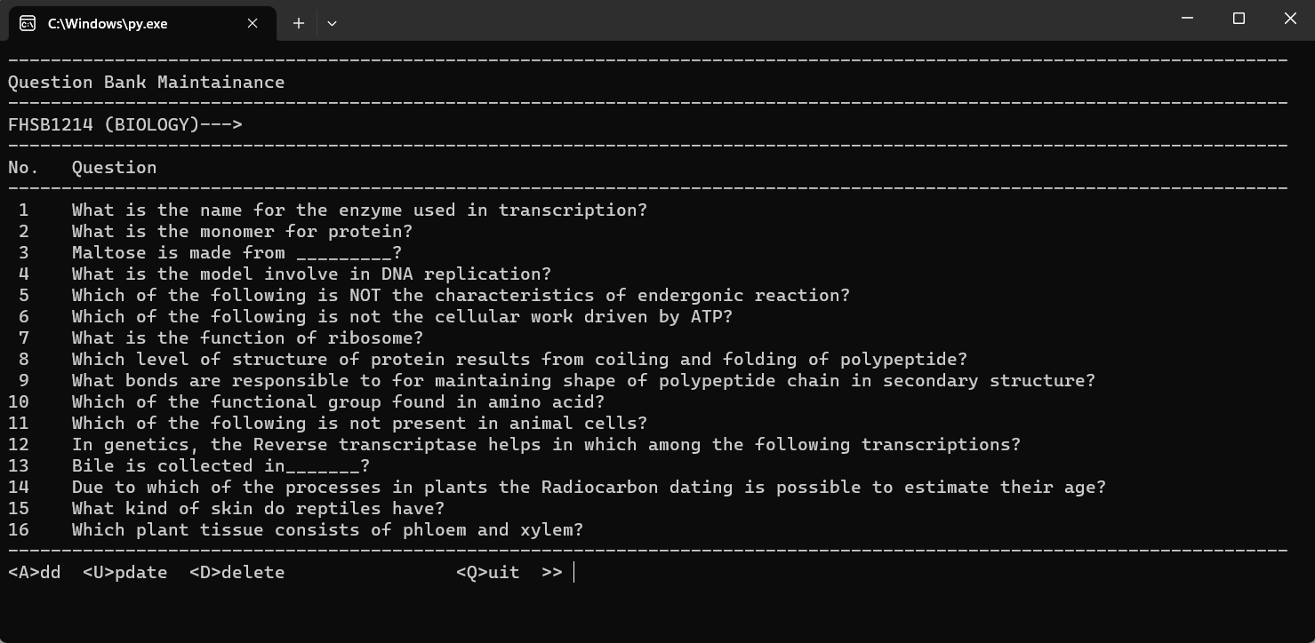

4.3.2 Validation for Deleting Question

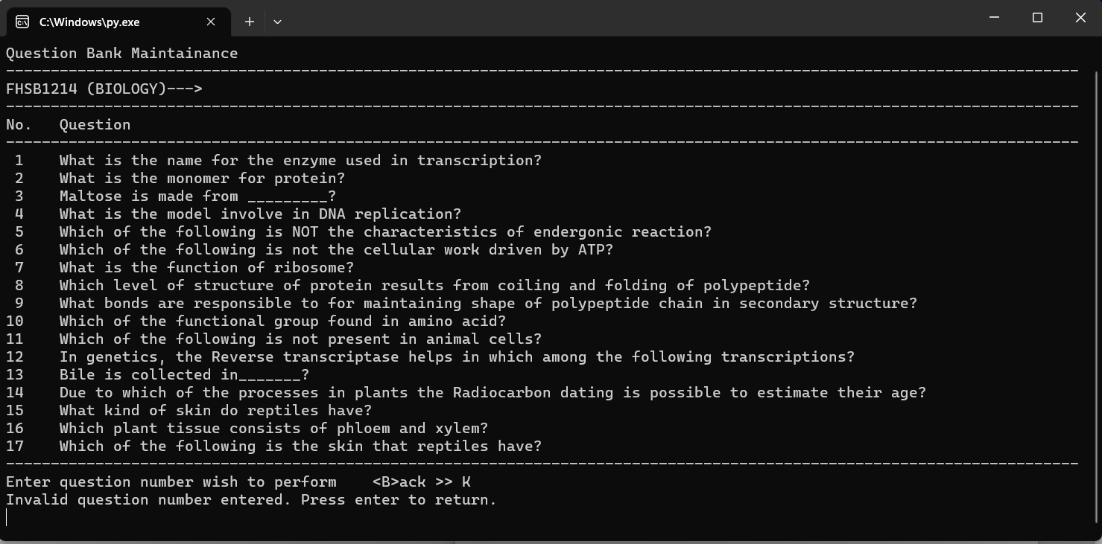

*Invalid question number entered. (Question number entered should be a digit)

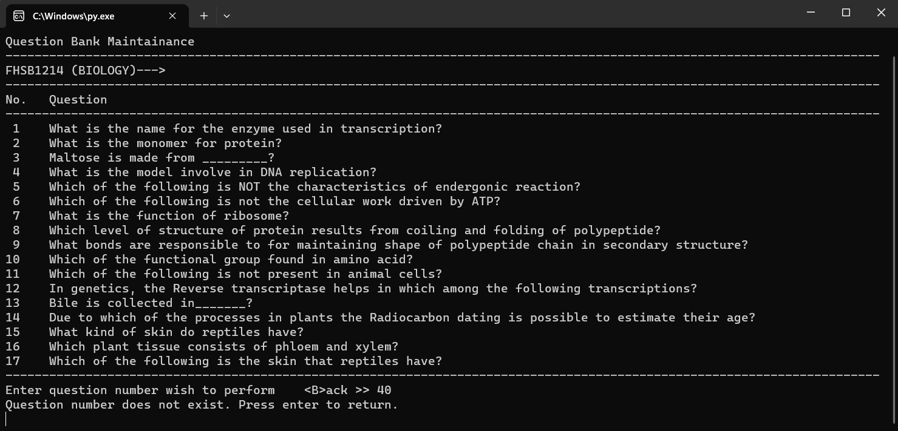

*Invalid question number entered (Question number entered should be existed)

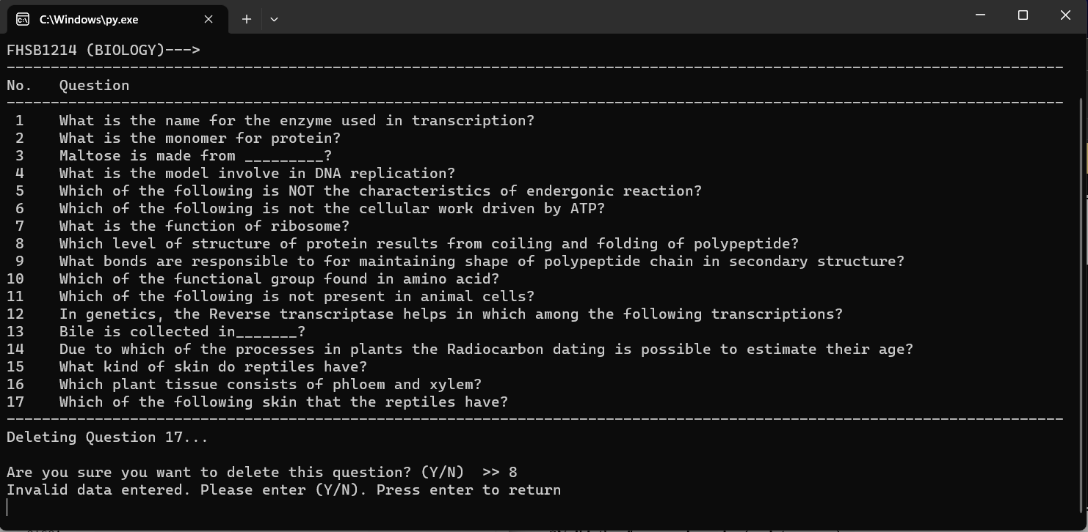

*Invalid confirmation entered (Confirmation entered should not be a digit)

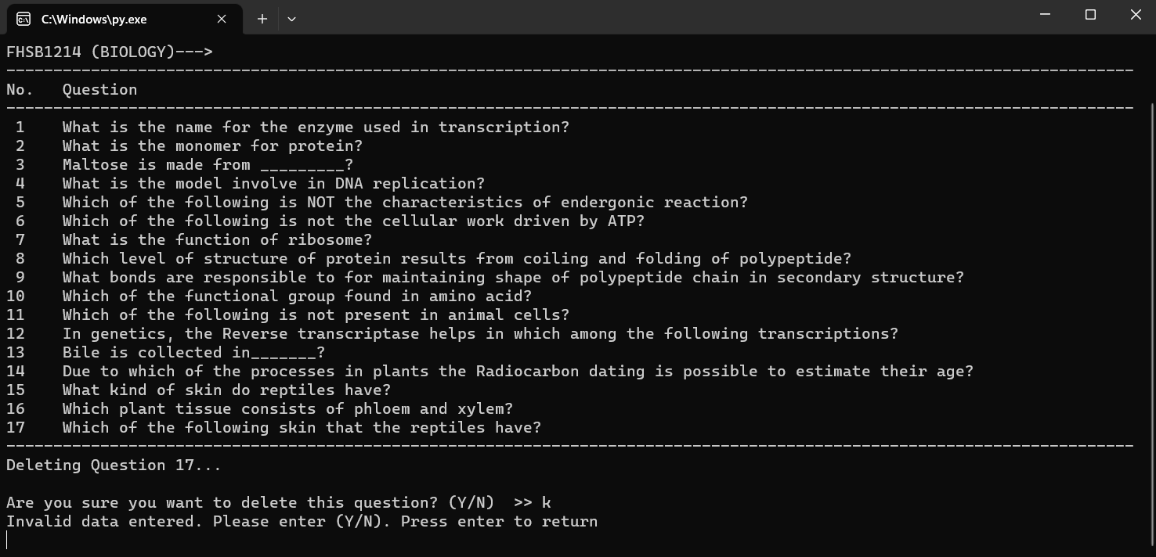

*Invalid confirmation entered (Confirmation entered should be “Y” or “N”)

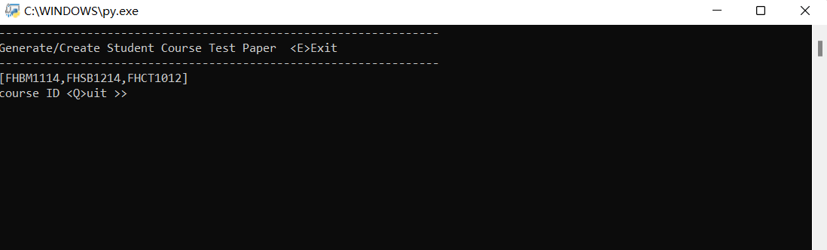5.Test Paper Generation

**\*Test paper generation profile**

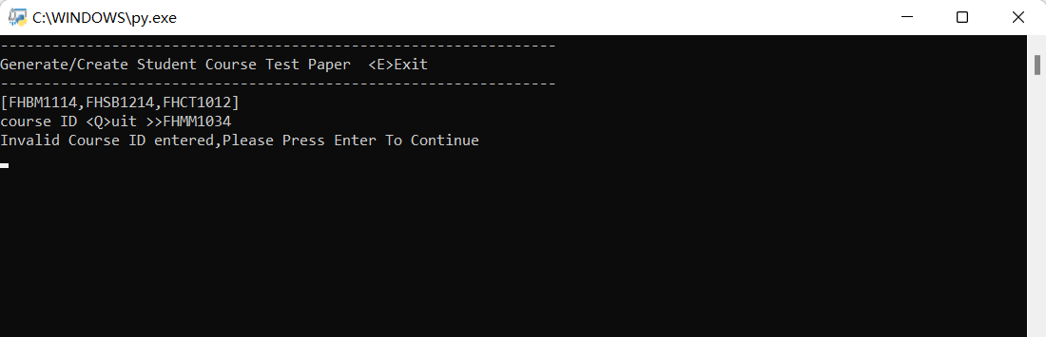

**\*Validation for courseID**

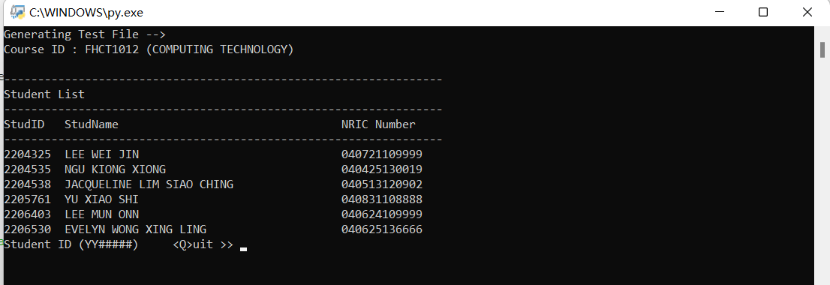

**\*Student list display**

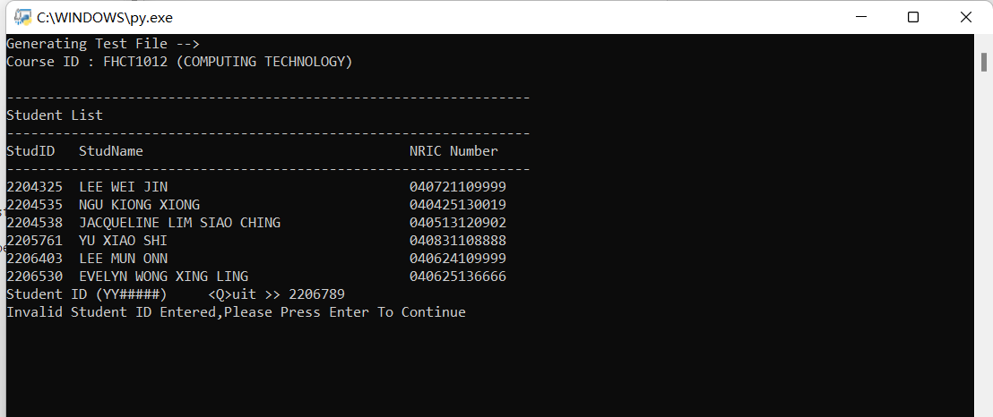

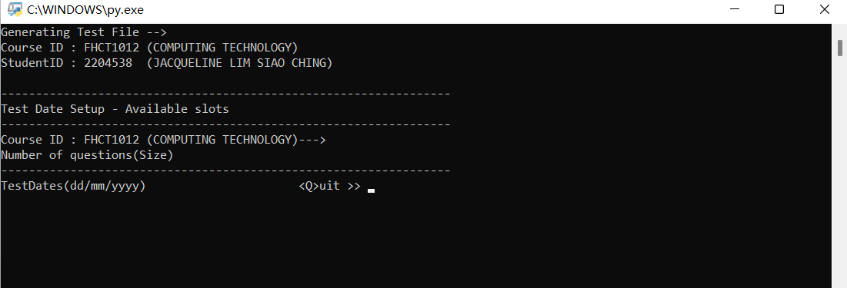**\*Validation for student ID**

**\*Test date setup display**

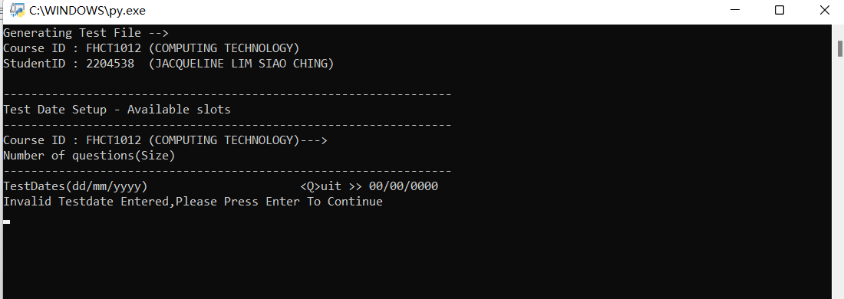

**\*Validation for test date**

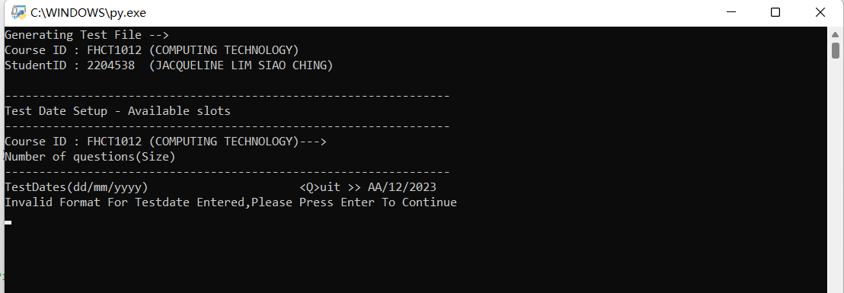

**\*Validation for the length of the test date**

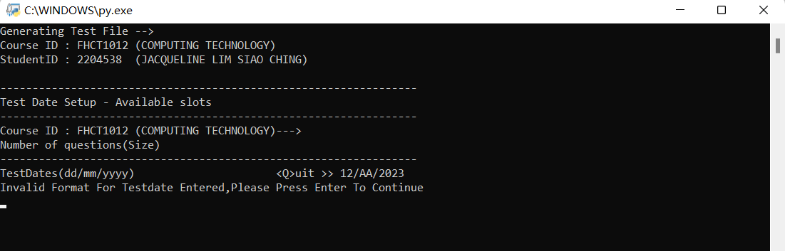

**\*Validation for the format of the test date**

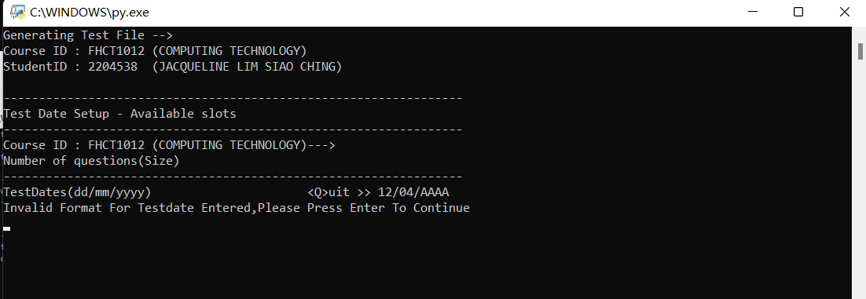

*Validation for the format of test date

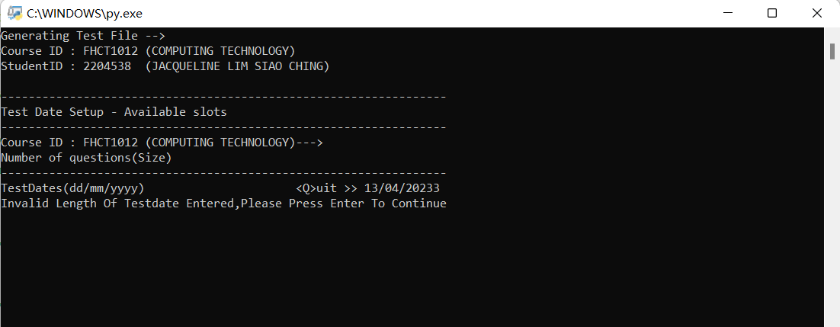

*Validation for the length of test date

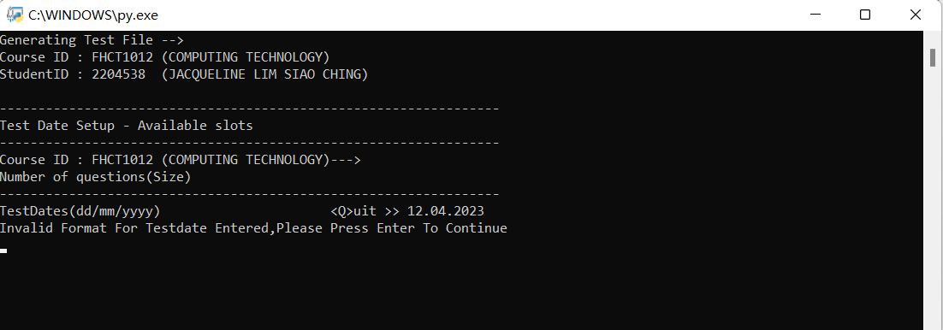

*Validation for the format of test date

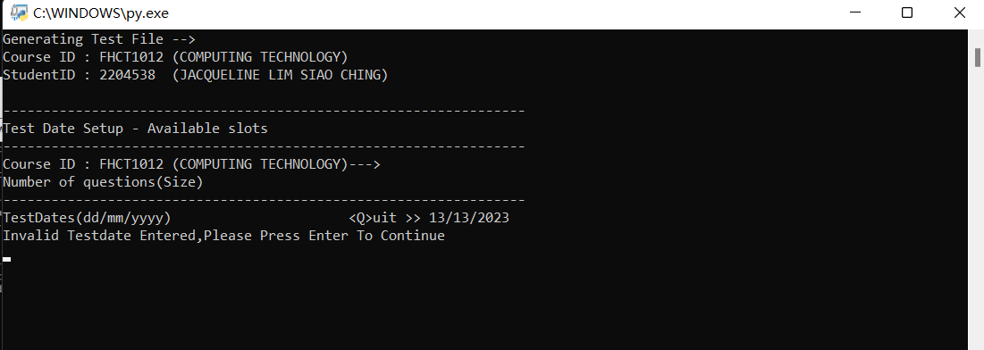

*Validation for test date

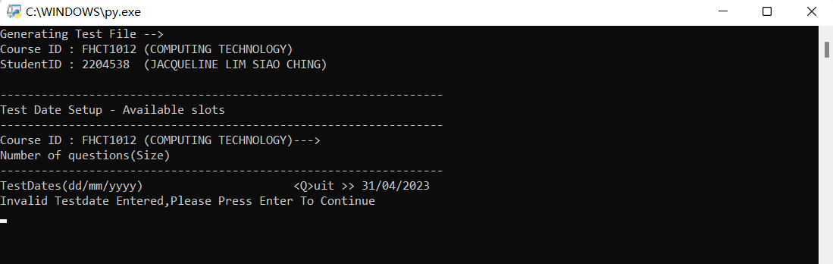

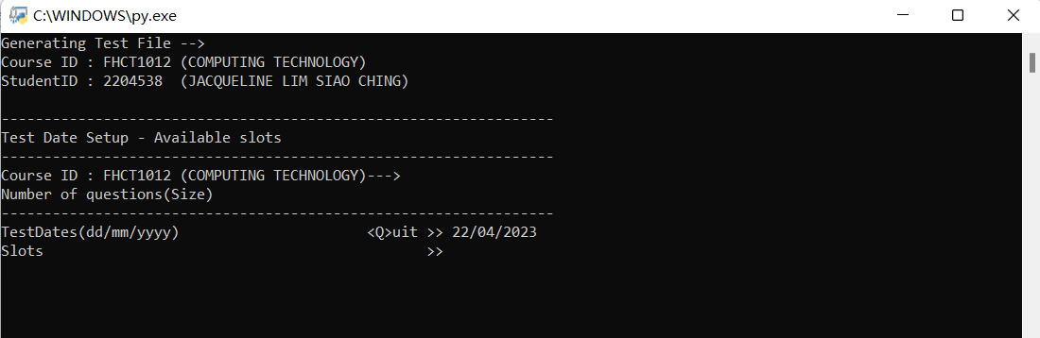*Validation for test date(April has only 30 days)

*Slots input display

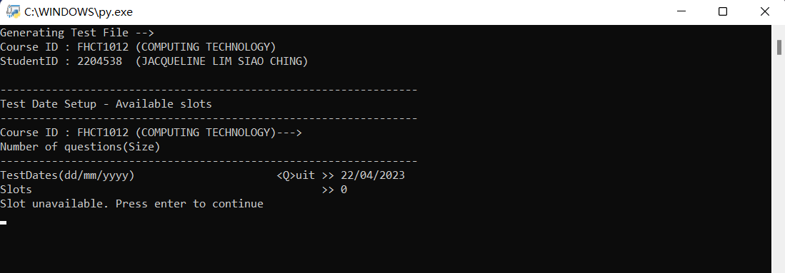

*Validation for slots(0 is unavailable)

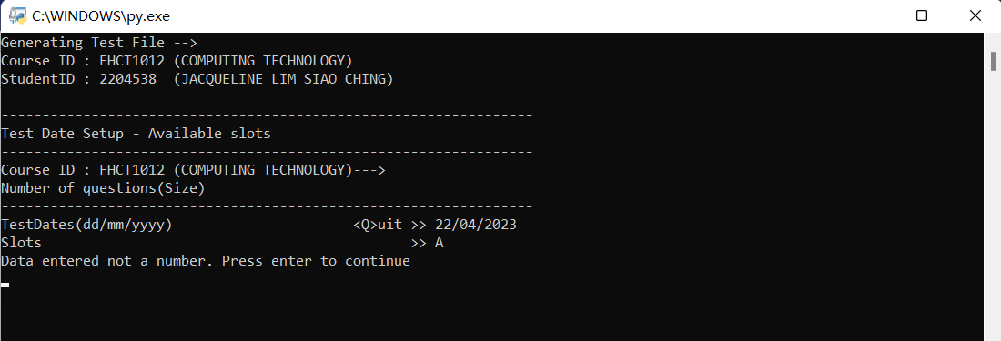*Validation for slots

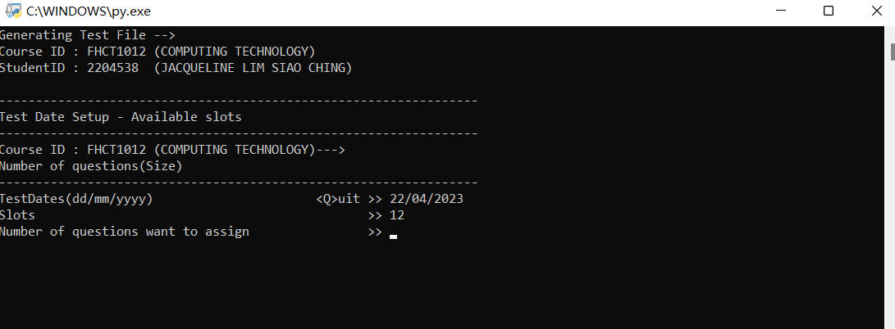

*Question design display

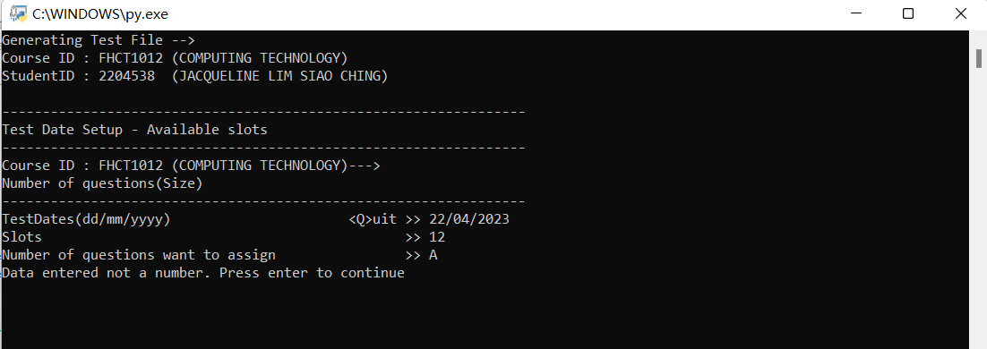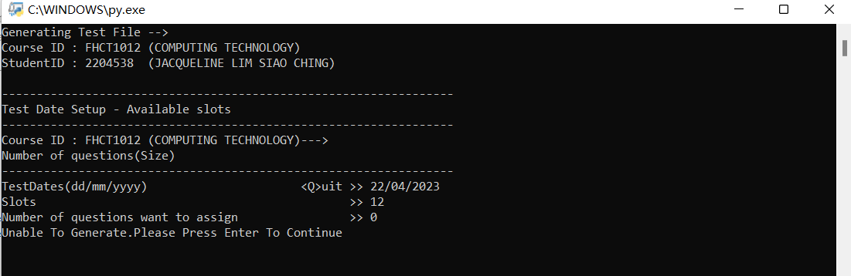

**\*Validation for question want to design ( alphabet is unable)**

*Validation for number of questions (0 is unable to generate)

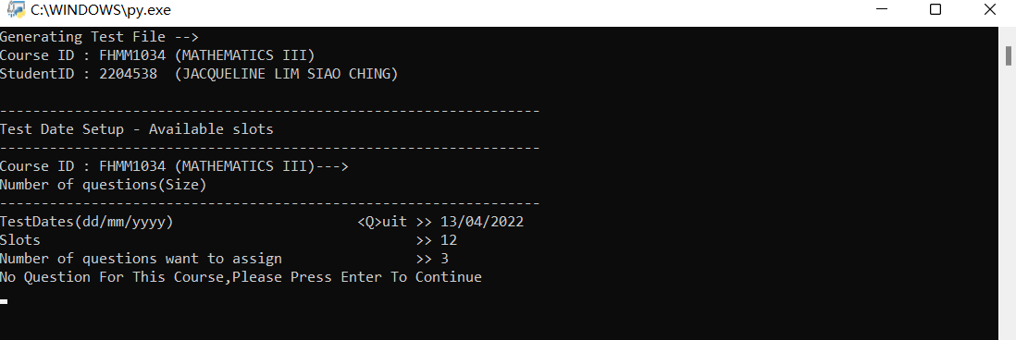

**\*Validation for number of questions (No question for this course)**

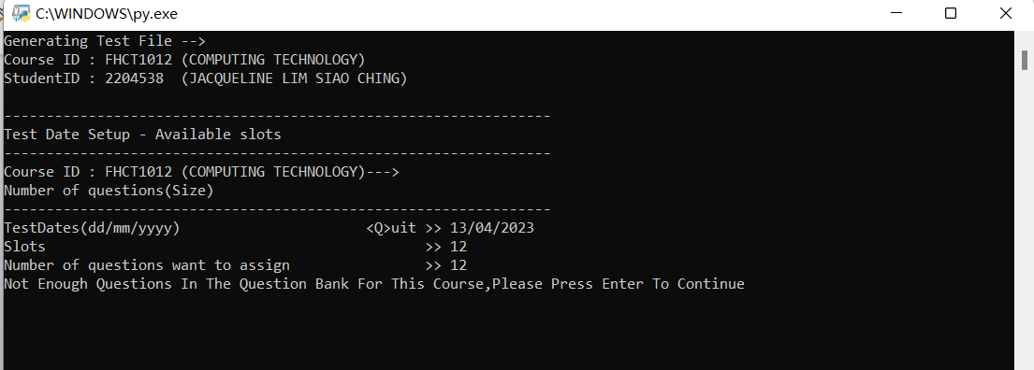*Validation for number of question ( More than the question available)

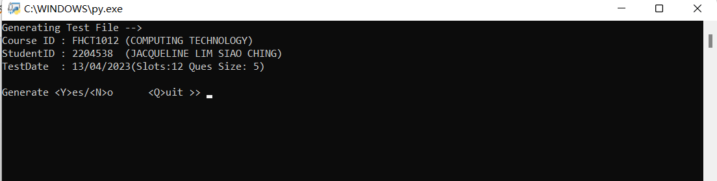*Display for Generation

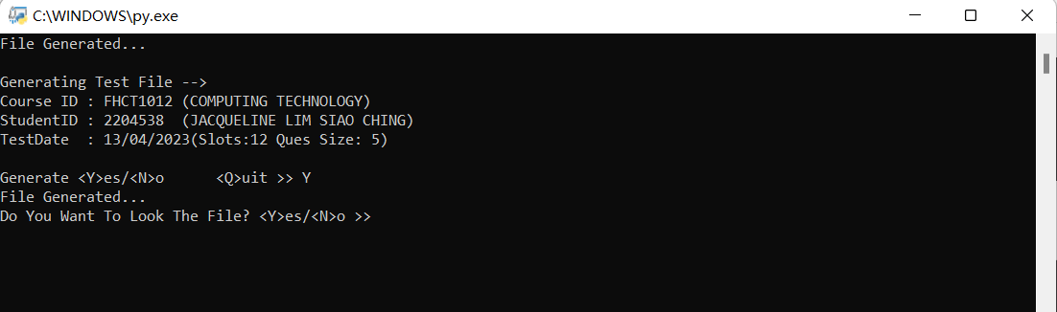* Display for the looking file

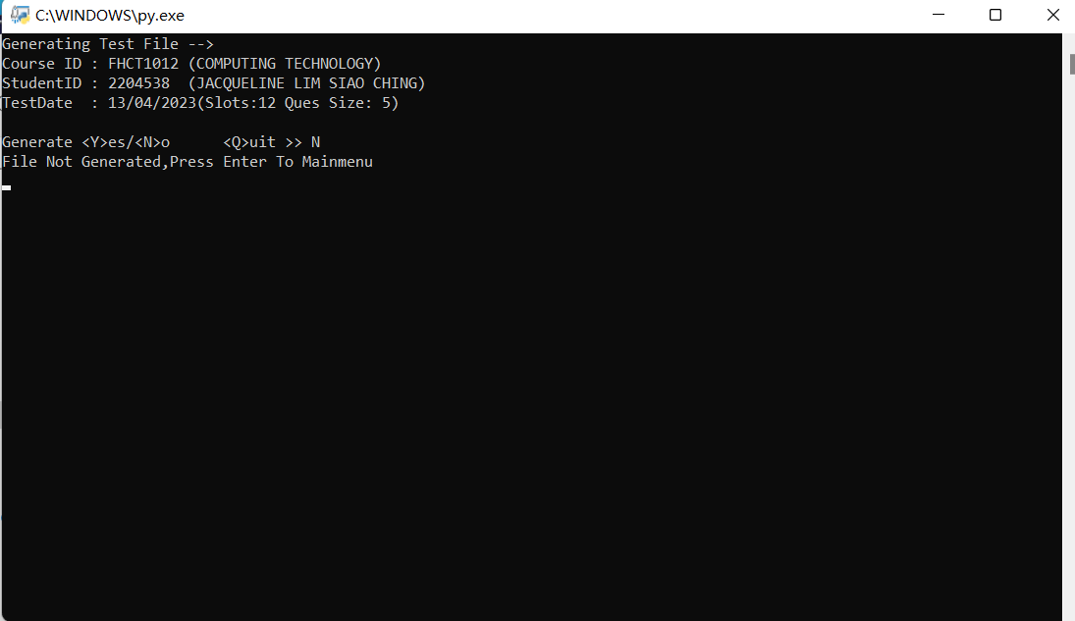

*Display for not generate file

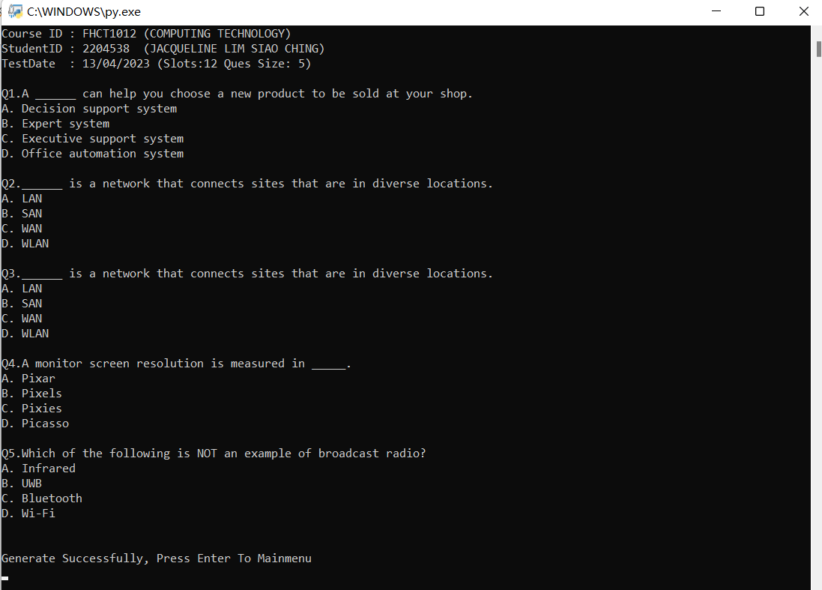*Display for the test paper generated

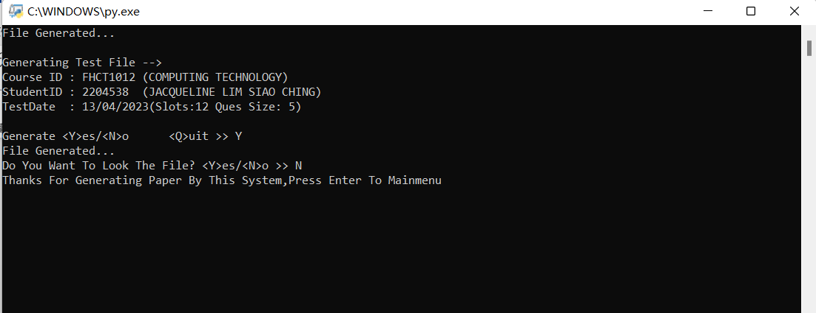*Display for not looking the file

*Display for generated file

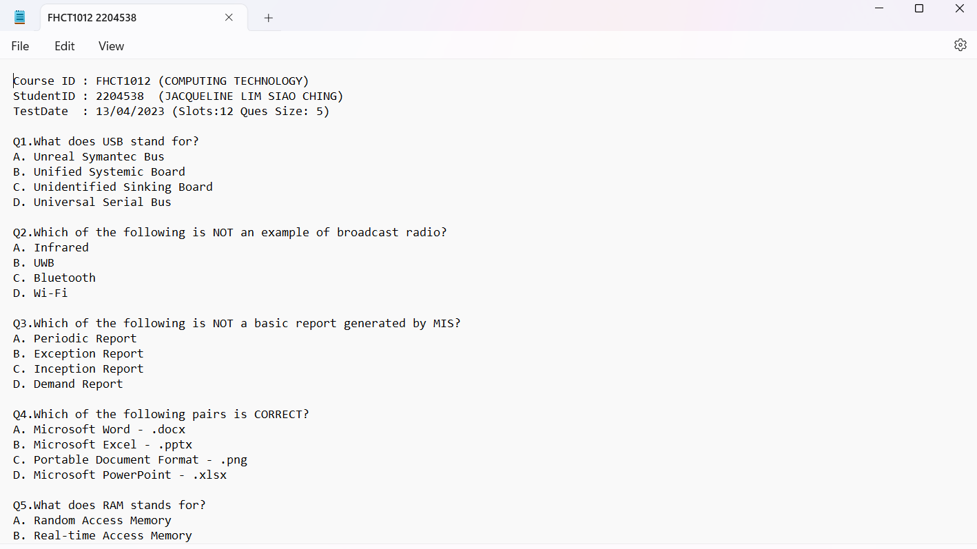

*output

Source-code (program code)

1. **Mainmenu**

#Module/Program name: P1G1mainmenu.py

#date created : 17th March 2023

#created by : Lee Wei Jin, Yu Xiao Shi

#import : os(system clear screen)

#modification : screen will be clear if have invalid input before

# user can input data again

import os

import P1G1student as stud

import P1G1course as course

import P1G1qbank as bank

import P1G1generate as generate

def mainmenu():

cont1="C"

while cont1=="C":

os.system("cls")

print("-"*65)

print("Test Management System --> Process Steps")

print("-"*65)

print("<1>Setup\n"+"<2>Generat Test Paper\n"+"<E>xit\n",end="")

opt=input("option >>").upper()

if opt=="1":

mainask()

elif opt=="2":

generate.genemain()

elif opt=="E":

print ("\nThank you for using the system\nPlease press enter to close the program.")

input()

cont1="Q"

else:

print("\tError.Please enter <1>,<2>,<E>. Press enter to continue")

input()

os.system("cls")

def mainask():

cont2="C"

while cont2=="C":

os.system("cls")

print("-"*65)

print("System Configuration -> Process steps")

print("-"*65)

opt1=input("<1>Student <2>Courses <3>Question Bank <E>xit:").upper()

if opt1=="1":

os.system("cls")

stud.student()

elif opt1=="2":

os.system("cls")

course.courses()

elif opt1=="3":

os.system("cls")

bank.displaymain()

elif opt1=="E":

cont2="Q"

else:

print("\tError.Please enter <1>,<2>,<3>,<E>. Press enter to continue")

input()

mainmenu()

**2.Student maintenance**

#Module/Program name: P1G1student.py

#date created : 16th March 2023

#created by : Yu Xiao Shi

#import : os(system clear screen), json

#modification : check if got any repeated input, can skip an

# input if do not wish to update, student added

# will automatic arrange according the ascending

# order of the student ID order, screen will be

# clear if have invalid input before user can

# input data again

import os, json

def readFile():

import json

f=open("studprofile.txt","r")

lst=json.load(f)

lst.sort()

f.close()

return lst

def saveFile(recLst):

import json

f=open("studprofile.txt","w")

json.dump(recLst,f)

f.close()

return

def isdigit(studNRIC,studID,recID):

status=True

try:

int(studNRIC,studID,recID)

except:

status=False

return status

def displayLst(lst):

f=open("studprofile.txt","r")

print("-"*85)

print("Student Maintenance")

print("-"*85)

if len(lst)==0:

print("No records available")

else:

print(" Num Student ID Student Name NRIC")

print("-"*85)

for i in range(len(lst)):

print("%2s %7s %-40s%12s"%((i+1),lst[i][0],lst[i][1],lst[i][2]))

print("-"*85)

def delUpd(lst,opt):

optLst=["U","D"]

optDLst=["Modify","Delete"]

cont="C"

step=1

while cont=="C":

if step==1:

idx=optLst.index(opt)

os.system("cls")

displayLst(lst)

recID=input("Rec to <Q>uit >> ").upper()

if recID=="Q":

step=99

elif not recID.isdigit():

print("Invalid record number entered. Press enter to continue")

input()

else:

recID=int(recID)

num=[x[0] for x in lst]

if recID>len(num):

print("Not enough data. Press enter to continue")

input()

elif recID==0:

print("Wrong data. Press enter to continue")

input()

else:

studID=lst[recID-1][0]

studName=lst[recID-1][1]

studNRIC=lst[recID-1][2]

step+=1

if step==2:

os.system("cls")

displayLst(lst)

if opt=="D":

print("Enter student ID <Q>uit >> %7s"%studID)

print("Enter student Name <Q>uit >> %s"%studName)

print("Enter student ID <Q>uit >> %12s"%studNRIC)

step=5

else:

print("Press <S> if do not wish to change this data")

print("Record number >> %d"%recID)

nstudID=input("Please enter 7 digit student ID <S>kip <Q>uit >>").upper()

sLst=[x[0] for x in lst]

if nstudID=="Q":

step=99

elif nstudID=="S":

nstudID=studID

step +=1

elif not nstudID.isdigit():

print("Data entered not a number. Press enter to continue")

input()

elif not len(str(nstudID)) == 7:

print("Data entered not a 7 digit number. Press enter to continue")

input()

else:

if nstudID in sLst:

print("Student ID repeated. Press enter to continue")

input()

else:

step= step+1

if step==3:

os.system("cls")

displayLst(lst)

print("Press <S> if do not wish to change this data")

print("Record number >> %d"%recID)

print("Please enter student's ID <S>kip <Q>uit >> %s"%nstudID)

validCharacters="abcdefghijklmnopqrstuvwxyzABCDEFGHIJKLMNOPQRSTUVWXYZ "

nstudName=input("Please enter student's name <S>kip <Q>uit >>").upper()

sLst=[x[1] for x in lst]

if nstudName=="Q":

step=99

elif nstudName.upper()=="S":

nstudName=studName

step +=1

elif nstudName=="":

print("Data entered cannot be blank. Press enter to continue")

input()

elif all(char in validCharacters for char in nstudName):

if nstudName in sLst:

print("Student name repeated. Press enter to continue")

input()

else:

step +=1

else:

print("Error with data entered.Please enter data without any digit or punctuation mark. Press enter to continue")

input()

if step==4:

os.system("cls")

displayLst(lst)

print("Press <S> if do not wish to change this data")

print("Record number >> %d"%recID)

print("Please enter student's ID <S>kip <Q>uit >> %s"%nstudID)

print("Please enter student's name <S>kip <Q>uit >> %s"%nstudName)

nstudNRIC=input("Please enter 12 digit IC number without dash <S>kip <Q>uit >>").upper()

sLst=[x[2] for x in lst]

if nstudNRIC=="Q":

step=99

elif nstudNRIC.upper()=="S":

nstudNRIC=studNRIC

step +=1

elif not str(nstudNRIC).isdigit():

print("Data entered not a number. Press enter to continue")

input()

elif not len(str(nstudNRIC)) == 12:

print("Data entered not a 12 digit number. Press enter to continue")

input()

else:

if nstudNRIC in sLst:

print("Student NRIC repeated. Press enter to continue")

input()

else:

step= step+1

if step==5:

if opt=="D":

lst.pop(recID-1)

print("Record deleted. Press enter to continue")

input()

else:

os.system("cls")

displayLst(lst)

print("Record number >> %d"%recID)

print("Student ID >> %s"%nstudID)

print("Student Name >> %s"%nstudName)

print("Student NRIC >> %s"%nstudNRIC)

recID=int(recID)

lst[recID-1]=[nstudID,nstudName,nstudNRIC]

print("Record updated. Press enter to continue")

input()

step=1

if step==99:

os.system("cls")

cont=False

return lst

def addstudent(lst):

cont="C"

step=1

while cont=="C":

if step==1:

os.system("cls")

displayLst(lst)

studID=input("Please enter 7 digit student ID <Q>uit >> ")

sLst=[x[0] for x in lst]

if studID in ["Q","q"]:

step=99

elif not studID.isdigit():

print("Data entered not a number. Press enter to continue")

input()

elif not len(str(studID)) == 7:

print("Data entered not a 7 digit number. Press enter to continue")

input()

else:

if studID in sLst:

print("Student ID repeated. Press enter to continue")

input()

else:

step= step+1

if step==2:

os.system("cls")

displayLst(lst)

print("Please enter 7 digit student ID <Q>uit >> %s"%studID)

validCharacters="abcdefghijklmnopqrstuvwxyzABCDEFGHIJKLMNOPQRSTUVWXYZ "

studName=input("Please enter student's name <Q>uit >> ").upper()

sLst=[x[1] for x in lst]

if studName in ["Q","q"]:

step=99

elif studName=="":

print("Data entered cannot be blank. Press enter to continue")

input()

elif all(char in validCharacters for char in studName):

if studName in sLst:

print("Student name repeated. Press enter to continue")

input()

else:

step +=1

else:

print("Error with data entered.Please enter data without any digit or punctuation mark. Press enter to continue.")

input()

if step==3:

os.system("cls")

displayLst(lst)

print("Please enter 7 digit student ID <Q>uit >> %s"%studID)

print("Please enter student's name <Q>uit >> %s"%studName)

studNRIC=input("Please enter 12 digit IC number without dash <Q>uit >> ")

sLst=[x[2] for x in lst]

if studNRIC in ["Q","q"]:

step=99

elif not str(studNRIC).isdigit():

print("Data entered not a number. Press enter to continue.")

input()

elif not len(str(studNRIC)) == 12:

print("Data entered not a 12 digit number. Press enter to continue.")

input()

else:

if studNRIC in sLst:

print("Student NRIC repeated. Press enter to continue")

input()

else:

step= step+1

if step==4:

os.system("cls")

displayLst(lst)

print("Student ID >> %s"%studID)

print("Student Name >> %s"%studName)

print("Student NRIC >> %s"%studNRIC)

print("Record added. Press enter to continue")

input()

lst.append([studID, studName, studNRIC])

f=open("studprofile.txt","a")

f.write(str(lst.append))

f.close()

os.system("cls")

return lst

if step==99:

os.system("cls")

cont=False

return lst

def student():

loop=True

recLst=readFile()

while loop:

displayLst(recLst)

opt=input("<A>dd <U>pdate <D>delete <Q>uit >> ").upper()

if opt=="Q":

loop=False

elif opt=="A":

recLst=addstudent(recLst)

recLst.sort()

saveFile(recLst)

elif opt in ["U","D"]:

recLst=delUpd(recLst,opt)

recLst.sort()

saveFile(recLst)

else:

print("Error.Please enter <A>, <U>, <D> or <Q>. Press enter to continue")

input()

os.system("cls")

if __name__=="__main__":

student()

**3. Course maintenance**

#Module/Program name:P1G1course.py

#date created :17th March 2023

#created by :Lee Wei Jin

#import :os(system clear screen),json

#modification :no repeated input(course code and course name),

# arrange course code added or updated according alphabet,

# skip if do not wish to update course code or course name, # clear screen after every input

import os, json

def displayLst(lst):

print("-"*65)

print("Courses Maintenance")

print("-"*65)

if len(lst)==0:

print("No records available")

else:

print("Num Code Description")

print("-"*65)

for i in range(len(lst)):

print("%2d %s %s"%((i+1),lst[i][0],lst[i][1]))

print("-"*65)

def delUpd(lst,opt):

optLst =["U","D"]

optDLst=["Modify","Delete"]

cont="C"

step=1

while cont=="C":

if step==1:

idx=optLst.index(opt)

os.system("cls")

displayLst(lst)

recID=input("Rec to Stop <Q>uit >> ").upper()

if recID=="Q":

step=99

elif not recID.isdigit():

print("Invalid record number entered. Press enter to continue")

input()

os.system("cls")

displayLst(lst)

else:

recID=int(recID)

num=[x[0] for x in lst]

if recID > len(num):

print("Not enough course. Press enter to continue")

input()

elif recID==0:

print("Wrong data. Press enter to continue")

input()

else:

code =lst[recID-1][0]

course=lst[recID-1][1]

step +=1

if step==2:

os.system("cls")

displayLst(lst)

if opt=="D":

print("Enter course code <Q>uit >> %s"%code)

print("Enter course name <Q>uit >> %s"%course)

step=4

else:

print("Press <S> if do not wish to change this data")

print("Record number >> %d"%recID)

ncode=input("Please enter course code <S>kip <Q>uit >> ").upper()

clst=[x[0] for x in lst]

if ncode=="Q":

step=99

elif ncode=="S":

ncode=code

step +=1

elif ncode[4:8].isdigit() and ncode[:4].isalpha():

if len(ncode)!=8:

print("Data entered must have 4 alphabets before 4 digits. Press enter to continue")

input()

elif ncode in clst:

print("Course code repeated. Press enter to continue")

input()

else:

step+=1

else:

print("Data entered must have 4 alphabets before 4 digits. Press enter to continue")

input()

if step==3:

os.system("cls")

displayLst(lst)

print("Press <S> if do not wish to change this data")

print("Record number >> %d"%recID)

print("Please enter course code <S>kip <Q>uit >> %s"%ncode)

validCharacters="abcdefghijklmnopqrstuvwxyzABCDEFGHIJKLMNOPQRSTUVWXYZ "

ncourse = input("Enter course name Stop <S>kip <Q>uit >> ").upper()

nlst=[x[1] for x in lst]

if ncourse=="Q":

step=99

elif ncourse=="S":

ncourse=course

step +=1

elif ncourse=="":

print("Error with data entered.Please enter data without any digit or punctuation mark. Press enter to continue.")

input()

print("Record number >> %d"%recID)

print("Enter course code <S>kip <Q>uit >> %s"%ncode)

elif all(char in validCharacters for char in ncourse):

if ncourse in nlst:

print("Course name repeated. Press enter to continue")

input()

else:

step+=1

else:

print("Error with data entered.Please enter data without any digit or punctuation mark. Press enter to continue.")

input()

print("Record number >> %d"%recID)

print("Enter course code <S>kip <Q>uit >> %s"%ncode)

if step==4:

if opt=="D":

lst.pop(recID-1)

print("Record deleted. Press enter to continue")

input()

else:

os.system("cls")

displayLst(lst)

print("Record number >> %d"%recID)

print("Course Code <Q>uit >> %s"%ncode)

print("Course name <Q>uit >> %s"%ncourse)

recID=int(recID)

lst[recID-1]=[ncode, ncourse]

print("Record updated. Press enter to continue")

input()

step=1

if step==99:

os.system("cls")

cont="Q"

return lst

def addcourse(lst):

cont="C"

step=1

while cont=="C":

if step==1:

os.system("cls")

displayLst(lst)

code=input("Enter course code added <Q>uit >>").upper()

clst=[x[0] for x in lst]

if code=="Q":

step=99

else:

if code[4:8].isdigit() and code[:4].isalpha():

if code in clst:

print("Course code repeated.Press enter to continue.")

input()

elif len(code)!=8:

print("Data entered must have 4 alphabets before 4 digits. Press enter to continue")

input()

else:

step+=1

else:

print("Data entered must have 4 alphabets before 4 digits. Press enter to continue")

input()

if step==2:

os.system("cls")

displayLst(lst)

print("Enter the course code <Q>uit >> %s"%code)

validCharacters="abcdefghijklmnopqrstuvwxyzABCDEFGHIJKLMNOPQRSTUVWXYZ "

course = input("Enter course name <Q>uit >> ").upper()

nlst=[x[1] for x in lst]

if course=="":

print("Error with data entered.Please enter data without any digit or punctuation mark. Press enter to continue")

input("")

os.system("cls")

displayLst(lst)

print("Enter course code added <Q>uit >> %s"%code)

elif course=="Q":

step=99

elif all(char in validCharacters for char in course):

if course in nlst:

print("Course name repeated. Press enter to continue")

input()

else:

step+=1

else:

print("Error with data entered.Please enter data without any digit or punctuation mark. Press enter to continue.")

input("")

if step==3:

os.system("cls")

displayLst(lst)

print("Course Code <Q>uit >> %s"%code)

print("Course name <Q>uit >> %s"%course)

print("Record added. Press enter to continue")

input()

lst.append([code, course])

f=open("courses.txt","a")

f.write(str(lst.append))

f.close()

os.system("cls")

return lst

if step==99:

os.system("cls")

cont="Q"

return lst

def readFile():

import json

f=open("courses.txt","r")

lst=json.load(f)

lst.sort()

f.close()

return lst

def saveFile(recLst):

import json

f=open("courses.txt","w")

json.dump(recLst,f)

f.close()

return

def courses():

loop=True

recLst=readFile()

while loop:

displayLst(recLst)

opt=input("<A>dd <U>pdate <D>delete <Q>uit >> ").upper()

if opt=="Q":

loop=False

elif opt=="A":

recLst=addcourse(recLst)

recLst.sort()

saveFile(recLst)

elif opt in ["U","D"]:

recLst=delUpd(recLst,opt)

recLst.sort()

saveFile(recLst)

else:

print("Error.Please enter <A>, <U>, <D> or <Q>. Press enter to continue")

input()

os.system("cls")

if __name__=="__main__":

courses()

**4.** **Question Bank Maintenance**

#Module/Programs name: P1G1qbank.py

#date created : 23th March 2023

#created by : Lee Mun Onn

#import : os, json

#modification : Skip if do not wish to update question/option A,B,C,D

#                 or answer, clear screen (after any invalid inputed)

import os, json

def displaymain():

clst=readFile2()

loop=True

while loop:

os.system("cls")

print("-"*65)

print("Question Bank Maintainance")

print("-"*65)

ccodelst=[]

for i in range(len(clst)):

ccode=clst[i][0]

ccodelst.append(ccode)

ncStr=", ".join(ccodelst)

print("[ "+ncStr+" ]")

cID=input("course ID <Q>uit >> ").upper()

if cID=="Q":

loop=False

os.system("cls")

elif not len(cID)==8:

print("Course ID must have 4 alphabets follow by 4 digits. Press enter to return.")

input()

elif not cID[4:8].isdigit():

print("Course ID entered must end with 4 digits. Press enter to return.")

input()

elif not cID[:4].isalpha():

print("Course ID entered must start with 4 alphabets. Press enter to return.")

input()

elif not cID in ccodelst:

print("Invalid course code entered. Press enter to return.")

input()

else:

qbank(clst,cID)

def displayLst(reclst,clst,cID):

print("-"*120)

print("Question Bank Maintainance")

print("-"*120)

for c in clst:

if c[0]==cID:

cDesc=c[1]

print("%s (%s)--->"%(cID,cDesc))

print("-"*120)

print("No. Question")

print("-"*120)

findQues=False

for p in reclst:

if cID == p[0]:

findQues= True

if not findQues:

print("No questions for this course found")

else:

dispNum=1

for a in reclst:

if a[0]==cID:

qdisp=a[1]

print("%2d %s"%(dispNum,qdisp))

dispNum+=1

print("-"*120)

def UDques(lst,opt,cID):

clst=readFile2()

reclst=readFile()

optLst =["U","D"]

optDLst=["Modify","Delete"]

udLst=[]

idx = 0

while idx < len(lst):

if lst[idx][0] == cID:

udLst.append(lst.pop(idx))

else:

idx += 1

cont="C"

step=1

while cont=="C":

if step==1:

os.system("cls")

displayLst(reclst,clst,cID)

idx=optLst.index(opt)

rec=input("Enter question number wish to perform <B>ack >> ").upper()

if rec=="B":

step=99

elif not rec.isdigit():

print("Invalid question number entered. Press enter to return.")

input()

elif int(rec) not in range(1,len(udLst)+1):

print("Question number does not exist. Press enter to return.")

input()

else:

rec=int(rec)

ques, optA, optB, optC, optD, ans = udLst[rec-1][1:]

step +=1

if step==2:

os.system("cls")

print("Updating Question %d..."%rec)

print()

print(ques)

print(optA)

print(optB)

print(optC)

print(optD)

if opt=="D":

step=6

else:

print("Answer : "+ans)

print()

print("Press <S> if do not wish to change this data")

nques=input("Enter new question <S>kip <Q>uit >> ")

if nques in ["Q","q"]:

step=99

elif nques.upper()=="S":

nques=ques

step +=1

elif nques=="":

print("Invalid data entered. Press enter to return.")

input()

else:

step +=1

if step==3:

os.system("cls")

cnt=0

while cnt < 4:

os.system("cls")

print("Updating Question %d..."%rec)

print()

print(ques)

print(optA)

print(optB)

print(optC)

print(optD)

print("Answer : "+ans)

print()

if cnt == 0:

print("Press <S> if do not wish to change this data")

print("Enter new question <Q>uit >> %s"%nques)

noptA = input("Enter new option A <S>kip >> ")

if noptA == "":

print("Please enter an answer for option A. Press enter to return.")

input()

elif noptA.upper()=="S":

optA=optA

noptA=optA[3:]

cnt+=1

else:

cnt += 1

elif cnt == 1:

print("Press <S> if do not wish to change this data")

print("Enter new question <Q>uit >> %s"%nques)

print("Enter new option A <S>kip >> %s"%noptA)

noptB = input("Enter new option B <S>kip >> ")

if noptB == "":

print("Please enter an answer for option B. Press enter to return.")

input()

elif noptB.upper()=="S":

optB=optB

noptB=optB[3:]

cnt+=1

else:

cnt += 1

elif cnt == 2:

print("Press <S> if do not wish to change this data")

print("Enter new question <Q>uit >> %s"%nques)

print("Enter new option A <S>kip >> %s"%noptA)

print("Enter new option B <S>kip >> %s"%noptB)

noptC = input("Enter new option C <S>kip >> ")

if noptC == "":

print("Please enter an answer for option C. Press enter to return.")

input()

elif noptC.upper()=="S":

optC=optC

noptC=optC[3:]

cnt+=1

else:

cnt += 1

elif cnt == 3:

print("Press <S> if do not wish to change this data")

print("Enter new question <Q>uit >> %s"%nques)

print("Enter new option A <S>kip >> %s"%noptA)

print("Enter new option B <S>kip >> %s"%noptB)

print("Enter new option C <S>kip >> %s"%noptC)

noptD = input("Enter new option D <S>kip >> ")

if noptD == "":

print("Please enter an answer for option D. Press enter to return.")

input()

elif noptD.upper()=="S":

optD=optD

noptD=optD[3:]

cnt+=1

else:

cnt+=1

step+=1

if step==4:

os.system("cls")

print("Updating Question %d..."%rec)

print()

print(ques)

print(optA)

print(optB)

print(optC)

print(optD)

print("Answer : "+ans)

print()

print("Enter new question <Q>uit >> %s"%nques)

print("Enter new option A >> %s"%noptA)

print("Enter new option B >> %s"%noptB)

print("Enter new option C >> %s"%noptC)

print("Enter new option D >> %s"%noptD)

confirm= input("Confirm your input (Y/N) <Q>uit >> ").upper()

if confirm=="Q":

step=99

elif confirm=="":

print("Invalid data entered. Press enter to return")

input()

elif not confirm.isalpha():

print("Invalid data entered. Please enter (Y/N). Press enter to return.")

input()

elif confirm=="N":

print("Question entered is not saved. Press enter to return.")

input()

step=99

elif confirm=="Y":

step +=1

else:

print("Invalid data entered. Press enter to return")

input()

if step==5:

os.system("cls")

print("Updating Question %d..."%rec)

print()

print(ques)

print(optA)

print(optB)

print(optC)

print(optD)

print("Answer : "+ans)

print()

print("Enter new question <Q>uit >> %s"%nques)

print("Enter new option A >> %s"%noptA)

print("Enter new option B >> %s"%noptB)

print("Enter new option C >> %s"%noptC)

print("Enter new option D >> %s"%noptD)

print("Confirm your input (Y/N) <Q>uit >> %s"%confirm)

print("Press <S> if do not wish to change this data")

nans=input("Enter new answer <ABCD> <S>kip <B>ack >> ").upper()

if nans=="B":

step=99

elif nans=="S":

nans=ans

step+=1

elif not nans.isalpha():

print("Invalid answer entered. Press enter to return")

input()

elif not nans in ["A","B","C","D","S"]:

print("Invalid answer entered. Press enter to return")

input()

else:

print()

print("Update Successfully!!! Press enter to return")

input()

step +=1

if step==6:

os.system("cls")

displayLst(reclst,clst,cID)

if opt=="D":

print("Deleting Question %d..."%rec)

print()

valid=input("Are you sure you want to delete this question? (Y/N) >> ").upper()

if valid == "Y":

udLst.pop(rec-1)

print()

print("Question is deleted... Press enter to return")

input()

step=99

elif valid == "N":

print("Question is not deleted.")

step=99

else:

print("Invalid data entered. Please enter (Y/N). Press enter to return")

input()

else:

recID=int(rec)

wNoptA="A. %s"%noptA

wNoptB="B. %s"%noptB

wNoptC="C. %s"%noptC

wNoptD="D. %s"%noptD

udLst[rec-1]=[cID,nques, wNoptA,wNoptB,wNoptC,wNoptD,nans]

print("Record updated... Press enter to continue")

input()

step=99

if step==99:

lst.extend(udLst)

cont="Q"

os.system("cls")

return lst

def addQues(lst,cID):

clst=readFile2()

reclst=readFile()

validLst=[]

idx = 0

while idx < len(lst):

if lst[idx][0] == cID:

validLst.append(lst.pop(idx))

else:

idx += 1

cont="C"

step=1

while cont=="C":

if step==1:

os.system("cls")

displayLst(reclst,clst,cID)

qnum= input("Question number <Q>uit >> ").upper()

if qnum=="Q":

step=99

elif not qnum.isdigit():

print("Invalid question number entered. Press enter to return.")

input()

elif qnum=="0":

print("Invalid question number entered. Press enter to return.")

input()

elif int(qnum) in range(1,len(validLst)+1):

print("Question number already existed. Press enter to return.")

input()

elif int(qnum) > len(validLst)+1:

print("The added question must be the next number of the last question.")

print("Press enter to return")

input()

else:

step +=1

if step==2:

os.system("cls")

displayLst(reclst,clst,cID)

print("Question number <Q>uit >> %s"%qnum)

ques= input("Enter question <Q>uit >> ")

if ques in["Q","q"]:

step=1

elif ques=="":

print("Invalid question entered. Press enter to return.")

input()

else:

step +=1

if step==3:

cnt=0

while cnt < 4:

os.system("cls")

displayLst(reclst,clst,cID)

print("Question number <Q>uit >> %s"%qnum)

print("Enter question <Q>uit >> %s"%ques)

if cnt == 0:

optA=input("Enter option A >> ")

if optA == "":

print("Please enter an answer for option A. Press enter to return.")

input()

else:

cnt += 1

elif cnt == 1:

print("Enter option A >> %s"%optA)

optB=input("Enter option B >> ")

if optB == "":

print("Please enter an answer for option B. Press enter to return.")

input()

else:

cnt += 1

elif cnt == 2:

print("Enter option A >> %s"%optA)

print("Enter option B >> %s"%optB)

optC=input("Enter option C >> ")

if optC == "":

print("Please enter an answer for option C. Press enter to return.")

input()

else:

cnt += 1

elif cnt == 3:

print("Enter option A >> %s"%optA)

print("Enter option B >> %s"%optB)

print("Enter option C >> %s"%optC)

optD=input("Enter option D >> ")

if optD == "":

print("Please enter an answer for option D. Press enter to return.")

input()

else:

cnt+=1

step +=1

if step==4:

os.system("cls")

displayLst(reclst,clst,cID)

print("Question number <Q>uit >> %s"%qnum)

print("Enter question <Q>uit >> %s"%ques)

print("Enter option A >> %s"%optA)

print("Enter option B >> %s"%optB)

print("Enter option C >> %s"%optC)

print("Enter option D >> %s"%optD)

confirm= input("Confirm your input (Y/N) <Q>uit >> ").upper()

if confirm=="Q":

step=99

elif not confirm.isalpha():

print("Invalid entered. Press enter to return")

input()

elif confirm=="N":

print("Question entered is not saved. Press enter to return.")

input()

step=99

elif confirm=="Y":

step +=1

else:

print("Invalid data entered. Please enter (Y/N). Press enter to return")

input()

if step==5:

os.system("cls")

displayLst(reclst,clst,cID)

print("Question number <Q>uit >> %s"%qnum)

print("Question number <Q>uit >> %s"%ques)

print("Enter option A >> %s"%optA)

print("Enter option B >> %s"%optB)

print("Enter option C >> %s"%optC)

print("Enter option D >> %s"%optD)

print("Confirm your input (Y/N) <Q>uit >> %s"%confirm)

ans= input("Answer <ABCD> <S>kip <Q>uit >> ").upper()

if ans=="Q":

step=99

elif not ans.isalpha():

print("Invalid answer entered. Press enter to return")

input()

elif ans in ["A","B","C","D","S"]:

print()

print("Question is added... Press enter to return")

input()

step +=1

else:

print("Invalid answer entered. Press enter to return")

input()

if step==6:

woptA="A. %s"%optA

woptB="B. %s"%optB

woptC="C. %s"%optC

woptD="D. %s"%optD

lst.extend(validLst)

lst.append([cID,ques,woptA,woptB,woptC,woptD,ans])

f=open("quesbank.txt","a")

f.write(str(lst.append))

f.close()

os.system("cls")

return lst

if step==99:

lst.extend(validLst)

os.system("cls")

cont="Q"

return lst

def readFile():

import json

f=open("quesbank.txt","r")

reclst=json.load(f)

f.close()

return reclst

def readFile2():

import json

f=open("courses.txt","r")

clst=json.load(f)

f.close()

return clst

def saveFile(recLst):

import json

f=open("quesbank.txt","w")

json.dump(recLst,f)

f.close()

return

def qbank(clst,cID):

loop=True

recLst=readFile()

while loop:

os.system("cls")

displayLst(recLst,clst,cID)

opt=input("<A>dd <U>pdate <D>delete <Q>uit >> ").upper()

if opt=="Q":

loop=False

elif opt=="A":

recLst=addQues(recLst,cID)

saveFile(recLst)

elif opt in ["U","D"]:

recLst=UDques(recLst,opt,cID)

saveFile(recLst)

else:

print("Error in option entered. Please enter <A>,<U>,<D>,<Q>. Press enter to return")

input()

if __name__=="__main__":

displaymain()

**5. Test Paper Generation**

#Module/Program name:P1G1generate.py

#date created :17th March 2023

#created by :Jacqueline Lim Siao Ching, Ngu Kiong Xiong

#import :os(system clear screen), json, random

#modification :Clear screen(clear the error message before input

again),read file from generated file,testdate manually

input

import os, json, random

def genemain():

os.system("cls")

step=1

fCourses=openFile("courses","r")

student=openFile("studprofile","r")

question=openFile("quesbank","r")

bLst=[]

loop=True

while loop:

if step==1:

print("-"*65)

print("Generate/Create Student Course Test Paper <E>Exit")

print("-"*65)

courID=([i[0] for i in fCourses])

courID2=",".join(courID)

print("["+courID2+"]")

step+=1

if step==2:

courses=input("course ID <Q>uit >>").upper()

recCour=[x[1] for x in fCourses]

recID=[x[0] for x in fCourses]

if courses=="Q":

os.system("cls")

step=99

elif courses in recID:

os.system("cls")

step+=1

else:

print("Invalid Course ID entered,Please Press Enter To Continue")

input()

os.system("cls")

step=1

if step==3:

index=recID.index(courses)

print("Generating Test File -->")

print("Course ID : %s (%s)"%(courses,recCour[index]))

print()

print("-"*65)

print("Student List")

print("-"*65)

print("StudID StudName NRIC Number")

print("-"*65)

for i in range(len(student)):

print("%s %-

40s %s"%(student[i][0],student[i][1],student[i][2]))

studId=input("Student ID (YY#####) <Q>uit >> ").upper()

recname=[x[1] for x in student]

recStudId=[x[0] for x in student]

if studId=="Q":

os.system("cls")

step=1

elif studId in recStudId:

os.system("cls")

step+=1

else:

print("Invalid Student ID Entered,Please Press Enter To

Continue")

input()

os.system("cls")

if step==4:

os.system("cls")

mthLst=[0,31,28,31,30,31,30,31,31,30,31,30,31]

index2=recStudId.index(studId)

print("Generating Test File -->")

print("Course ID : %s (%s)"%(courses,recCour[index]))

print("StudentID : %s (%s)"%(studId,recname[index2]))

print()

print("-"*65)

print("Test Date Setup - Available slots")

print("-"*65)

print("Course ID : %s (%s)--->"%(courses,recCour[index]))

print("Number of questions(Size)")

print("-"*65)

testDate=input("TestDates(dd/mm/yyyy) <Q>uit >>

").upper()

if testDate=="Q":

os.system("cls")

step=3

elif testDate=="00/00/0000":

print("Invalid Testdate Entered,Please Press Enter To Continue")

input()

elif not testDate[0:2].isdigit():

print("Invalid Format For Testdate Entered,Please Press Enter

To Continue")

input()

elif not testDate[3:5].isdigit():

print("Invalid Format For Testdate Entered,Please Press Enter

To Continue")

input()

elif not testDate[6:10].isdigit():

print("Invalid Format For Testdate Entered,Please Press Enter

To Continue")

input()

elif len(testDate)!=10:

print("Invalid Length Of Testdate Entered,Please Press Enter To

Continue")

input()

elif (testDate[2] and testDate[5])!="/":

print("Invalid Format For Testdate Entered,Please Press Enter

To Continue")

input()

elif int(testDate[3:5])>12:

print("Invalid Testdate Entered,Please Press Enter To Continue")

input()

elif int(testDate[:2]) > mthLst[int(testDate[3:5])]:

print("Invalid Testdate Entered,Please Press Enter To Continue")

input()

else:

step+=1

if step==5:

os.system("cls")

index2=recStudId.index(studId)

print("Generating Test File -->")

print("Course ID : %s (%s)"%(courses,recCour[index]))

print("StudentID : %s (%s)"%(studId,recname[index2]))

print()

print("-"*65)

print("Test Date Setup - Available slots")

print("-"*65)

print("Course ID : %s (%s)--->"%(courses,recCour[index]))

print("Number of questions(Size)")

print("-"*65)

print("TestDates(dd/mm/yyyy)

<Q>uit >> %s"%(testDate))

slot=input("Slots >> ")

if not slot.isdigit():

print("Data entered not a number. Press enter to continue")

input()

os.system("cls")

elif slot=="0":

print("Slot unavailable. Press enter to continue")

input()

os.system("cls")

else:

step+=1

if step==6:

os.system("cls")

index2=recStudId.index(studId)

print("Generating Test File -->")

print("Course ID : %s (%s)"%(courses,recCour[index]))

print("StudentID : %s (%s)"%(studId,recname[index2]))

print()

print("-"*65)

print("Test Date Setup - Available slots")

print("-"*65)

print("Course ID : %s (%s)--->"%(courses,recCour[index]))

print("Number of questions(Size)")

print("-"*65)

print("TestDates(dd/mm/yyyy)

<Q>uit >> %s"%(testDate))

print("Slots >> %s"%(slot))

numQues=input("Number of questions want to assign >> ")

code=[x[0]for x in question]

if not numQues.isdigit():

print("Data entered not a number. Press enter to continue")

input()

os.system("cls")

elif numQues=="0":

print("Unable To Generate.Please Press Enter To Continue")

input()

os.system("cls")

elif code.count(courses)==0:

print("No Question For This Course,Please Press Enter To

Continue")

input()

os.system("cls")

elif int(numQues) > code.count(courses):

print("Not Enough Questions In The Question Bank For This

Course,Please Press Enter To Continue")

input()

os.system("cls")

else:

os.system("cls")

step+=1

if step==7:

print("Generating Test File -->")

print("Course ID : %s (%s)"%(courses,recCour[index]))

print("StudentID : %s (%s)"%(studId,recname[index2]))

print("TestDate : %s(Slots:%s Ques

Size: %s)"%(testDate,slot,numQues))

print()

generate=input("Generate <Y>es/<N>o      <Q>uit >> ").upper()

for line in question:

if line[0]==courses:

bLst.append(line)

if generate=="Q":

os.system("cls")

print("-"*65)

print("Test Date Setup - Available slots")

print("-"*65)

print("Course ID : %s (%s)--->"%(courses,recCour[index]))

print("Number of questions(Size)")

print("-"*65)

step=4

elif generate=="Y":

os.system("cls")

newFile=open("%s %s"%(courses,studId),"a")

mystr=""

mystr +="Course ID : %s (%s)"%(courses,recCour[index])+"\n"

mystr +="StudentID : %s (%s)"%(studId,recname[index2])+"\n"

mystr +="TestDate : %s (Slots:%s Ques

Size: %s)"%(testDate,slot,numQues)+"\n\n"

cLst=random.sample(bLst,int(numQues))

for i in range(len(cLst)):

mystr +="Q%d."%(i+1)+"%s"%cLst[i][1]+"\n"

mystr+="%s\n%s\n%s\n%s"%

(cLst[i][2],cLst[i][3],cLst[i][4],cLst[i][5])+"\n\n"

newFile.write(mystr)

newFile.close()

print("File Generated...")

print()

step+=1

elif generate=="N":

print("File Not Generated,Press Enter To Mainmenu")

input()

step=99

else:

print("Invalid Option Entered,Please Press Enter To Continue")

input()

os.system("cls")

print()

if step==8:

print("Generating Test File -->")

print("Course ID : %s (%s)"%(courses,recCour[index]))

print("StudentID : %s (%s)"%(studId,recname[index2]))

print("TestDate : %s(Slots:%s Ques

Size: %s)"%(testDate,slot,numQues))

print()

print("Generate <Y>es/<N>o      <Q>uit >> %s"%(generate))

print("File Generated...")

lookFile=input("Do You Want To Look The File? <Y>es/<N>o >>

").upper()

if lookFile=="Y":

os.system("cls")

f=open("%s %s"%(courses,studId),"r")

txt=f.read()

f.close()

print(txt)

print("Generate Successfully, Press Enter To Mainmenu")

input()

step=99

elif lookFile=="N":

print("Thanks For Generating Paper By This System,Press Enter

To Mainmenu")

input()

step=99

else:

print("Invalid Option Entered,Please Press Enter To Continue")

input()

os.system("cls")

if step==99:

loop=False

def openFile(fileName,mode):

f=open(fileName+".txt",mode)

lst=json.load(f)

f.close()

return lst

if __name__=="__main__":

genemain()